Key points
- Territory-wide business confidence was +57% in the September quarter 2023, up from +43% in the June quarter 2023, and down from +77% in the September quarter 2022.
- The increase in the quarter was driven by greater confidence in Darwin, partly retracing the large decline in the previous quarter.
- The most commonly cited reasons for confidence this quarter were ‘strong customer relations’, ‘been in business a long time’ and ‘strong market position’.
- The most commonly cited reasons for concern were ‘lack of suitably skilled workers’, ‘decrease in business/sales’ and ‘increasing business costs’.

Territory businesses confidence increases in the quarter
Territory-wide business confidence was +57% for the September quarter 2023 in response to the question ‘How confident are you about your business prospects over the next 12 months?’ This is a 14 percentage point (ppt) increase in the quarter and a decrease of 20 ppt annually (Table 1).
The quarterly change partly retraces the 25 ppt decline in the previous quarter where perceptions around anti-social behaviour were existent. The result is also supported by optimism around factors such as declining inflation, slight relief in labour shortages, and increased tourism numbers in the Territory. The annual decline follows the record high confidence level in the September quarter 2022 of +77%.
Table 1: Business confidence index
 | Sep qtr 2023 | Quarterly change | Annual change*
Confident | 67% | +10ppt |  | -15ppt
Worried | 10% | -4ppt |  | +5ppt
Net Balance | 57% | +14ppt |  | -20ppt
*Current quarter compared with the same quarter in the previous year.
Figure 1: Responses to the business confidence question and change from previous quarter
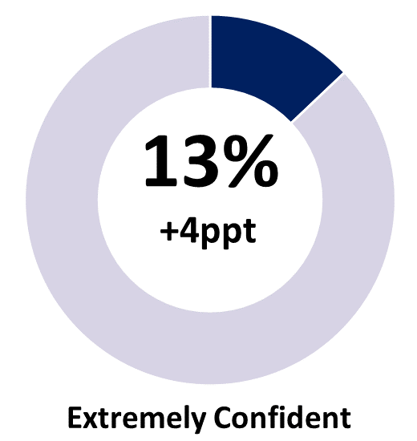 | 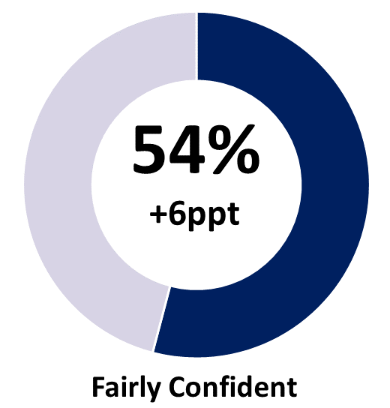 | 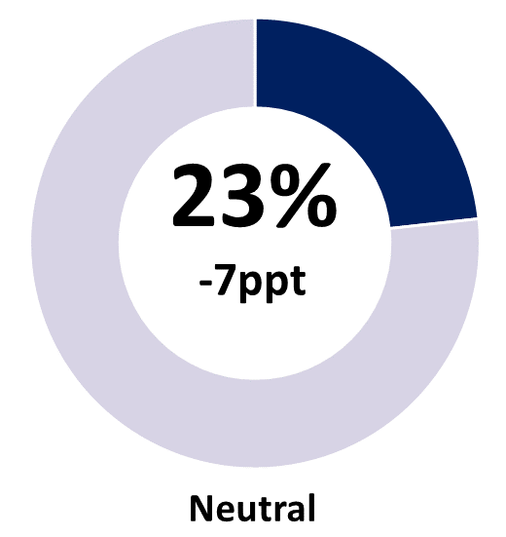
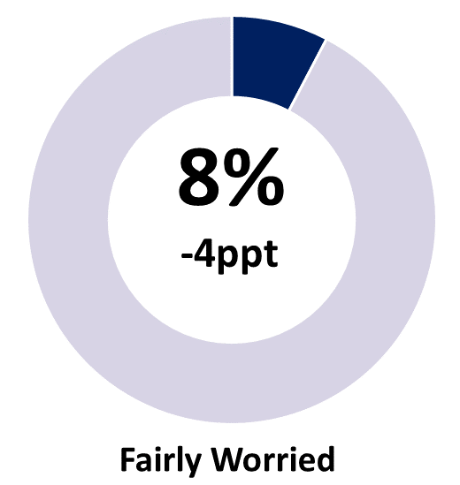 | 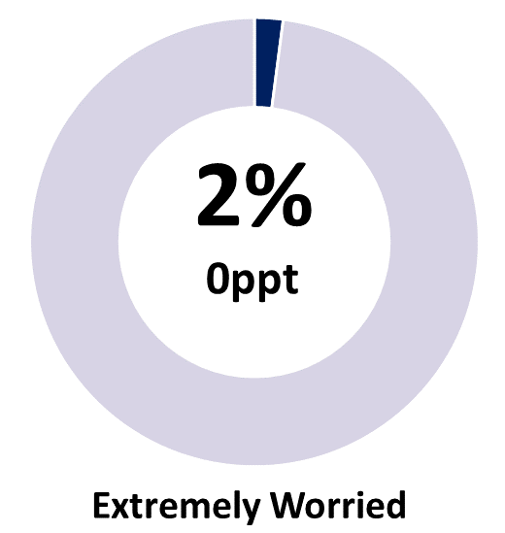 | 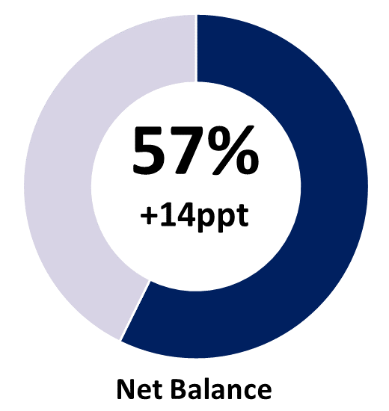
Note: Individual categories may not add to the net balance figure due to rounding.

Business confidence remains well-above pre-pandemic levels
The proportion of confident businesses increased by 10 ppt this quarter, picking up shares from neutral (-7 ppt) and worried (-4 ppt) businesses. Following the dip last quarter, business confidence this quarter returned to well above pre-pandemic levels (Chart 1). Despite the drag from the previous quarter, in calendar year terms, confidence in 2023 to date is well above pre-pandemic levels (Chart 2).
Chart 1
Business confidence by quarter (%)
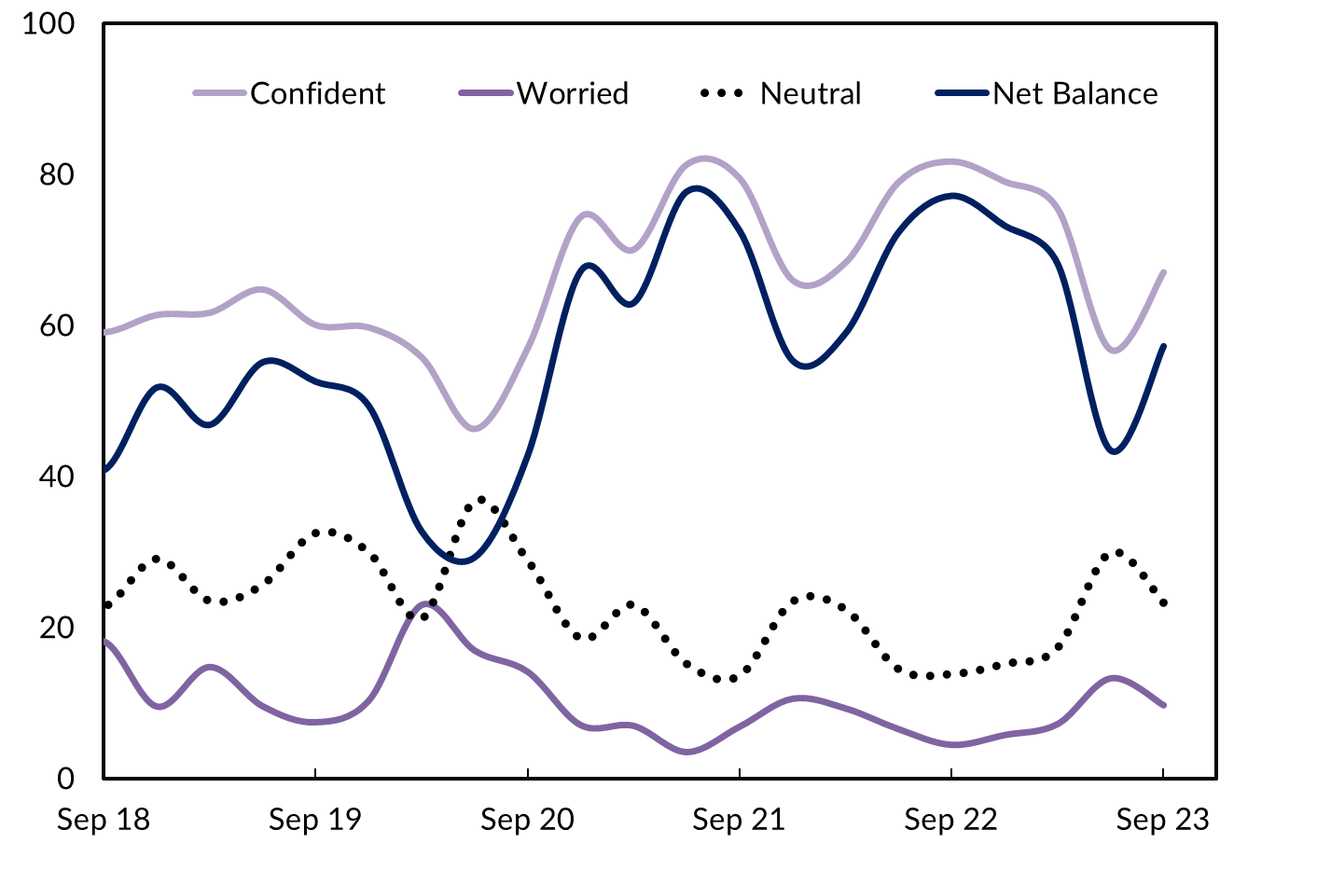
Chart 2
Average business confidence by calendar year (%)
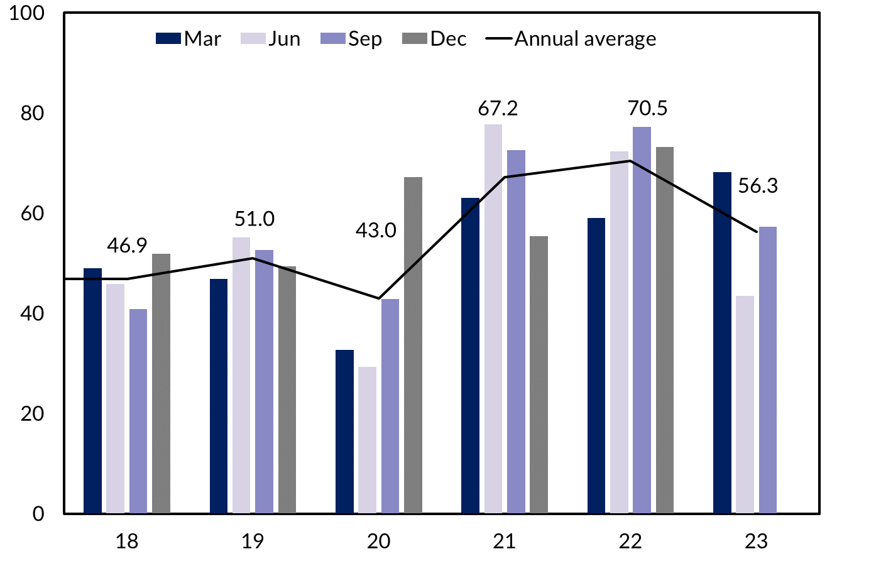

Business performance increased this quarter
When asked ‘How is your business performing this year compared to last year?’, 46% of businesses responded with ‘better’, representing a 1 ppt increase from the June quarter 2023 and an 18 ppt decrease from September quarter 2022 (Table 2).
Table 2: Business performance compared to last year
 | Sep qtr 2023 | Quarterly change | Annual change*
Better | 46% | +1ppt | -18ppt
Same | 33% | -2ppt | +5ppt
Worse | 21% | 0ppt | +14ppt
*Current quarter compared with the same quarter in the previous year.
Figure 2: Responses to the business performance question and quarterly change
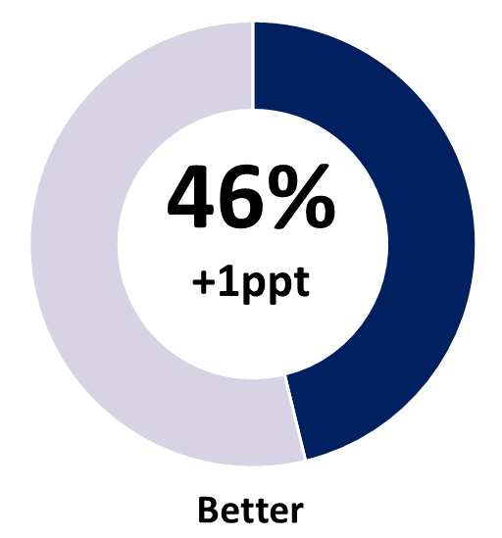 | 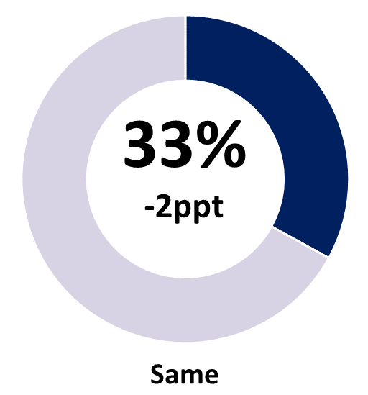 | 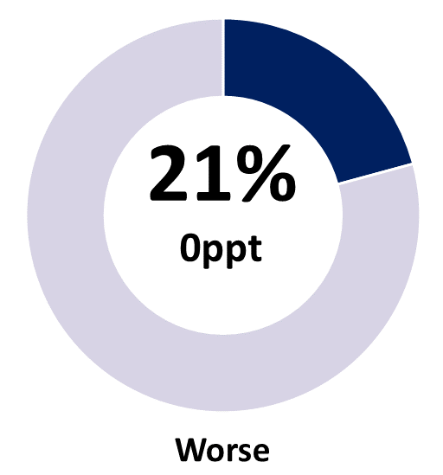
Note: Individual categories may not sum to 100 due to rounding.
The number of businesses stating performance this year is worse than last year was steady at 21% in the September quarter 2023, the highest level since 2020 and up by 14 ppt in annual terms (Chart 3).
Chart 3
Business performance – comparing this year to last – by quarter (%)
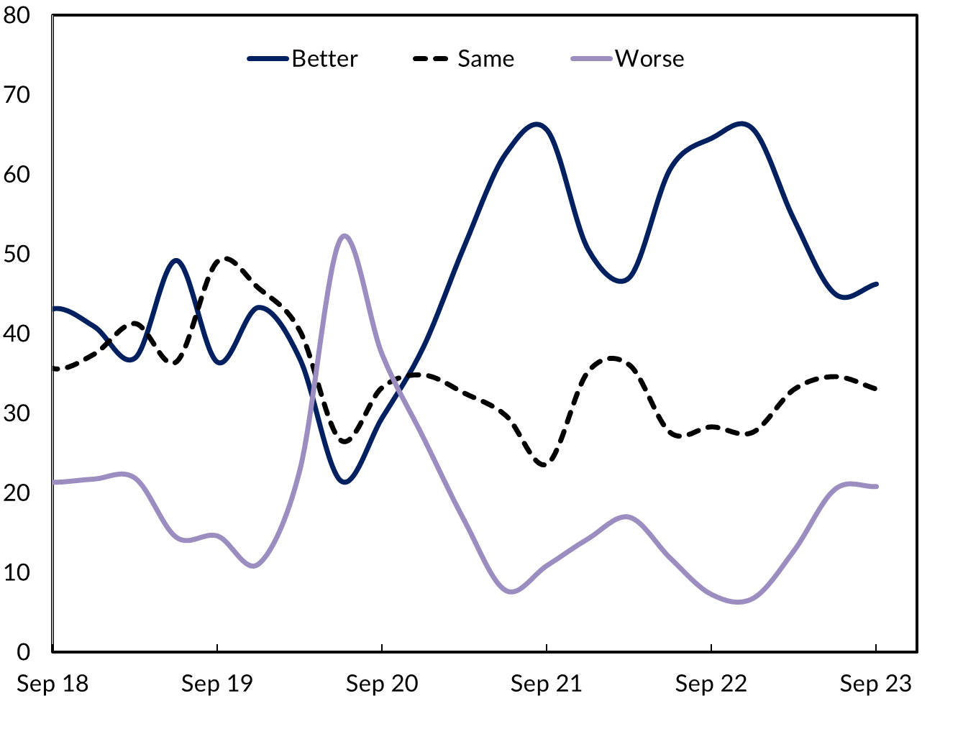

Customer relations and business duration drive confidence
The key reasons cited for business confidence in the September quarter 2023 were ‘strong customer relations’, ‘been in business a long time’ and ‘strong market position’ (Chart 4). ‘Business opportunity’ and ‘plenty of work coming up’ were also cited by a significant number of businesses, consistent with investment growth at 5.3% in 2022-23 (Chart 5).
Chart 4
Reasons for confidence cited, share of businesses (%)
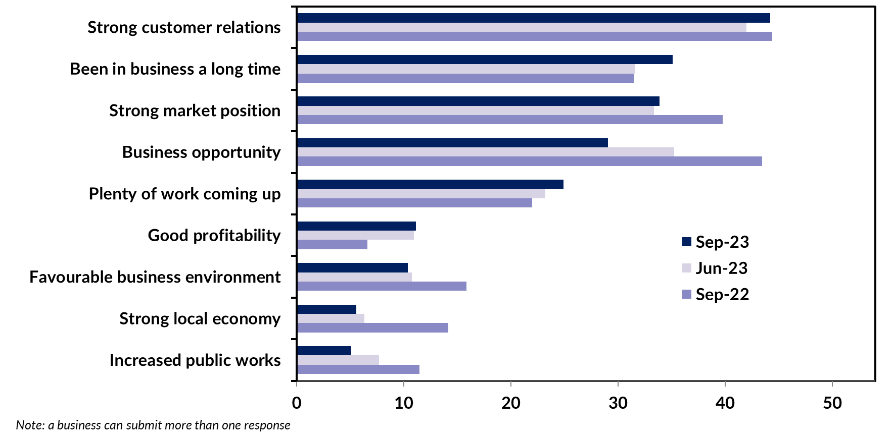

Chart 5
Territory state final demand, component contribution, year-on-year growth (%)
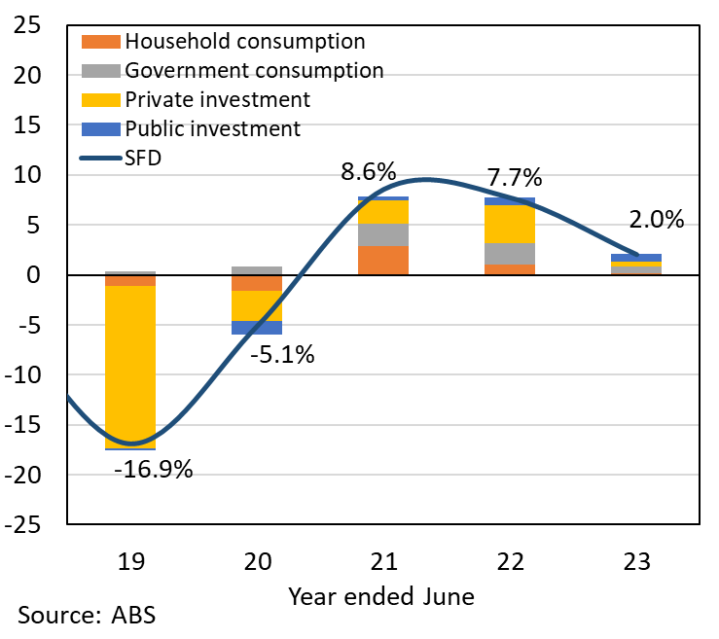

Labour shortages and decreasing sales are a concern
A ‘lack of suitably skilled workers’ remains the most common reason for concern, cited by 21% of businesses in the September quarter 2023 (Chart 6), following an encouraging reprieve of 11% in the June quarter. Latest data reports, Territory job vacancies have declined for six consecutive quarters to around 6,000 positions, down from the high point of 8,500 in early 2022, but still well above historical levels.
Chart 6
Reasons for worry cited, share of businesses (%)
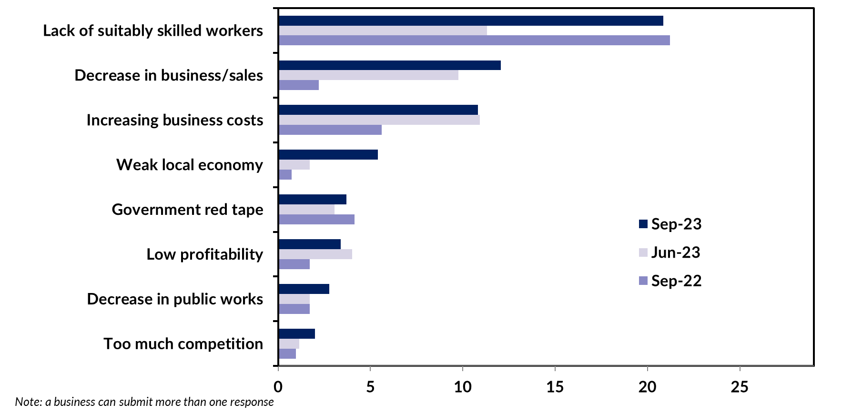

12% of businesses cited ‘decrease in business/sales’ as a reason for concern, consistent with the decline in real retail sales, attributed to reduced discretionary spending amidst rapid monetary tightening (Chart 7). Inflation is also ‘increasing business costs’ across a broad base of inputs with the cost of materials to build a house in Australia reporting a 33% increase compared with pre-COVID levels. Timber is the highest weighted contributor to the index (Chart 8) recording significant cost increases, driven by a combination of supply side factors (pandemic shipping restrictions and the 2019-20 bushfires) and the surge in demand.
Chart 7 | Chart 8
Nominal vs real retail sales - NT  Year-on-year growth (%) | House construction industry input costs - Australia  Index (2011-12 = 100), materials contribution to the index
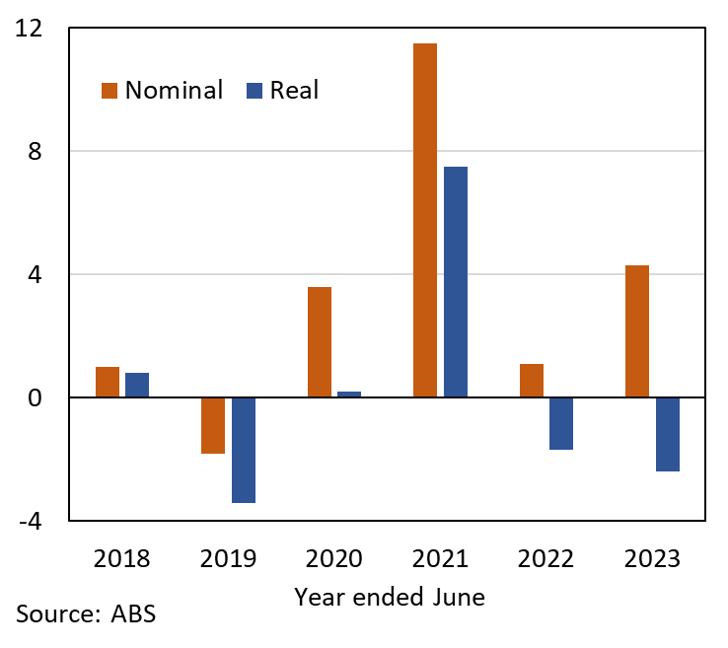 | 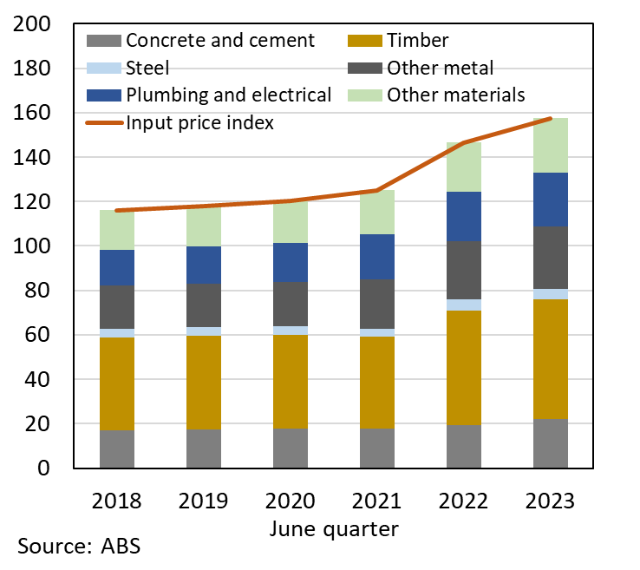

Business confidence and performance vary among the regions
Business confidence and performance varies by region (Table 3). Business confidence was highest in the East Arnhem region in the September quarter with a net balance of +92%. Daly-Tiwi-West Arnhem region recorded a net balance of +79%, supported by 55% of businesses in the region reporting better performance on a year ago, the highest of the regions for the second straight quarter. Please note that a small sample size in some regions can contribute to large quarterly movements.
Business confidence in Greater Darwin increased by 19 ppt in the quarter to a net balance of +58%, rebounding from the 29 ppt decline in the June quarter and comfortably back above pre-pandemic levels. Business confidence in Alice Springs declined by 15 ppt this quarter to a net balance of +52%, down by 33 ppt annually, continuing to fall away from the record highs observed in the second half of 2022.
Perceptions around local factors, notably in Darwin and Alice Springs, continue to pervade business confidence. The Territory Government has proactively implemented various initiatives to address these challenges.
Table 3: Business confidence and performance by region
Business Confidence |  |  |  |  | Business Performance
 | Sep qtr 2023 | Quarterly change | Annual change |  |  | Sep qtr 2023 | Quarterly change | Annual change
Territory-wide (n=647) |  |  |  |  | Territory-wide (n=647)
Confident | 67% | +10ppt | -15ppt |  | Better | 46% | +1ppt | -18ppt
Worried | 10% | -4ppt | +5ppt |  | Same | 33% | -2ppt | +5ppt
Net Balance | 57% | +14ppt | -20ppt |  | Worse | 21% | 0ppt | +14ppt
Greater Darwin (n=217) |  |  |  |  | Greater Darwin (n=217)
Confident | 67% | +13ppt | -16ppt |  | Better | 48% | +4ppt | -19ppt
Worried | 9% | -5ppt | +5ppt |  | Same | 31% | -4ppt | +5ppt
Net Balance | 58% | +19ppt | -21ppt |  | Worse | 21% | 0ppt | +14ppt
Daly-Tiwi-West Arnhem (n=33) |  |  |  |  | Daly-Tiwi-West Arnhem (n=33)
Confident | 85% | +14ppt | +8ppt |  | Better | 55% | -6ppt | +1ppt
Worried | 6% | +4ppt | -17ppt |  | Same | 33% | +9ppt | +3ppt
Net Balance | 79% | +10ppt | +25ppt |  | Worse | 12% | -3ppt | -3ppt
East Arnhem (n=25) |  |  |  |  | East Arnhem (n=25)
Confident | 96% | +34ppt | +10ppt |  | Better | 38% | +4ppt | +13ppt
Worried | 4% | -10ppt | +4ppt |  | Same | 50% | +6ppt | 0ppt
Net Balance | 92% | +43ppt | +6ppt |  | Worse | 13% | -10ppt | -13ppt
Katherine (n=165) |  |  |  |  | Katherine (n=165)
Confident | 65% | +9ppt | -3ppt |  | Better | 40% | -16ppt | -33ppt
Worried | 18% | -8ppt | +14ppt |  | Same | 25% | +18ppt | +5ppt
Net Balance | 48% | +16ppt | -17ppt |  | Worse | 36% | -2ppt | +28ppt
Barkly (n=19) |  |  |  |  | Barkly (n=19)
Confident | 74% | -6ppt | +7ppt |  | Better | 39% | -13ppt | -18ppt
Worried | 16% | +11ppt | +16ppt |  | Same | 39% | +9ppt | -4ppt
Net Balance | 58% | -17ppt | -9ppt |  | Worse | 22% | +4ppt | +22ppt
Alice Springs (n=188) |  |  |  |  | Alice Springs (n=188)
Confident | 62% | -9ppt | -26ppt |  | Better | 40% | -6ppt | -14ppt
Worried | 10% | +5ppt | +7ppt |  | Same | 44% | 0ppt | +4ppt
Net Balance | 52% | -15ppt | -33ppt |  | Worse | 17% | +6ppt | +10ppt
Note: Caution should be taken when interpreting these results as the sample size in some regions may be relatively small.

Business confidence varies across industries
Of the 10 industries with the largest number of respondents, confidence varied from Professional, Scientific and Technical Services reporting a net balance of +77% to Retail Trade at +30% (Chart 9).
The Arts and Recreation Services industry reported a net balance of +67% this quarter, a significant turnaround of 29 ppt from the June quarter. Confidence in the Accommodation and Food Services industry reported a 7 ppt increase from the previous quarter. This aligns with the latest data, reporting a post-COVID record of $3 billion in tourism revenue for the Territory in 2022-23, supporting tourism-related sectors.
The Territory’s construction industry recorded a solid net balance of +71%, supported by the significant pipeline of work, including the Territory Government’s capital works program. The 2023-24 Budget outlines a record $2.24 billion program for road and transport infrastructure.
Chart 9
Business confidence responses by industry (%)
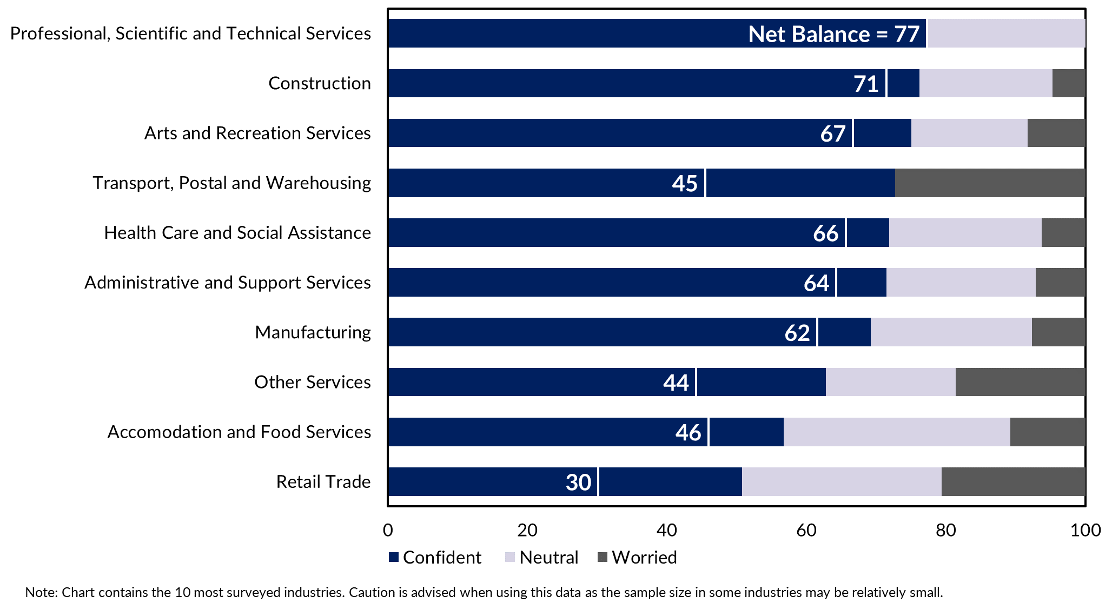

Appendix

Methodology
The Department of Industry, Tourism and Trade conducts a survey of businesses operating in the Territory on a quarterly basis. The results have been used to construct a business confidence index.
The business confidence index is calculated as the difference between the proportion of businesses that are ‘confident about their business prospects for the next 12 months' and the proportion of businesses that are ‘worried about their business prospects for the next 12 months’ (net balance approach).
The Territory-wide confidence index is weighted to account for the number of businesses in each region. The weighted result provides a more balanced reflection of overall business confidence. Business confidence results are also presented by region and industry.
647 businesses were surveyed this quarter out of 15,777 operating businesses in the Territory (Table 4). For the sample survey to achieve a 95% confidence level with a margin of error of 5%, 376 survey responses are required.
Table 4: Survey Numbers
Region | Total number of businesses | Businesses surveyed | Proportion of total
Greater Darwin | 11,577 | 217 | 1.9%
Daly-Tiwi-West Arnhem | 378 | 33 | 8.7%
East Arnhem | 241 | 25 | 10.4%
Katherine | 960 | 165 | 17.2%
Barkly | 193 | 19 | 9.8%
Alice Springs | 2,034 | 188 | 9.2%
Total | 15,777 | 647 | 4.1%
Note: Total number of businesses do not add up to individuals due to some businesses missing location information.

