Mineral Titles Act 2010
NOTICE OF LAND CEASING TO BE A MINERAL TITLE APPLICATION AREA
Title Type and Number: | Exploration Licence 24029
Area Ceased on: | 18 November 2022
Area: | 16 Blocks, 42.78 km²
Locality: | MOROAK
Name of Applicant(s)/Holder(s): | 80% KALYAN RESOURCES PTY LTD [ACN. 163 734 147], 5% EDWARDS Ronald John, 5% JOHNSTON Rodney, 5% REDDICLIFFE Thomas, 5% SCRIVEN EXPLORATION PTY LTD [ACN. 006 264 615]
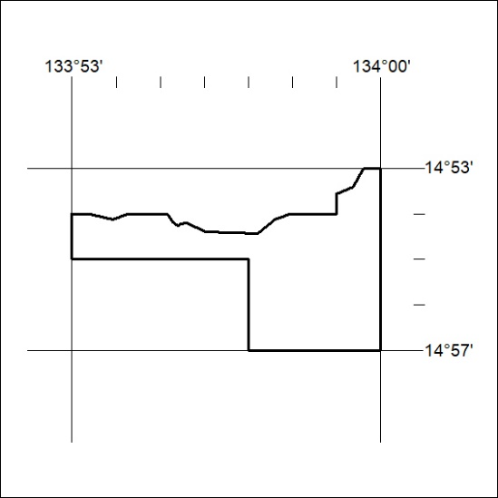
403/22

Mineral Titles Act 2010
NOTICE OF LAND CEASING TO BE A MINERAL TITLE AREA
Title Type and Number: | Exploration Licence 29349
Area Ceased on: | 20 November 2022
Area: | 29 Blocks, 73.77 km²
Locality: | MOROAK
Name of Applicant(s)/Holder(s): | 80% KALYAN RESOURCES PTY LTD [ACN. 163 734 147], 5% EDWARDS Ronald John, 5% JOHNSTON Rodney, 5% REDDICLIFFE Thomas, 5% SCRIVEN EXPLORATION PTY LTD [ACN. 006 264 615]
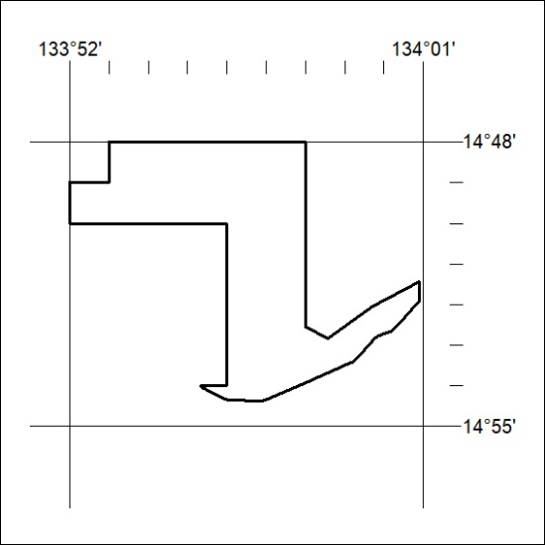
404/22
Mineral Titles Act 2010
NOTICE OF LAND CEASING TO BE A MINERAL TITLE AREA
Title Type and Number: | Exploration Licence 29490
Area Ceased on: | 22 November 2022
Area: | 12 Blocks, 26.82 km²
Locality: | MOROAK
Name of Applicant(s)/Holder(s): | 80% KALYAN RESOURCES PTY LTD [ACN. 163 734 147], 5% EDWARDS Ronald John, 5% JOHNSTON Rodney, 5% REDDICLIFFE Thomas, 5% SCRIVEN EXPLORATION PTY LTD [ACN. 006 264 615]
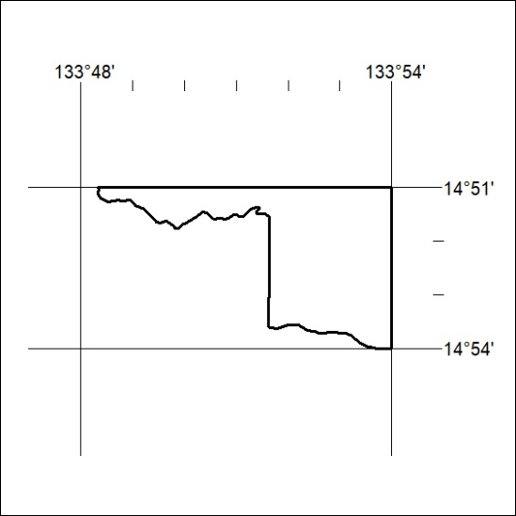
405/22

Mineral Titles Act 2010
NOTICE OF LAND CEASING TO BE A MINERAL TITLE AREA
Title Type and Number: | Exploration Licence 29493
Area Ceased on: | 22 November 2022
Area: | 4 Blocks, 13.23 km²
Locality: | MOROAK
Name of Applicant(s)/Holder(s): | 80% KALYAN RESOURCES PTY LTD [ACN. 163 734 147], 5% EDWARDS Ronald John, 5% JOHNSTON Rodney, 5% REDDICLIFFE Thomas, 5% SCRIVEN EXPLORATION PTY LTD [ACN. 006 264 615]
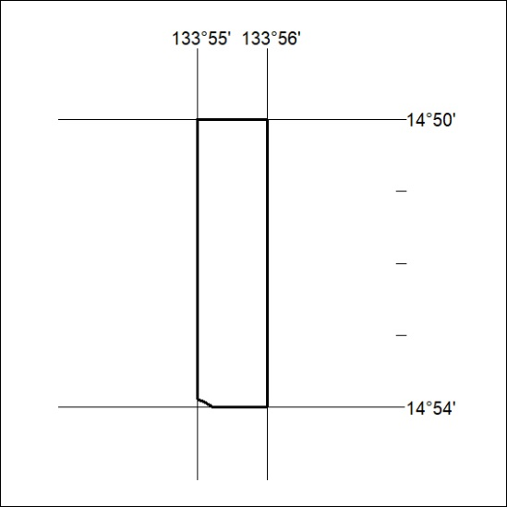
406/22
Mineral Titles Act 2010
NOTICE OF LAND CEASING TO BE A MINERAL TITLE AREA
Title Type and Number: | Exploration Licence 30115
Area Ceased on: | 22 November 2022
Area: | 12 Blocks, 39.53 km²
Locality: | MOROAK
Name of Applicant(s)/Holder(s): | 80% KALYAN RESOURCES PTY LTD [ACN. 163 734 147], 5% EDWARDS Ronald John, 5% JOHNSTON Rodney, 5% REDDICLIFFE Thomas, 5% SCRIVEN EXPLORATION PTY LTD [ACN. 006 264 615]
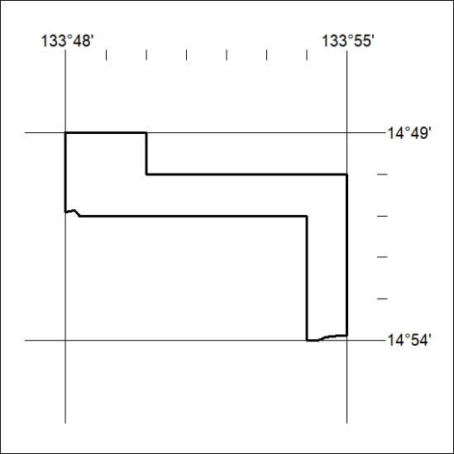

407/22

Mineral Titles Act 2010
NOTICE OF LAND CEASING TO BE A MINERAL TITLE APPLICATION AREA
Title Type and Number: | Exploration Licence 33163
Area Ceased on: | 22 November 2022
Area: | 83 Blocks, 263.51 km²
Locality: | SEIGAL
Name of Applicant(s)/Holder(s): | 100% COPPER GREEN PTY LTD [ACN. 119 559 974]
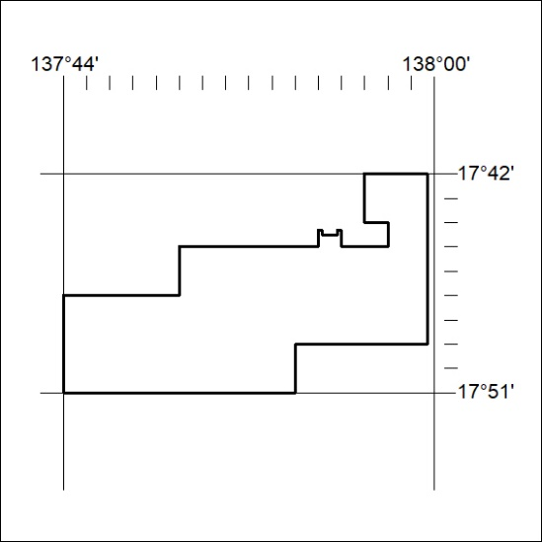

408/22

