Mineral Titles Act 2010
NOTICE OF LAND CEASING TO BE A MINERAL TITLE AREA
Title Type and Number: | Exploration Licence 32711
Area Ceased on: | 27 October 2022
Area: | 249 Blocks, 798.14 km²
Locality: | PLAYFORD
Name of Applicant(s)/Holder(s): | 100% RED METAL LIMITED [ACN. 103 367 684]
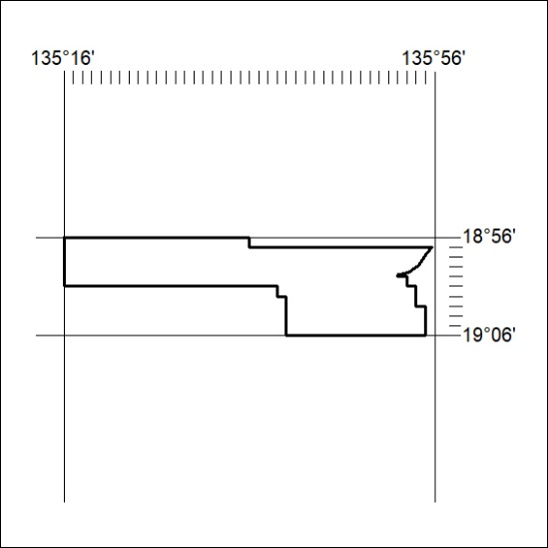

362/22

Mineral Titles Act 2010
NOTICE OF LAND CEASING TO BE A MINERAL TITLE AREA
Title Type and Number: | Exploration Licence 32712
Area Ceased on: | 27 October 2022
Area: | 250 Blocks, 810.83 km²
Locality: | PLAYFORD
Name of Applicant(s)/Holder(s): | 100% RED METAL LIMITED [ACN. 103 367 684]
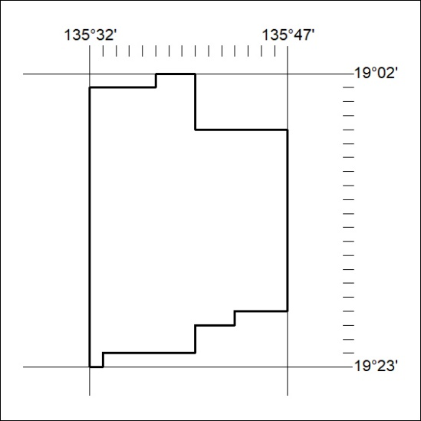

363/22

Mineral Titles Act 2010
NOTICE OF LAND CEASING TO BE A MINERAL TITLE AREA
Title Type and Number: | Exploration Licence 32713
Area Ceased on: | 27 October 2022
Area: | 154 Blocks, 488.34 km²
Locality: | FREWENA
Name of Applicant(s)/Holder(s): | 100% RED METAL LIMITED [ACN. 103 367 684]
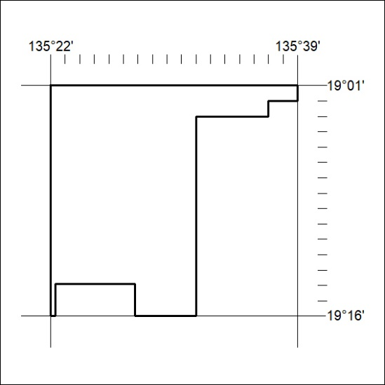

364/22

