Mineral Titles Act
NOTICE OF GRANT OF A MINERAL TITLE
Title Type and Number: | Exploration Licence 33062
Granted: | 14 October 2022, for a period of 6 Years
Area: | 126 Blocks, 372.93 km²
Locality: | JOILDUNG
Name of Holder/s: | 100% MINEMAKERS AUSTRALIA PTY LTD* [ACN. 081 911 917]
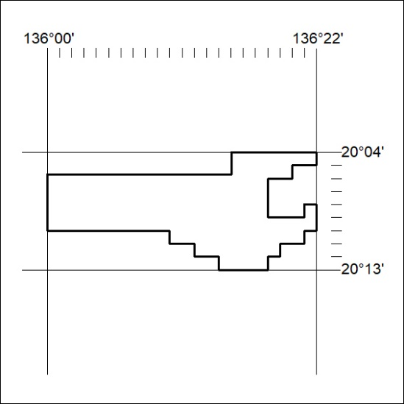
Area granted is indicated above. The titleholder is not permitted to exercise occupational rights on any land that is subject to a development title, or an application for a development title. Any land the subject of a Reserved Land gazettal under the Mineral Titles Act and all land vested in the Commonwealth of Australia is also excluded by description but not excised from the grant area.

356/22

