Mineral Titles Act
NOTICE OF GRANT OF A MINERAL TITLE
Title Type and Number: | Extractive Mineral Lease 32402
Granted: | 08 August 2022, for a period of 10 Years
Area: | 15.00 Hectares
Locality: | GOVE
Name of Holder/s: | 100% GULKULA MINING COMPANY PTY LTD [ACN. 153 861 806]
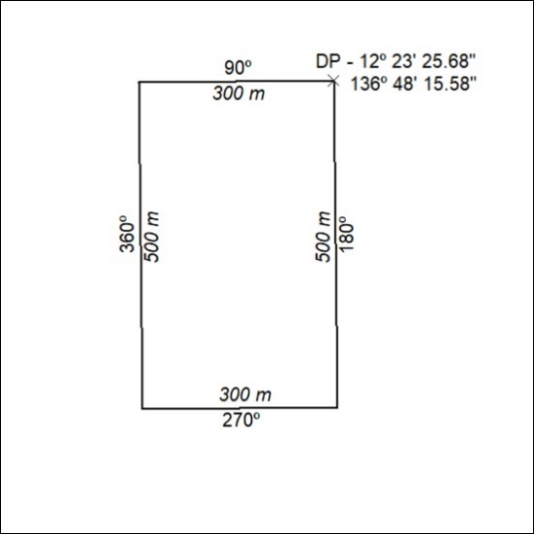

279/22

Mineral Titles Act
NOTICE OF GRANT OF A MINERAL TITLE
Title Type and Number: | Exploration Licence 33000
Granted: | 09 August 2022, for a period of 6 Years
Area: | 115 Blocks, 790.62 km²
Locality: | AILERON
Name of Holder/s: | 100% URO CORPORATION PTY LTD [ACN. 653 927 998]
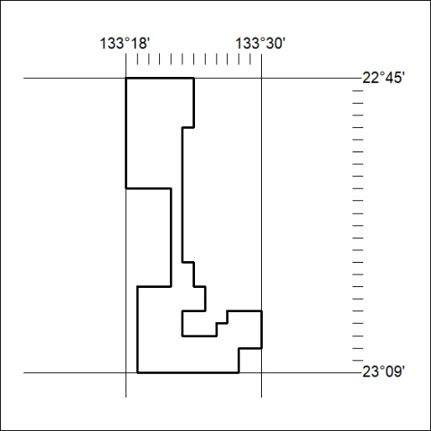
Area granted is indicated above. The titleholder is not permitted to exercise occupational rights on any land that is subject to a development title, or an application for a development title. Any land the subject of a Reserved Land gazettal under the Mineral Titles Act and all land vested in the Commonwealth of Australia is also excluded by description but not excised from the grant area.

280/22

Mineral Titles Act
NOTICE OF GRANT OF A MINERAL TITLE
Title Type and Number: | Exploration Licence 33005
Granted: | 09 August 2022, for a period of 6 Years
Area: | 142 Blocks, 786.75 km²
Locality: | ANBURLA
Name of Holder/s: | 100% URO CORPORATION PTY LTD [ACN. 653 927 998]
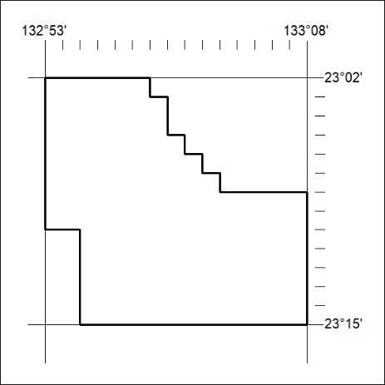
Area granted is indicated above. The titleholder is not permitted to exercise occupational rights on any land that is subject to a development title, or an application for a development title. Any land the subject of a Reserved Land gazettal under the Mineral Titles Act and all land vested in the Commonwealth of Australia is also excluded by description but not excised from the grant area.

281/22

Mineral Titles Act
NOTICE OF GRANT OF A MINERAL TITLE
Title Type and Number: | Exploration Licence 33006
Granted: | 09 August 2022, for a period of 6 Years
Area: | 220 Blocks, 788.42 km²
Locality: | BURT
Name of Holder/s: | 100% URO CORPORATION PTY LTD [ACN. 653 927 998]
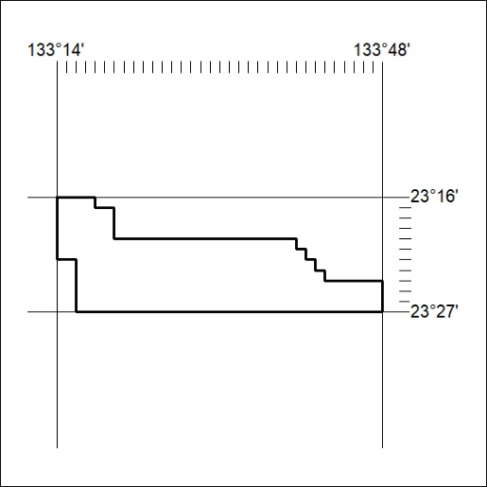
Area granted is indicated above. The titleholder is not permitted to exercise occupational rights on any land that is subject to a development title, or an application for a development title. Any land the subject of a Reserved Land gazettal under the Mineral Titles Act and all land vested in the Commonwealth of Australia is also excluded by description but not excised from the grant area.

282/22

Mineral Titles Act
NOTICE OF GRANT OF A MINERAL TITLE
Title Type and Number: | Exploration Licence 33060
Granted: | 15 August 2022, for a period of 6 Years
Area: | 250 Blocks, 740.11 km²
Locality: | WOODGREEN
Name of Holder/s: | 100% BAUDIN RESOURCES PTY LTD [ACN. 618 455 593]
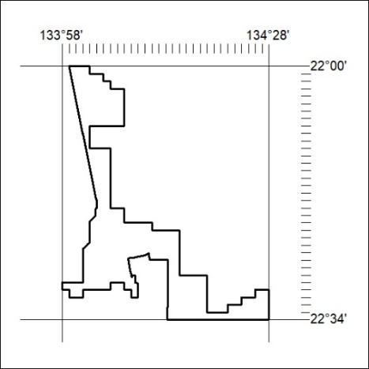
Area granted is indicated above. The titleholder is not permitted to exercise occupational rights on any land that is subject to a development title, or an application for a development title. Any land the subject of a Reserved Land gazettal under the Mineral Titles Act and all land vested in the Commonwealth of Australia is also excluded by description but not excised from the grant area.

283/22

Mineral Titles Act
NOTICE OF GRANT OF A MINERAL TITLE
Title Type and Number: | Exploration Licence 33065
Granted: | 15 August 2022, for a period of 6 Years
Area: | 208 Blocks, 665.33 km²
Locality: | CRAWFORD
Name of Holder/s: | 100% BAUDIN RESOURCES PTY LTD [ACN. 618 455 593]
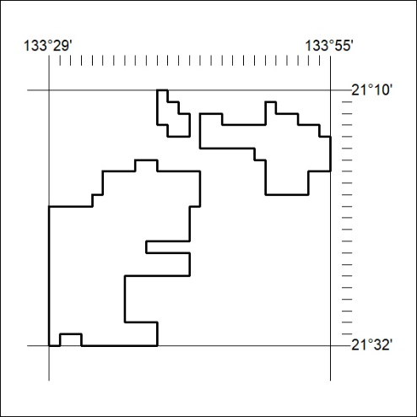
Area granted is indicated above. The titleholder is not permitted to exercise occupational rights on any land that is subject to a development title, or an application for a development title. Any land the subject of a Reserved Land gazettal under the Mineral Titles Act and all land vested in the Commonwealth of Australia is also excluded by description but not excised from the grant area.

284/22

Mineral Titles Act
NOTICE OF GRANT OF A MINERAL TITLE
Title Type and Number: | Exploration Licence 33051
Granted: | 16 August 2022, for a period of 6 Years
Area: | 92 Blocks, 292.38 km²
Locality: | NUMAGALONG
Name of Holder/s: | 100% NORTH TENNANT MINERALS PTY LTD [ACN. 654 828 912]
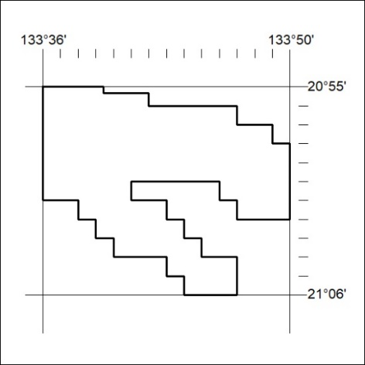
Area granted is indicated above. The titleholder is not permitted to exercise occupational rights on any land that is subject to a development title, or an application for a development title. Any land the subject of a Reserved Land gazettal under the Mineral Titles Act and all land vested in the Commonwealth of Australia is also excluded by description but not excised from the grant area.

285/22

