Mineral Titles Act 2010
NOTICE OF LAND CEASING TO BE A MINERAL TITLE APPLICATION AREA
Title Type and Number: | Exploration Licence 32555
Area Ceased on: | 11 July 2022
Area: | 250 Blocks, 824.60 km²
Locality: | NELLY CREEK
Name of Applicant(s)/Holder(s): | 100% GWC RESOURCES PTY LTD [ACN. 643 307 180]
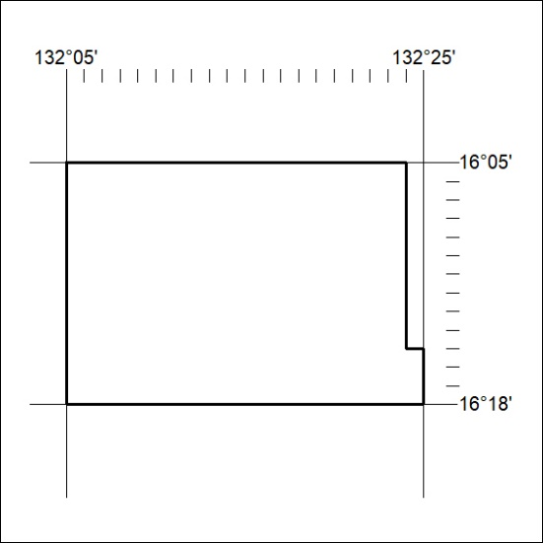

230/22

Mineral Titles Act 2010
NOTICE OF LAND CEASING TO BE A MINERAL TITLE APPLICATION AREA
Title Type and Number: | Exploration Licence 32556
Area Ceased on: | 11 July 2022
Area: | 250 Blocks, 824.57 km²
Locality: | MIDDLE CREEK
Name of Applicant(s)/Holder(s): | 100% GWC RESOURCES PTY LTD [ACN. 643 307 180]
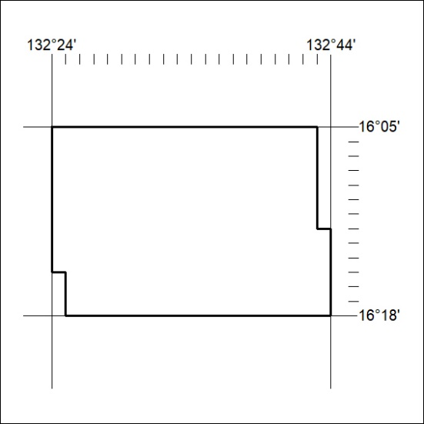

231/22

Mineral Titles Act 2010
NOTICE OF LAND CEASING TO BE A MINERAL TITLE APPLICATION AREA
Title Type and Number: | Exploration Licence 32557
Area Ceased on: | 11 July 2022
Area: | 250 Blocks, 823.52 km²
Locality: | MIDDLE CREEK
Name of Applicant(s)/Holder(s): | 100% GWC RESOURCES PTY LTD [ACN. 643 307 180]
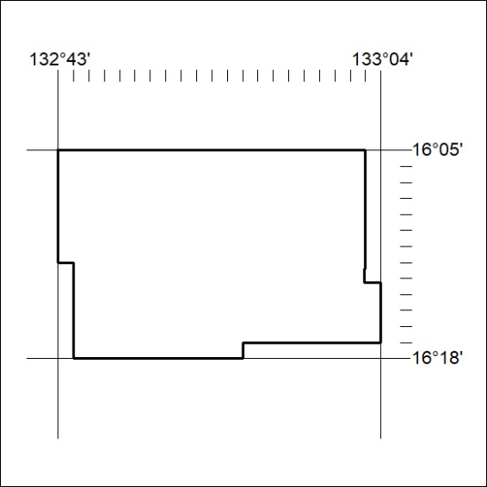

232/22

Mineral Titles Act 2010
NOTICE OF LAND CEASING TO BE A MINERAL TITLE APPLICATION AREA
Title Type and Number: | Exploration Licence 32558
Area Ceased on: | 11 July 2022
Area: | 250 Blocks, 818.50 km²
Locality: | DALY WATERS
Name of Applicant(s)/Holder(s): | 100% GWC RESOURCES PTY LTD [ACN. 643 307 180]
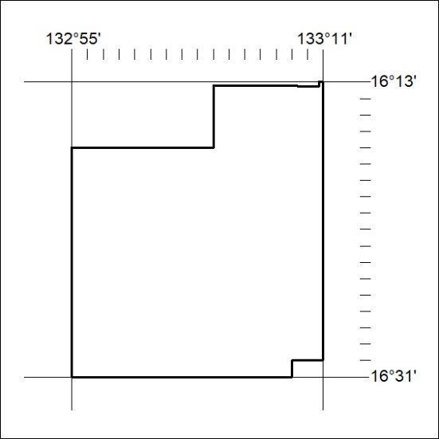

233/22

Mineral Titles Act 2010
NOTICE OF LAND CEASING TO BE A MINERAL TITLE APPLICATION AREA
Title Type and Number: | Exploration Licence 32559
Area Ceased on: | 11 July 2022
Area: | 250 Blocks, 822.79 km²
Locality: | HIDDEN VALLEY
Name of Applicant(s)/Holder(s): | 100% GWC RESOURCES PTY LTD [ACN. 643 307 180]
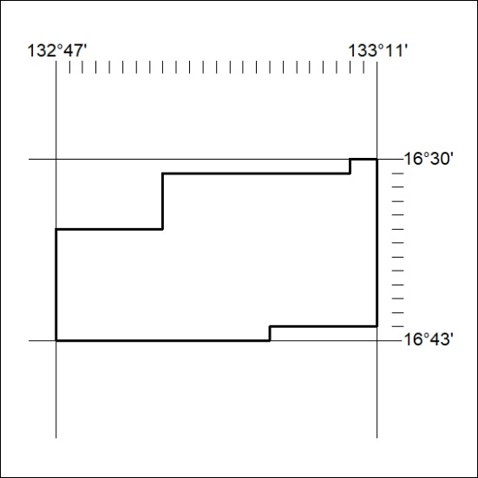

234/22

Mineral Titles Act 2010
NOTICE OF LAND CEASING TO BE A MINERAL TITLE APPLICATION AREA
Title Type and Number: | Exploration Licence 32560
Area Ceased on: | 11 July 2022
Area: | 250 Blocks, 762.33 km²
Locality: | HIDDEN VALLEY
Name of Applicant(s)/Holder(s): | 100% GWC RESOURCES PTY LTD [ACN. 643 307 180]
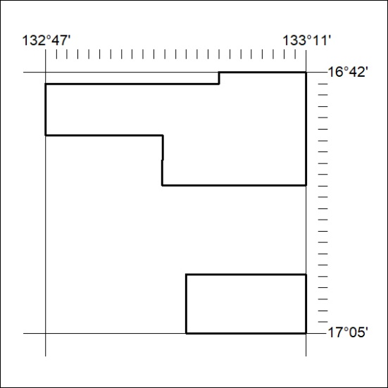

235/22

Mineral Titles Act 2010
NOTICE OF LAND CEASING TO BE A MINERAL TITLE APPLICATION AREA
Title Type and Number: | Exploration Licence 32561
Area Ceased on: | 11 July 2022
Area: | 250 Blocks, 778.93 km²
Locality: | MURRANJI
Name of Applicant(s)/Holder(s): | 100% GWC RESOURCES PTY LTD [ACN. 643 307 180]
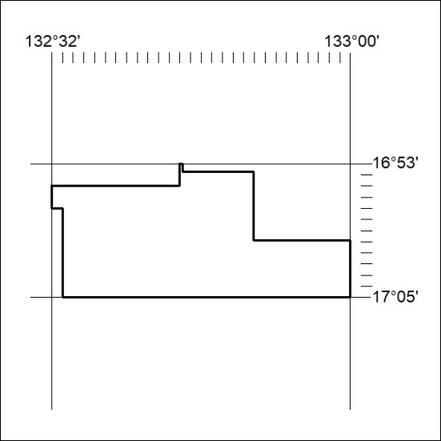

236/22

Mineral Titles Act 2010
NOTICE OF LAND CEASING TO BE A MINERAL TITLE APPLICATION AREA
Title Type and Number: | Exploration Licence 32562
Area Ceased on: | 11 July 2022
Area: | 250 Blocks, 821.12 km²
Locality: | FLAT TOP HILL
Name of Applicant(s)/Holder(s): | 100% GWC RESOURCES PTY LTD [ACN. 643 307 180]
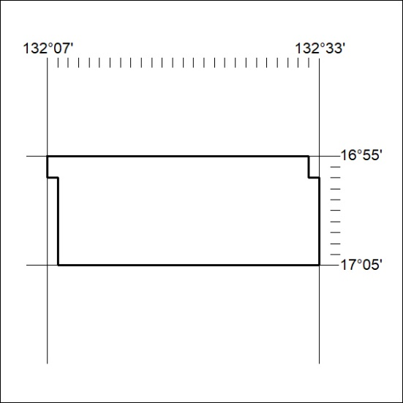

237/22

