Mineral Titles Act 2010
NOTICE OF LAND CEASING TO BE A MINERAL TITLE AREA
Title Type and Number: | Exploration Licence 30817
Area Ceased on: | 15 February 2022
Area: | 2 Blocks, 6.60 km²
Locality: | HUMBERT
Name of Applicant(s)/Holder(s): | 100% RIPPLE RESOURCES PTY LTD [ACN. 127 220 768]
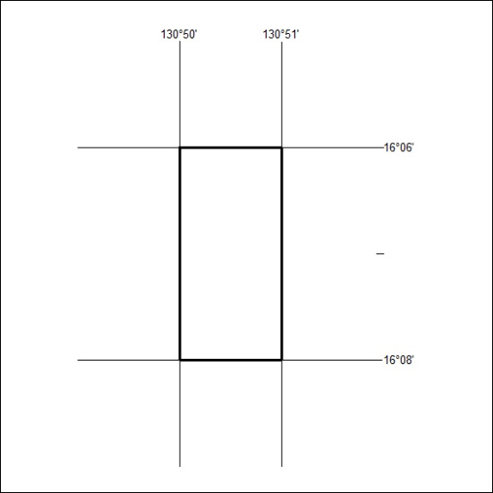

218/22

Mineral Titles Act 2010
NOTICE OF LAND CEASING TO BE A MINERAL TITLE AREA
Title Type and Number: | Exploration Licence 30818
Area Ceased on: | 15 February 2022
Area: | 11 Blocks, 36.27 km²
Locality: | VICTORIA RIVER DOWNS
Name of Applicant(s)/Holder(s): | 100% RIPPLE RESOURCES PTY LTD [ACN. 127 220 768]
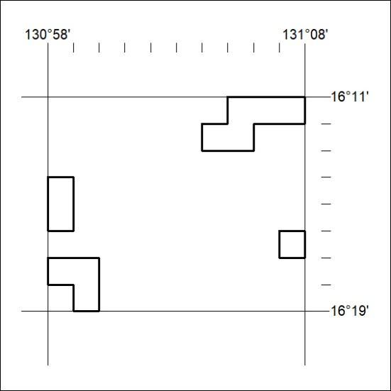

219/22

Mineral Titles Act 2010
NOTICE OF LAND CEASING TO BE A MINERAL TITLE AREA
Title Type and Number: | Extractive Mineral Permit 23036
Area ceased on: | 30 June 2022
Area: | 16.00 Hectare
Locality: | NOONAMAH
Name of Applicants(s)Holder(s): | 100% BERNO BROS. PTY. LIMITED [ACN. 009 592 741]
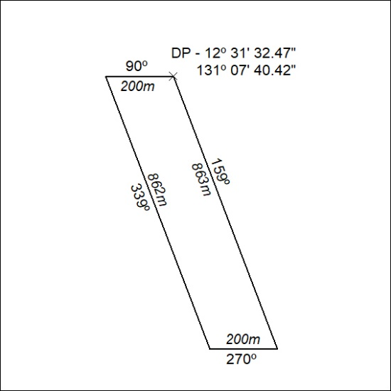

220/22

Mineral Titles Act 2010
NOTICE OF LAND CEASING TO BE A MINERAL TITLE AREA
Title Type and Number: | Extractive Mineral Permit 23037
Area ceased on: | 30 June 2022
Area: | 16.00 Hectare
Locality: | NOONAMAH
Name of Applicants(s)Holder(s): | 100% BERNO BROS. PTY. LIMITED [ACN. 009 592 741]
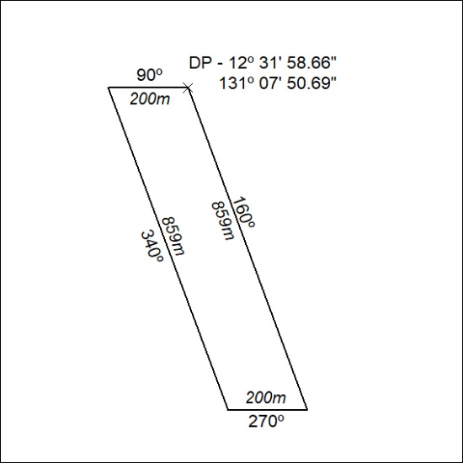

221/22

Mineral Titles Act 2010
NOTICE OF LAND CEASING TO BE A MINERAL TITLE AREA
Title Type and Number: | Extractive Mineral Permit 23039
Area ceased on: | 30 June 2022
Area: | 6.00 Hectare
Locality: | NOONAMAH
Name of Applicants(s)Holder(s): | 100% BERNO BROS. PTY. LIMITED [ACN. 009 592 741]
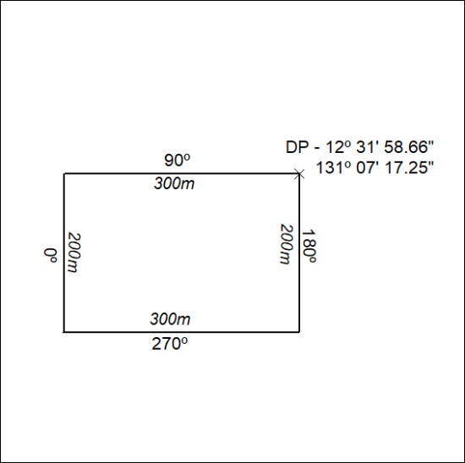

222/22

Mineral Titles Act 2010
NOTICE OF LAND CEASING TO BE A MINERAL TITLE AREA
Title Type and Number: | Extractive Mineral Permit 25527
Area ceased on: | 30 June 2022
Area: | 2.00 Hectare
Locality: | NOONAMAH
Name of Applicants(s)Holder(s): | 100% BERNOSAND PTY. LTD. [ACN. 009 615 810]
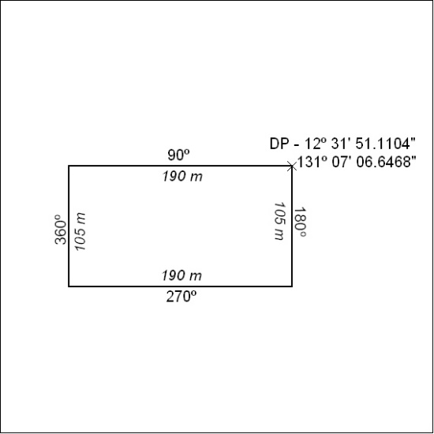

223/22

Mineral Titles Act 2010
NOTICE OF LAND CEASING TO BE A MINERAL TITLE AREA
Title Type and Number: | Extractive Mineral Permit (Northern) 1321
Area ceased on: | 30 June 2022
Area: | 13.00 Hectare
Locality: | NOONAMAH
Name of Applicants(s)Holder(s): | 100% BERNO BROS. PTY. LIMITED [ACN. 009 592 741]
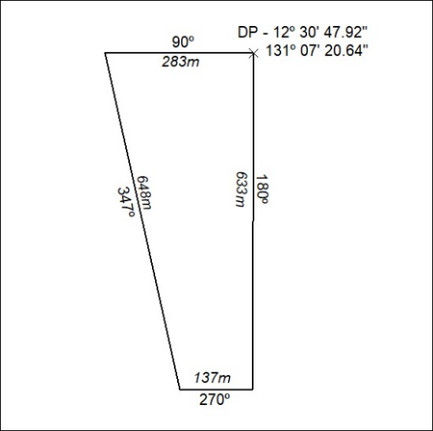

224/22

