# Economic growth

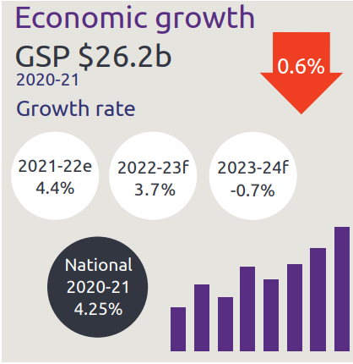

* Economic growth GSP $26.2 billion
* NT growth rate:
  + 2021-22 is 4.4%
  + 2022-23 is 3.7%
  + 2023-24 is -0.7%
* National growth rate in 2020-21 is 4.25%

# Industry share of output top 5

Industry share of output as described below

* Construction is 5.6%
* Mining is 24.6%
* Public admin is 11.9%
* Health is 8.1%
* Education is 4.9%

# Private business investment

Private business investment as described below

* Private business investment, up 30.8% to $3.4 billion year on year December 2021

# Business confidence for the Northern Territory

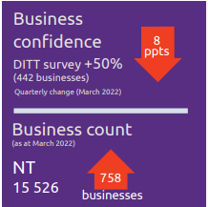

* Business confidence for the Northern Territory is +50% (442 businesses) in the March 2021 quarter, down 8 percentage points from the previous quarter
* Business count as at March 2022 for the Northern Territory was 15,526, up 758 business over the year

# Darwin inflation

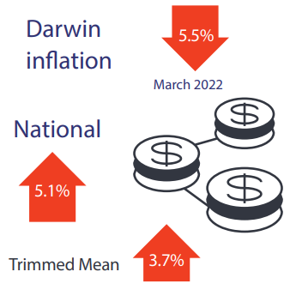

* Darwin inflation decreased 5.5% the year to March 2022
* National inflation increased 5.1%
* Trimmed mean increased 3.7%

# Labour market

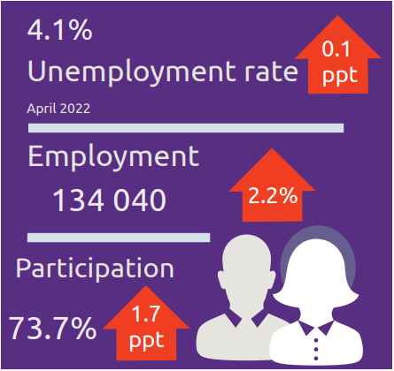

* Unemployment rate is 4.1%
* Employment is 134040, up 2.2%
* Participation rate was 73.7%, up 1.7 percentage points

# NT population

NT population as described below

* NT population is 245865, down 0.2% over the year
* National population is 25.7 million, up 0.3% over the year

# Population distribution

Population distribution as described below

Population distribution:

* Greater Darwin was 146982
* East Arnhem was 14584
* Katherine was 20893
* Alice Springs was 39458
* Barkly was 6140
* Daly-Tiwi-West Arnhem was 17852

# Average weekly earnings

Average weekly earnings as described below

Average weekly earnings in the NT is $1789, up 0.8%, and nationally is $1813, up 2.4%

# Median house prices

Median house prices as described below

Median house prices in the December quarter 2021:

* Katherine $345,000 up 11.3%
* Alice Springs $510,000 up 7.1%
* Palmerston $560,000 up 20.4%
* Darwin $592,500 up 18.5%

# Business size

Business size as described below

NT business size:

* Small is 96.7%
* Medium is 3.2%
* Large is 0.1%

# Business location

Business location as described below

Businesses by location:

* Greater Darwin has 72.9%
* Katherine has 6.4%
* Alice Springs has 13.1%
* Rest of NT has 7.6%

NT Department of Industry, Tourism and Trade  
t: 08 8999 5139  
industry.nt.gov.au