Mineral Titles Act 2010
NOTICE OF LAND CEASING TO BE A MINERAL TITLE AREA
Title Type and Number: | Exploration Licence 31143
Area Ceased on: | 11 May 2022
Area: | 166 Blocks, 512.65 km²
Locality: | BENDA
Name of Applicant(s)/Holder(s): | 100% ROPER ILMENITE PTY LTD [ACN. 609 843 978]
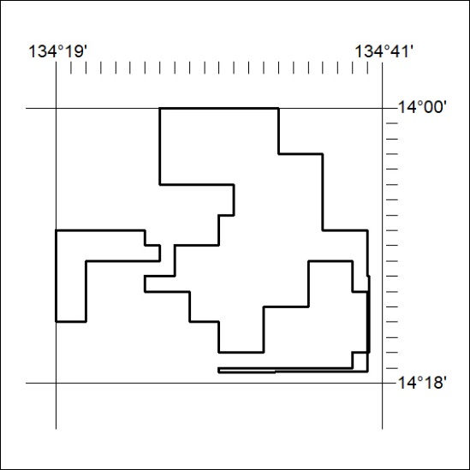

162/22

Mineral Titles Act
NOTICE OF GRANT OF A MINERAL TITLE
Title Type and Number: | Exploration Licence 32856
Granted: | 11 May 2022, for a period of 6 Years
Area: | 3 Blocks, 0.83 km²
Locality: | WONARAH
Name of Holder/s: | 90% INCA MINERALS LIMITED [ACN. 128 512 907], 5% MRG RESOURCES PTY LTD [ACN. 614 946 164], 5% WEST Jonathan
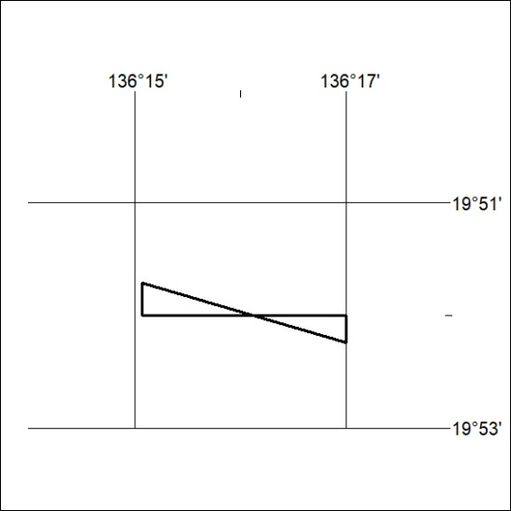
Area granted is indicated above. The titleholder is not permitted to exercise occupational rights on any land that is subject to a development title, or an application for a development title. Any land the subject of a Reserved Land gazettal under the Mineral Titles Act and all land vested in the Commonwealth of Australia is also excluded by description but not excised from the grant area.

163/22

Mineral Titles Act
NOTICE OF GRANT OF A MINERAL TITLE
Title Type and Number: | Exploration Licence 32857
Granted: | 11 May 2022, for a period of 6 Years
Area: | 187 Blocks, 585.20 km²
Locality: | BARRY CAVES
Name of Holder/s: | 90% INCA MINERALS LIMITED [ACN. 128 512 907], 5% MRG RESOURCES PTY LTD [ACN. 614 946 164], 5% WEST Jonathan
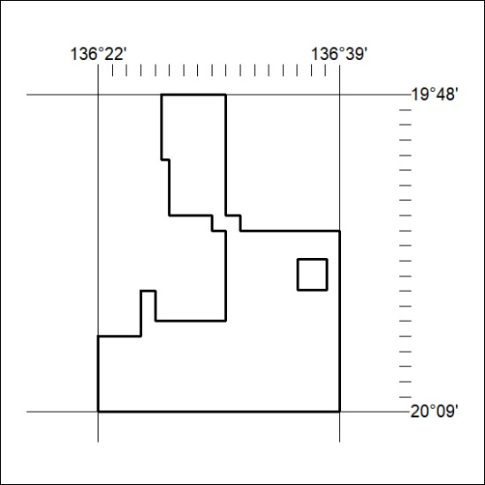
Area granted is indicated above. The titleholder is not permitted to exercise occupational rights on any land that is subject to a development title, or an application for a development title. Any land the subject of a Reserved Land gazettal under the Mineral Titles Act and all land vested in the Commonwealth of Australia is also excluded by description but not excised from the grant area.
164/22

