Mineral Titles Act
NOTICE OF GRANT OF A MINERAL TITLE
Title Type and Number: | Exploration Licence 32829
Granted: | 22 March 2022, for a period of 6 Years
Area: | 67 Blocks, 206.80 km²
Locality: | DOREEN
Name of Holder/s: | 100% CHALCO RESOURCES PTY LTD [ACN. 648 662 346]
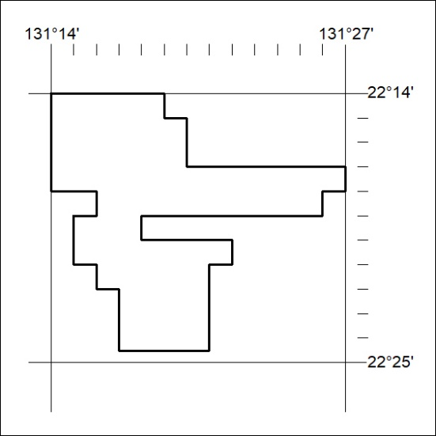
Area granted is indicated above. The titleholder is not permitted to exercise occupational rights on any land that is subject to a development title, or an application for a development title. Any land the subject of a Reserved Land gazettal under the Mineral Titles Act and all land vested in the Commonwealth of Australia is also excluded by description but not excised from the grant area.
73/22

Mineral Titles Act
NOTICE OF GRANT OF A MINERAL TITLE
Title Type and Number: | Exploration Licence 32864
Granted: | 22 March 2022, for a period of 6 Years
Area: | 174 Blocks, 536.51 km²
Locality: | MT WEDGE
Name of Holder/s: | 100% CHALCO RESOURCES PTY LTD [ACN. 648 662 346]
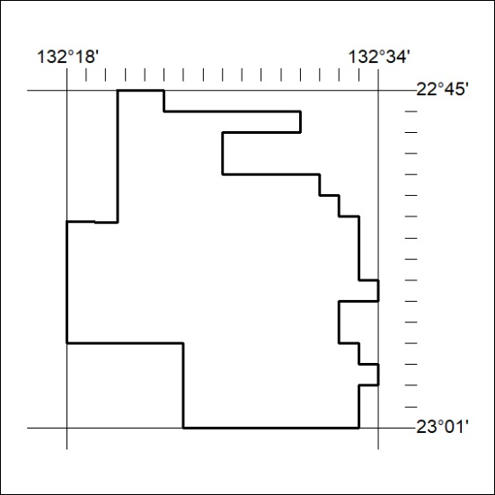
Area granted is indicated above. The titleholder is not permitted to exercise occupational rights on any land that is subject to a development title, or an application for a development title. Any land the subject of a Reserved Land gazettal under the Mineral Titles Act and all land vested in the Commonwealth of Australia is also excluded by description but not excised from the grant area.
74/22

