Mineral Titles Act 2010
NOTICE OF LAND CEASING TO BE A MINERAL TITLE AREA
Title Type and Number: | Exploration Licence 31984
Area Ceased on: | 22 March 2022
Area: | 4 Blocks, 12.79 km²
Locality: | GEORGE CREEK
Name of Applicant(s)/Holder(s): | 100% MAGNET EXPLORATION PTY LTD [ACN. 623 568 918]
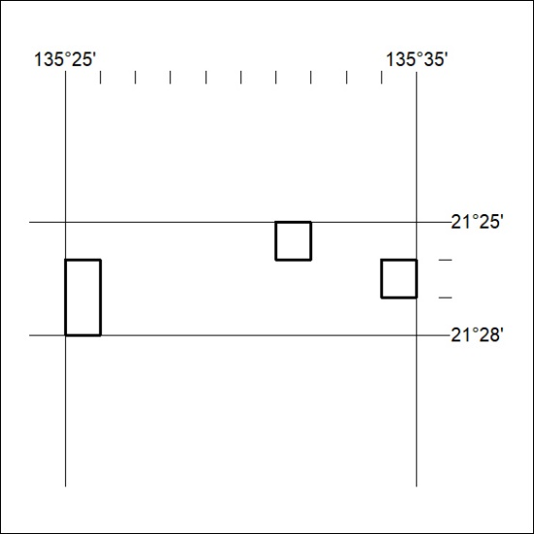

68/22

Mineral Titles Act 2010
NOTICE OF LAND CEASING TO BE A MINERAL TITLE AREA
Title Type and Number: | Exploration Licence 31951
Area Ceased on: | 22 March 2022
Area: | 114 Blocks, 365.17 km²
Locality: | GEORGE CREEK
Name of Applicant(s)/Holder(s): | 100% MAGNET EXPLORATION PTY LTD [ACN. 623 568 918]
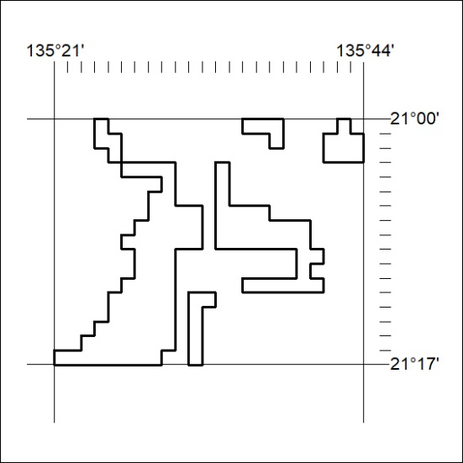

69/22
Mineral Titles Act 2010
NOTICE OF LAND CEASING TO BE A MINERAL TITLE AREA
Title Type and Number: | Exploration Licence 31952
Area Ceased on: | 22 March 2022
Area: | 106 Blocks, 339.05 km²
Locality: | GEORGE CREEK
Name of Applicant(s)/Holder(s): | 100% MAGNET EXPLORATION PTY LTD [ACN. 623 568 918]
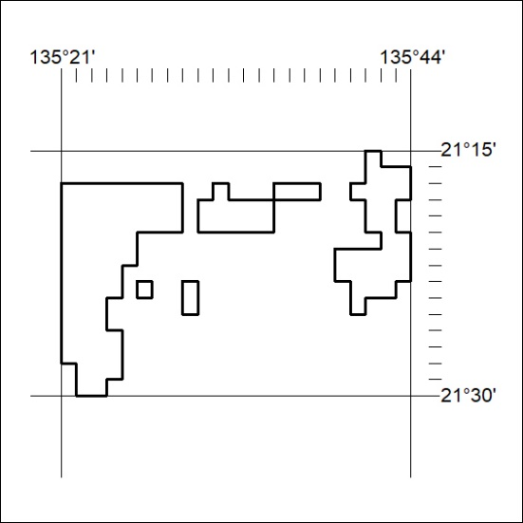

70/22

Mineral Titles Act 2010
NOTICE OF LAND CEASING TO BE A MINERAL TITLE AREA
Title Type and Number: | Exploration Licence 32244
Area Ceased on: | 20 March 2022
Area: | 102 Blocks, 319.84 km²
Locality: | TODD
Name of Applicant(s)/Holder(s): | 100% GEMPART (NT) PTY LTD* [ACN. 081 859 896]
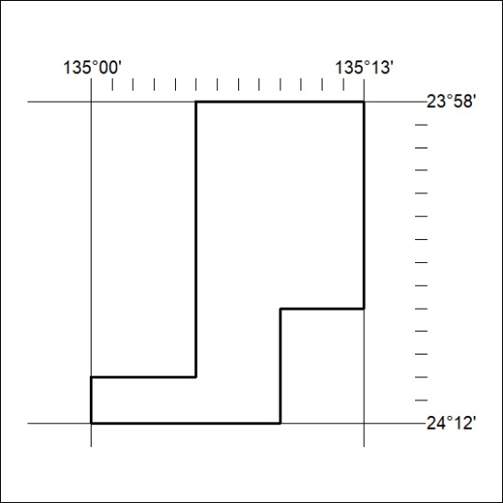

71/22

Mineral Titles Act
NOTICE OF GRANT OF A MINERAL TITLE
Title Type and Number: | Exploration Licence 32832
Granted: | 17 March 2022, for a period of 6 Years
Area: | 5 Blocks, 7.37 km²
Locality: | NOONAMAH
Name of Holder/s: | 100% MINING & CIVIL SERVICES PTY LTD [ACN. 082 654 297]
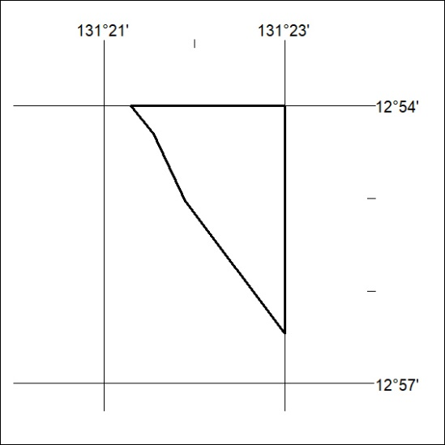
Area granted is indicated above. The titleholder is not permitted to exercise occupational rights on any land that is subject to a development title, or an application for a development title. Any land the subject of a Reserved Land gazettal under the Mineral Titles Act and all land vested in the Commonwealth of Australia is also excluded by description but not excised from the grant area.

72/22

