Mineral Titles Act 2010
NOTICE OF LAND CEASING TO BE A MINERAL TITLE AREA
Title Type and Number: | Extractive Mineral Lease 30443
Area ceased on: | 10 February 2022
Area: | 3.00 Hectare
Locality: | MALLAPUNYAH
Name of Applicants(s)Holder(s): | 100% SCHILLING Christopher Llewellyn
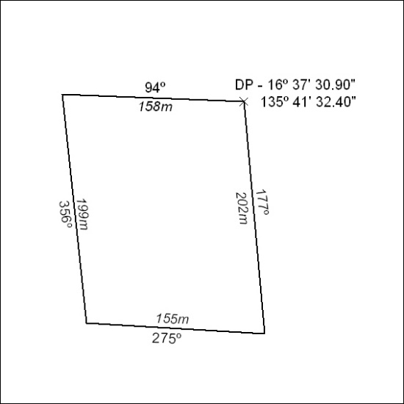

25/22

Mineral Titles Act 2010
NOTICE OF LAND CEASING TO BE A MINERAL TITLE AREA
Title Type and Number: | Extractive Mineral Permit 24595
Area ceased on: | 10 February 2022
Area: | 93.00 Hectare
Locality: | NOONAMAH
Name of Applicants(s)Holder(s): | 100% BOB KERR TRANSPORT PTY LTD [ACN. 109 115 059]
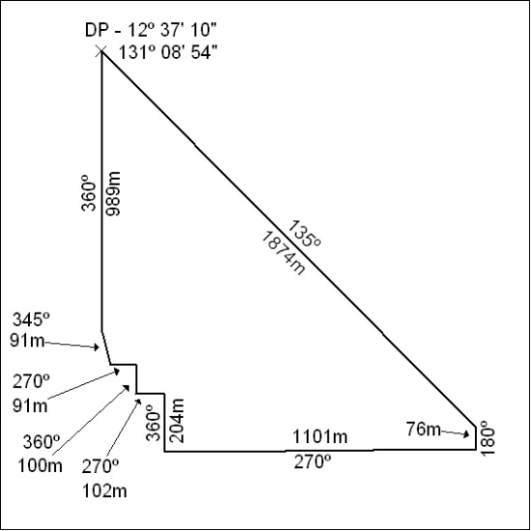

26/22

