Mineral Titles Act 2010
NOTICE OF LAND CEASING TO BE A MINERAL TITLE AREA
Title Type and Number: | Extractive Mineral Permit 27924
Area ceased on: | 07 January 2022
Area: | 62.00 Hectare
Locality: | KOOLPINYAH
Name of Applicants(s)Holder(s): | 100% MOUSELLIS & SONS PTY. LTD. [ACN. 009 654 791]
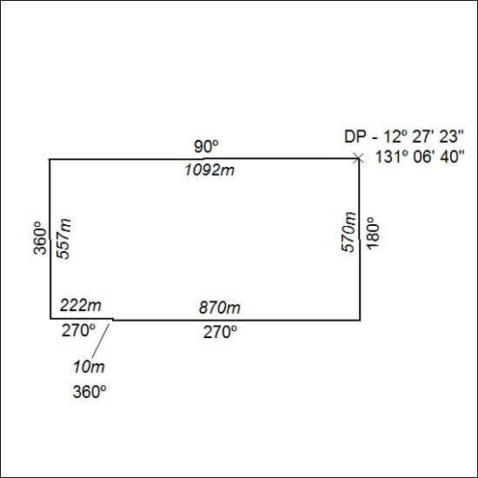

009/22

