Mineral Titles Act
NOTICE OF GRANT OF A MINERAL TITLE
Title Type and Number: | Exploration Licence 32708
Granted: | 27 October 2021, for a period of 6 Years
Area: | 222 Blocks, 722.65 km²
Locality: | BRUNETTE
Name of Holder/s: | 100% RED METAL LIMITED [ACN. 103 367 684]
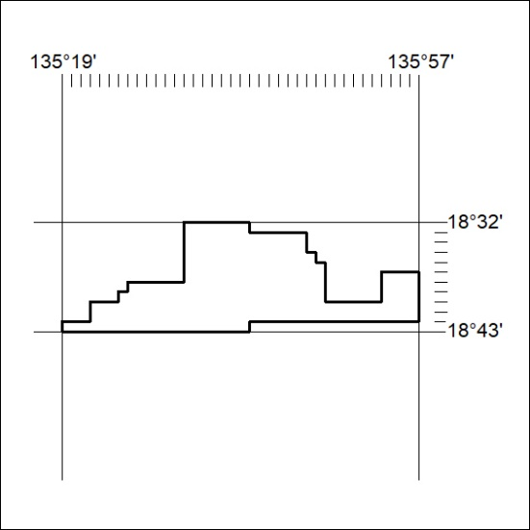
Area granted is indicated above. The titleholder is not permitted to exercise occupational rights on any land that is subject to a development title, or an application for a development title. Any land the subject of a Reserved Land gazettal under the Mineral Titles Act and all land vested in the Commonwealth of Australia is also excluded by description but not excised from the grant area.
408/21

Mineral Titles Act
NOTICE OF GRANT OF A MINERAL TITLE
Title Type and Number: | Exploration Licence 32709
Granted: | 27 October 2021, for a period of 6 Years
Area: | 250 Blocks, 812.69 km²
Locality: | BRUNETTE
Name of Holder/s: | 100% RED METAL LIMITED [ACN. 103 367 684]
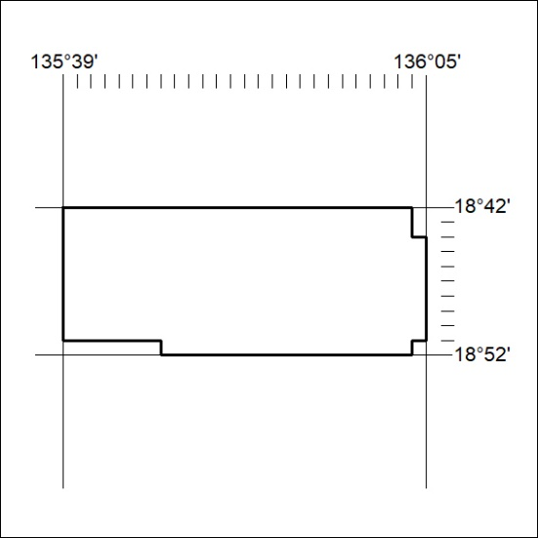
Area granted is indicated above. The titleholder is not permitted to exercise occupational rights on any land that is subject to a development title, or an application for a development title. Any land the subject of a Reserved Land gazettal under the Mineral Titles Act and all land vested in the Commonwealth of Australia is also excluded by description but not excised from the grant area.
409/21

Mineral Titles Act
NOTICE OF GRANT OF A MINERAL TITLE
Title Type and Number: | Exploration Licence 32710
Granted: | 27 October 2021, for a period of 6 Years
Area: | 247 Blocks, 795.55 km²
Locality: | BRUNETTE
Name of Holder/s: | 100% RED METAL LIMITED [ACN. 103 367 684]
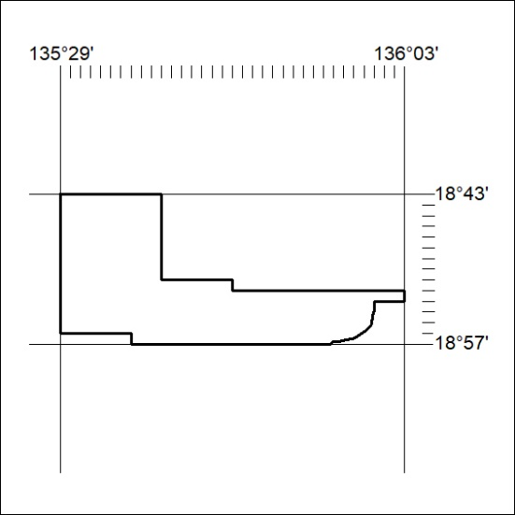
Area granted is indicated above. The titleholder is not permitted to exercise occupational rights on any land that is subject to a development title, or an application for a development title. Any land the subject of a Reserved Land gazettal under the Mineral Titles Act and all land vested in the Commonwealth of Australia is also excluded by description but not excised from the grant area.
410/21

Mineral Titles Act
NOTICE OF GRANT OF A MINERAL TITLE
Title Type and Number: | Exploration Licence 32711
Granted: | 27 October 2021, for a period of 6 Years
Area: | 249 Blocks, 798.35 km²
Locality: | PLAYFORD
Name of Holder/s: | 100% RED METAL LIMITED [ACN. 103 367 684]
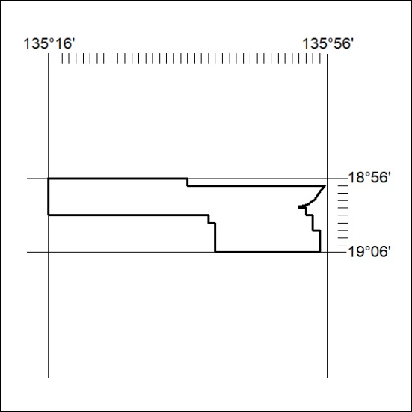
Area granted is indicated above. The titleholder is not permitted to exercise occupational rights on any land that is subject to a development title, or an application for a development title. Any land the subject of a Reserved Land gazettal under the Mineral Titles Act and all land vested in the Commonwealth of Australia is also excluded by description but not excised from the grant area.
411/21

Mineral Titles Act
NOTICE OF GRANT OF A MINERAL TITLE
Title Type and Number: | Exploration Licence 32712
Granted: | 27 October 2021, for a period of 6 Years
Area: | 250 Blocks, 810.83 km²
Locality: | PLAYFORD
Name of Holder/s: | 100% RED METAL LIMITED [ACN. 103 367 684]
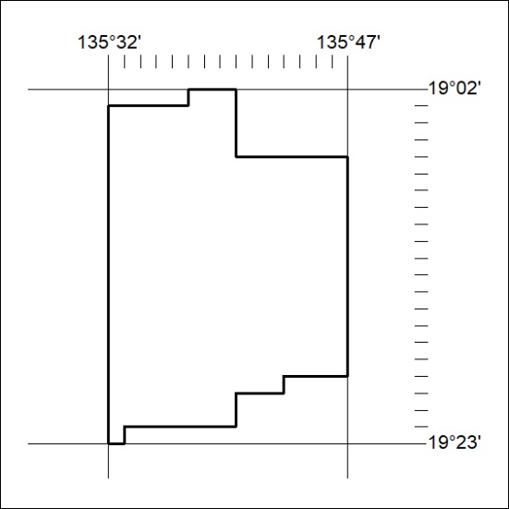
Area granted is indicated above. The titleholder is not permitted to exercise occupational rights on any land that is subject to a development title, or an application for a development title. Any land the subject of a Reserved Land gazettal under the Mineral Titles Act and all land vested in the Commonwealth of Australia is also excluded by description but not excised from the grant area.
412/21

Mineral Titles Act
NOTICE OF GRANT OF A MINERAL TITLE
Title Type and Number: | Exploration Licence 32713
Granted: | 27 October 2021, for a period of 6 Years
Area: | 154 Blocks, 488.34 km²
Locality: | FREWENA
Name of Holder/s: | 100% RED METAL LIMITED [ACN. 103 367 684]
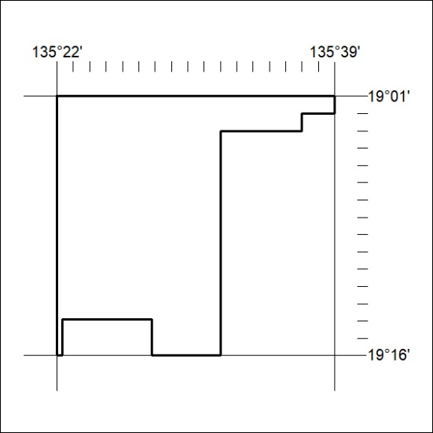
Area granted is indicated above. The titleholder is not permitted to exercise occupational rights on any land that is subject to a development title, or an application for a development title. Any land the subject of a Reserved Land gazettal under the Mineral Titles Act and all land vested in the Commonwealth of Australia is also excluded by description but not excised from the grant area.
413/21

Mineral Titles Act
NOTICE OF GRANT OF A MINERAL TITLE
Title Type and Number: | Exploration Licence 32714
Granted: | 27 October 2021, for a period of 6 Years
Area: | 172 Blocks, 559.13 km²
Locality: | ROCKHAMPTON DOWNS
Name of Holder/s: | 100% RED METAL LIMITED [ACN. 103 367 684]
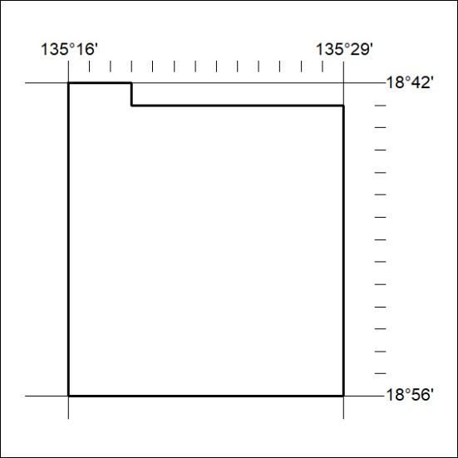
Area granted is indicated above. The titleholder is not permitted to exercise occupational rights on any land that is subject to a development title, or an application for a development title. Any land the subject of a Reserved Land gazettal under the Mineral Titles Act and all land vested in the Commonwealth of Australia is also excluded by description but not excised from the grant area.
414/21

Mineral Titles Act
NOTICE OF GRANT OF A MINERAL TITLE
Title Type and Number: | Extractive Mineral Permit 32169
Granted: | 27 October 2021, for a period of 5 Years
Area: | 25.79 Hectares
Locality: | KOOLPINYAH
Name of Holder/s: | 100% MOUSELLIS & SONS PTY. LTD. [ACN. 009 654 791]
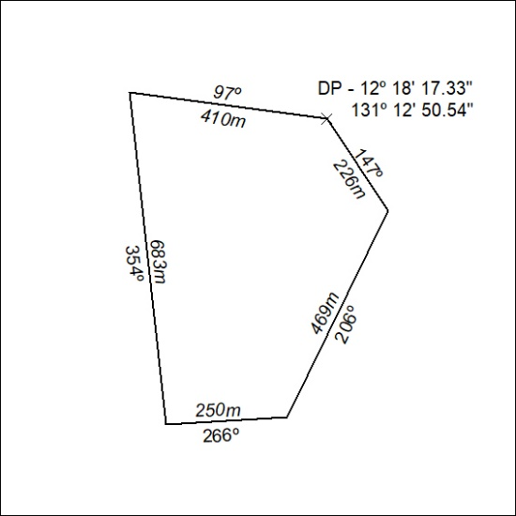
415/21

Mineral Titles Act
NOTICE OF GRANT OF A MINERAL TITLE
Title Type and Number: | Extractive Mineral Permit 32170
Granted: | 29 October 2021, for a period of 5 Years
Area: | 35.92 Hectares
Locality: | KOOLPINYAH
Name of Holder/s: | 100% MOUSELLIS & SONS PTY. LTD. [ACN. 009 654 791]
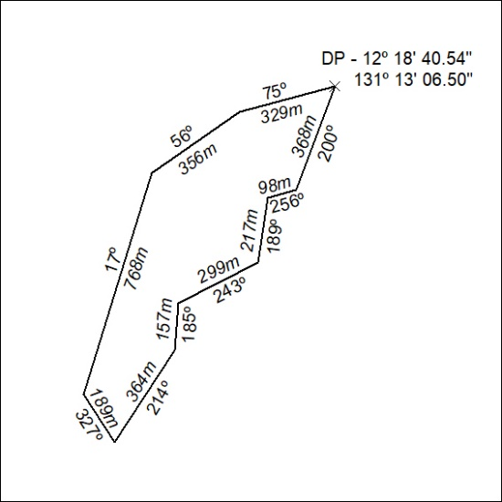

416/21

Mineral Titles Act
NOTICE OF GRANT OF A MINERAL TITLE
Title Type and Number: | Extractive Mineral Permit 32171
Granted: | 27 October 2021, for a period of 5 Years
Area: | 26.21 Hectares
Locality: | KOOLPINYAH
Name of Holder/s: | 100% MOUSELLIS & SONS PTY. LTD. [ACN. 009 654 791]
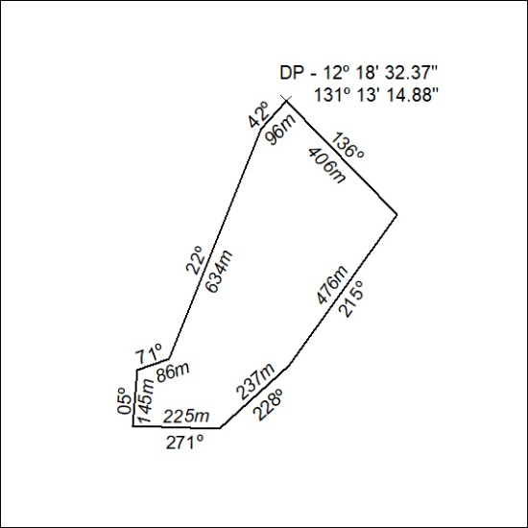

417/21

