Mineral Titles Act
NOTICE OF GRANT OF A MINERAL TITLE
Title Type and Number: | Exploration Licence 32694
Granted: | 27 October 2021, for a period of 6 Years
Area: | 250 Blocks, 792.71 km²
Locality: | BARROW
Name of Holder/s: | 100% BAUDIN RESOURCES PTY LTD [ACN. 618 455 593]
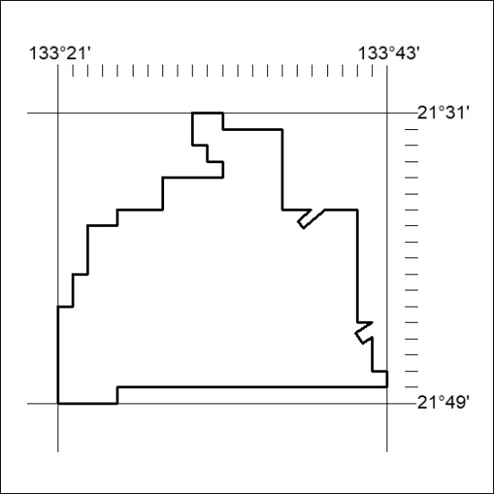
Area granted is indicated above. The titleholder is not permitted to exercise occupational rights on any land that is subject to a development title, or an application for a development title. Any land the subject of a Reserved Land gazettal under the Mineral Titles Act and all land vested in the Commonwealth of Australia is also excluded by description but not excised from the grant area.
404/21

Mineral Titles Act
NOTICE OF GRANT OF A MINERAL TITLE
Title Type and Number: | Exploration Licence 32695
Granted: | 27 October 2021, for a period of 6 Years
Area: | 250 Blocks, 787.39 km²
Locality: | BARROW
Name of Holder/s: | 100% BAUDIN RESOURCES PTY LTD [ACN. 618 455 593]
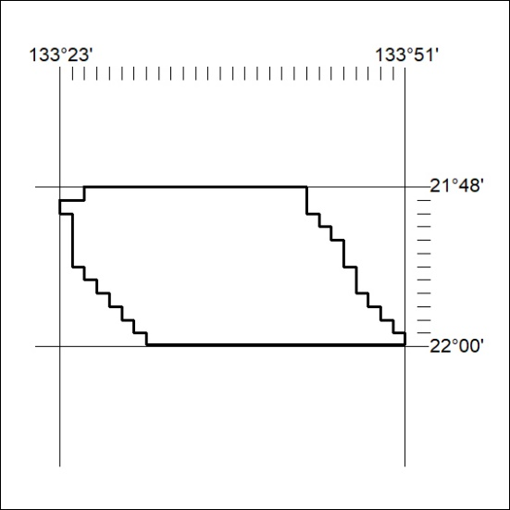
Area granted is indicated above. The titleholder is not permitted to exercise occupational rights on any land that is subject to a development title, or an application for a development title. Any land the subject of a Reserved Land gazettal under the Mineral Titles Act and all land vested in the Commonwealth of Australia is also excluded by description but not excised from the grant area.
405/21

Mineral Titles Act
NOTICE OF GRANT OF A MINERAL TITLE
Title Type and Number: | Exploration Licence 32696
Granted: | 27 October 2021, for a period of 6 Years
Area: | 250 Blocks, 763.60 km²
Locality: | BARROW
Name of Holder/s: | 100% BAUDIN RESOURCES PTY LTD [ACN. 618 455 593]
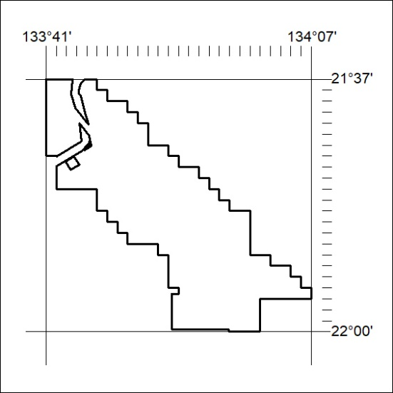
Area granted is indicated above. The titleholder is not permitted to exercise occupational rights on any land that is subject to a development title, or an application for a development title. Any land the subject of a Reserved Land gazettal under the Mineral Titles Act and all land vested in the Commonwealth of Australia is also excluded by description but not excised from the grant area.
406/21

Mineral Titles Act
NOTICE OF GRANT OF A MINERAL TITLE
Title Type and Number: | Exploration Licence 32701
Granted: | 27 October 2021, for a period of 6 Years
Area: | 250 Blocks, 801.69 km²
Locality: | CARRARA
Name of Holder/s: | 100% BAUDIN RESOURCES PTY LTD [ACN. 618 455 593]
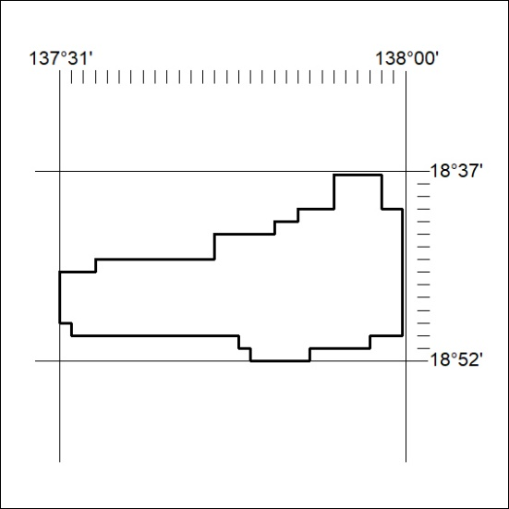
Area granted is indicated above. The titleholder is not permitted to exercise occupational rights on any land that is subject to a development title, or an application for a development title. Any land the subject of a Reserved Land gazettal under the Mineral Titles Act and all land vested in the Commonwealth of Australia is also excluded by description but not excised from the grant area.
407/21

