Mineral Titles Act 2010
NOTICE OF LAND CEASING TO BE A MINERAL TITLE AREA
Title Type and Number: | Exploration Licence 31475
Area Ceased on: | 01 September 2021
Area: | 2 Blocks, 6.67 km²
Locality: | TIPPERARY
Name of Applicant(s)/Holder(s): | 100% COPPEROZ PTY LTD [ACN. 603 957 124]
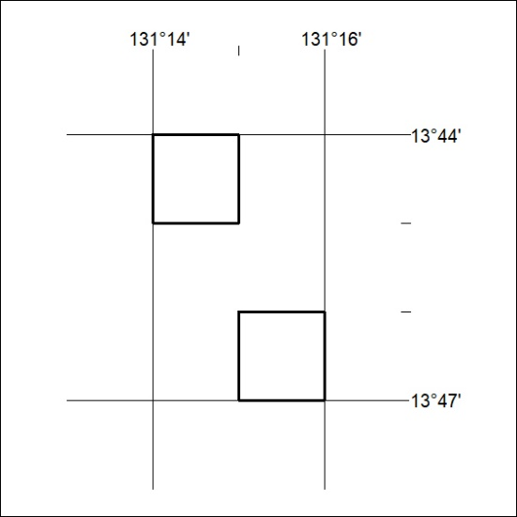

340/21

