Mineral Titles Act 2010
NOTICE OF LAND CEASING TO BE A MINERAL TITLE APPLICATION AREA
Title Type and Number: | Exploration Licence 32399
Area Ceased on: | 02 February 2021
Area: | 10 Blocks, 11.80 km²
Locality: | MT WEDGE
Name of Applicant(s)/Holder(s): | 100% JACKSON CAGE PTY LTD [ACN. 614 042 189]
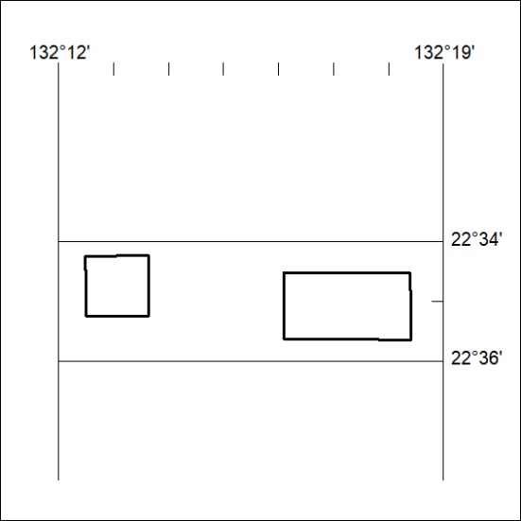

28/21

