Mineral Titles Act
NOTICE OF GRANT OF A MINERAL TITLE
Title Type and Number: | Extractive Mineral Exploration Licence 32263
Granted: | 31 August 2020, for a period of 2 Years
Area: | 4 Blocks, 13.29 km²
Locality: | MANBULLOO
Name of Holder/s: | 100% PATERSON Sandra Lee
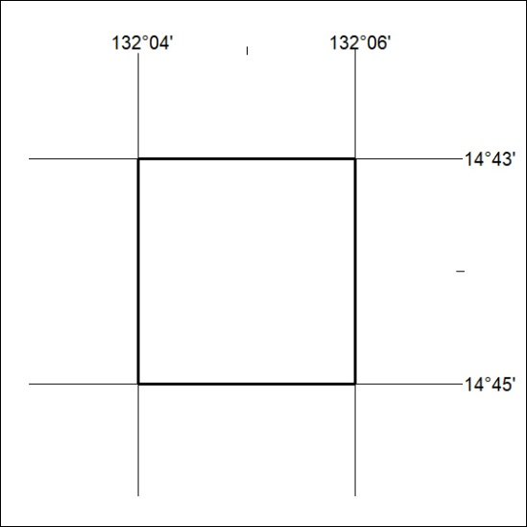
Area granted is indicated above. The titleholder is not permitted to exercise occupational rights on any land that is subject to a development title, or an application for a development title. Any land the subject of a Reserved Land gazettal under the Mineral Titles Act and all land vested in the Commonwealth of Australia is also excluded by description but not excised from the grant area.

304/20

