Mineral Titles Act 2010
NOTICE OF LAND CEASING TO BE A MINERAL TITLE AREA
Title Type and Number: | Exploration Licence 27821
Area Ceased on: | 25 August 2020
Area: | 35 Blocks, 112.50 km²
Locality: | HANLON
Name of Applicant(s)/Holder(s): | 100% AUTEC FOOD GROUP PTY LTD* [ACN. 152 123 754]
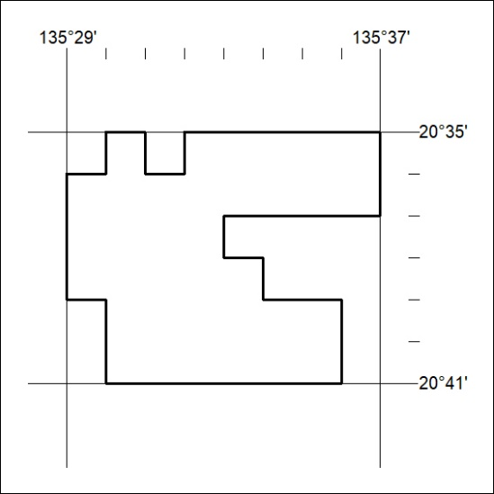

299/20

