Mineral Titles Act 2010
NOTICE OF LAND CEASING TO BE A MINERAL TITLE APPLICATION AREA
Title Type and Number: | Exploration Licence 31087
Area Ceased on: | 02 July 2020
Area: | 82 Blocks, 254.03 km²
Locality: | DUFFIELD
Name of Applicant(s)/Holder(s): | 100% GEMPART (NT) PTY LTD* [ACN. 081 859 896]
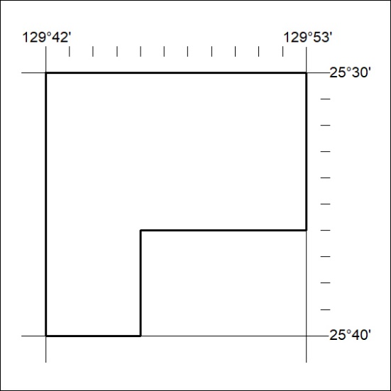

218/20

Mineral Titles Act 2010
NOTICE OF LAND CEASING TO BE A MINERAL TITLE APPLICATION AREA
Title Type and Number: | Exploration Licence 31089
Area Ceased on: | 02 July 2020
Area: | 167 Blocks, 515.00 km²
Locality: | COCKBURN
Name of Applicant(s)/Holder(s): | 100% GEMPART (NT) PTY LTD* [ACN. 081 859 896]
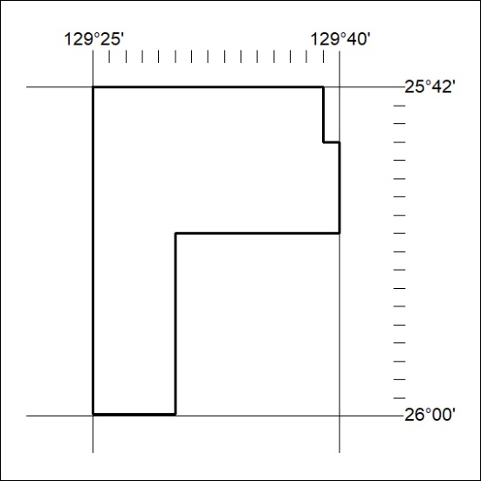

219/20
Mineral Titles Act 2010
NOTICE OF LAND CEASING TO BE A MINERAL TITLE AREA
Title Type and Number: | Exploration Licence 31146
Area Ceased on: | 02 July 2020
Area: | 110 Blocks, 335.95 km²
Locality: | BARROW
Name of Applicant(s)/Holder(s): | 100% LITHIUM DEVELOPMENTS PTY LTD [ACN. 612 245 020]
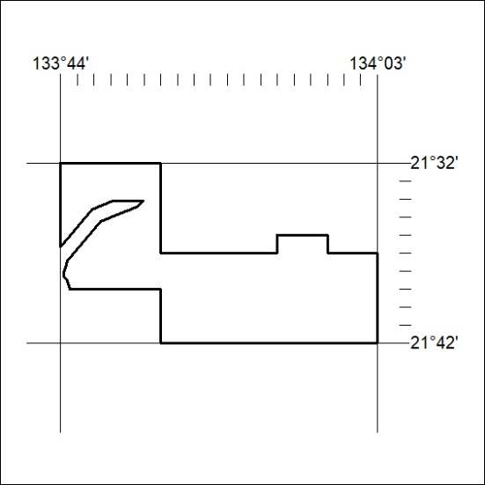

220/20

