Mineral Titles Act 2010
NOTICE OF LAND CEASING TO BE A MINERAL TITLE AREA
Title Type and Number: | Exploration Licence 29853
Area Ceased on: | 07 February 2020
Area: | 32 Blocks, 100.83 km²
Locality: | BURT
Name of Applicant(s)/Holder(s): | 100% CROSSLAND NICKEL PTY LTD* [ACN. 099 477 915]
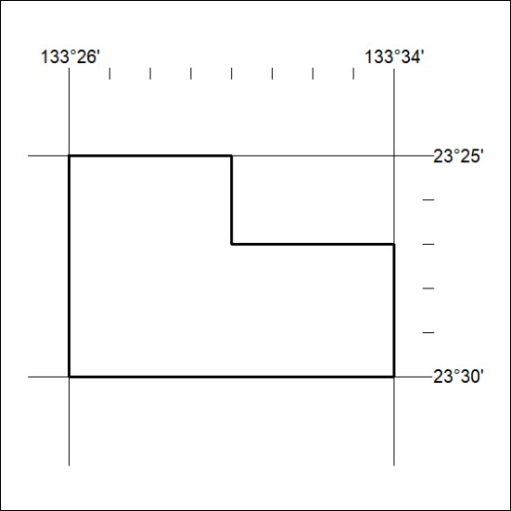

67/20

Mineral Titles Act 2010
NOTICE OF LAND CEASING TO BE A MINERAL TITLE AREA
Title Type and Number: | Exploration Licence 30058
Area Ceased on: | 07 February 2020
Area: | 106 Blocks, 334.30 km²
Locality: | ANBURLA
Name of Applicant(s)/Holder(s): | 56.28% CROSSLAND NICKEL PTY LTD* [ACN. 099 477 915], 43.72% ESSENTIAL MINING RESOURCES PTY LTD [ACN. 601 655 725]
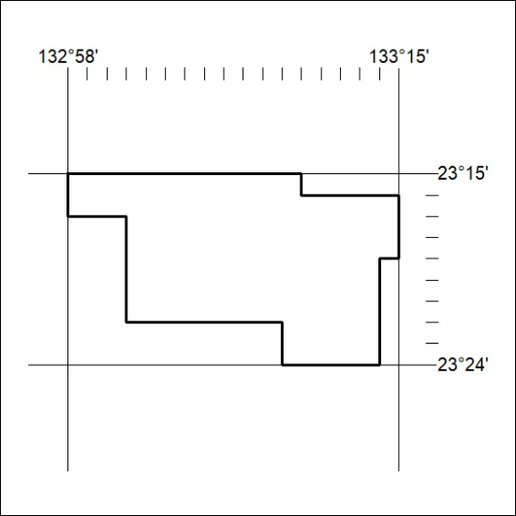

68/20
Mineral Titles Act 2010
NOTICE OF LAND CEASING TO BE A MINERAL TITLE AREA
Title Type and Number: | Exploration Licence 30348
Area Ceased on: | 07 February 2020
Area: | 50 Blocks, 163.00 km²
Locality: | HELEN
Name of Applicant(s)/Holder(s): | 100% TODD RIVER METALS PTY LTD [ACN. 600 314 038]
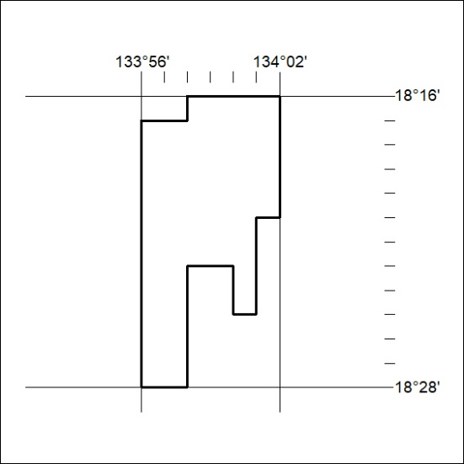

69/20

Mineral Titles Act 2010
NOTICE OF LAND CEASING TO BE A MINERAL TITLE AREA
Title Type and Number: | Exploration Licence 30359
Area Ceased on: | 07 February 2020
Area: | 61 Blocks, 198.40 km²
Locality: | HELEN
Name of Applicant(s)/Holder(s): | 100% TODD RIVER METALS PTY LTD [ACN. 600 314 038]
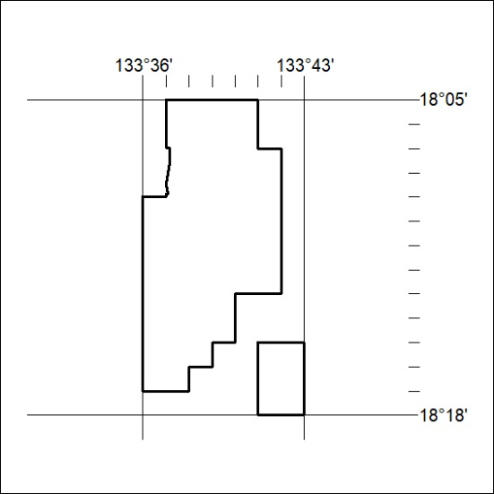

70/20

Mineral Titles Act
NOTICE OF GRANT OF A MINERAL TITLE
Title Type and Number: | Exploration Licence 32147
Granted: | 04 February 2020, for a period of 6 Years
Area: | 5 Blocks, 16.67 km²
Locality: | PINE CREEK
Name of Holder/s: | 100% BACCHUS RESOURCES PTY LTD [ACN. 606 340 872]
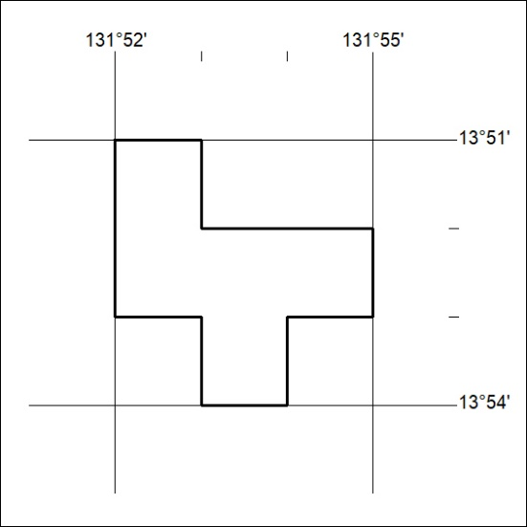
Area granted is indicated above. The titleholder is not permitted to exercise occupational rights on any land that is subject to a development title, or an application for a development title. Any land the subject of a Reserved Land gazettal under the Mineral Titles Act and all land vested in the Commonwealth of Australia is also excluded by description but not excised from the grant area.

71/20

