Mineral Titles Act 2010
NOTICE OF LAND CEASING TO BE A MINERAL TITLE AREA
Title Type and Number: | Exploration Licence 28727
Area Ceased on: | 02 October 2019
Area: | 28 Blocks, 89.54 km²
Locality: | TAYLOR
Name of Applicant(s)/Holder(s): | 100% PRODIGY GOLD NL* [ACN. 009 127 020]
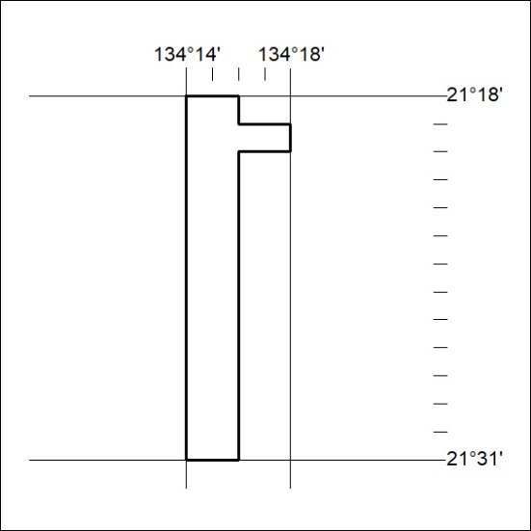

416/19

Mineral Titles Act 2010
NOTICE OF LAND CEASING TO BE A MINERAL TITLE AREA
Title Type and Number: | Exploration Licence 29616
Area Ceased on: | 02 October 2019
Area: | 33 Blocks, 106.27 km²
Locality: | OORADIDGEE
Name of Applicant(s)/Holder(s): | 100% HORN RESOURCES PTY LTD [ACN. 149 763 084]
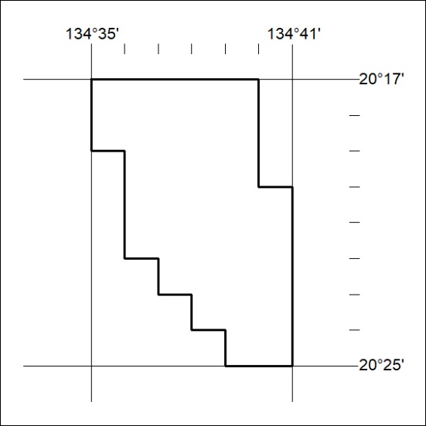

417/19

