Mineral Titles Act 2010
NOTICE OF LAND CEASING TO BE A MINERAL TITLE APPLICATION AREA
Title Type and Number: | Exploration Licence 25030
Area Ceased on: | 19 September 2019
Area: | 26 Blocks, 69.02 km²
Locality: | WINNALL
Name of Applicant(s)/Holder(s): | 100% PRODIGY GOLD NL* [ACN. 009 127 020]
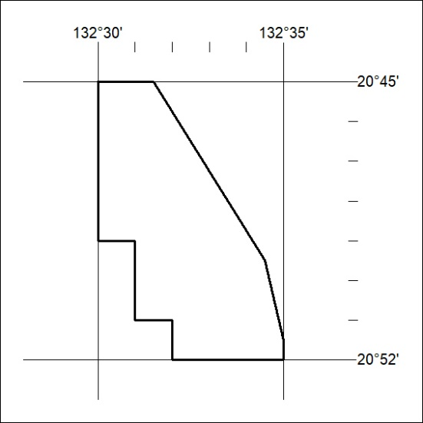

397/19

Mineral Titles Act 2010
NOTICE OF LAND CEASING TO BE A MINERAL TITLE APPLICATION AREA
Title Type and Number: | Exploration Licence 25036
Area Ceased on: | 19 September 2019
Area: | 52 Blocks, 142.74 km²
Locality: | WINNALL
Name of Applicant(s)/Holder(s): | 100% PRODIGY GOLD NL* [ACN. 009 127 020]
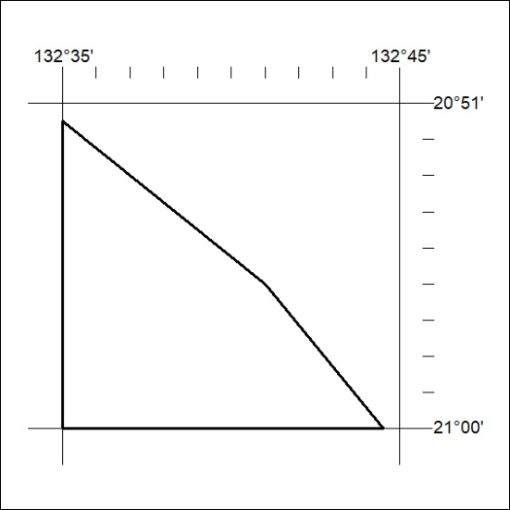

398/19
Mineral Titles Act 2010
NOTICE OF LAND CEASING TO BE A MINERAL TITLE APPLICATION AREA
Title Type and Number: | Exploration Licence 29819
Area Ceased on: | 19 September 2019
Area: | 4 Blocks, 3.79 km²
Locality: | LANDER
Name of Applicant(s)/Holder(s): | 100% PRODIGY GOLD NL* [ACN. 009 127 020]
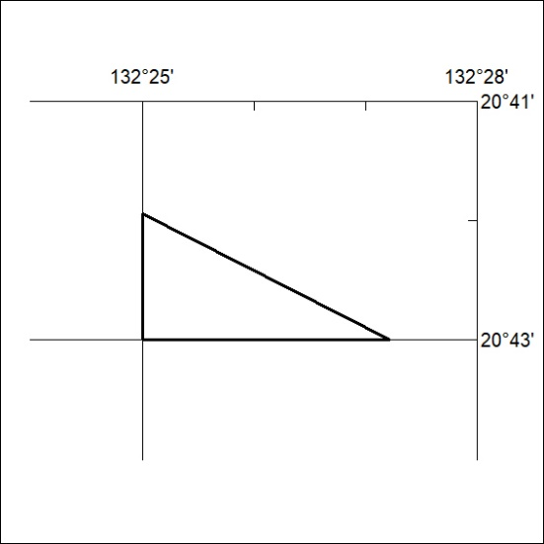

399/19

Mineral Titles Act 2010
NOTICE OF LAND CEASING TO BE A MINERAL TITLE APPLICATION AREA
Title Type and Number: | Exploration Licence 29820
Area Ceased on: | 19 September 2019
Area: | 9 Blocks, 22.08 km²
Locality: | LANDER
Name of Applicant(s)/Holder(s): | 100% PRODIGY GOLD NL* [ACN. 009 127 020]
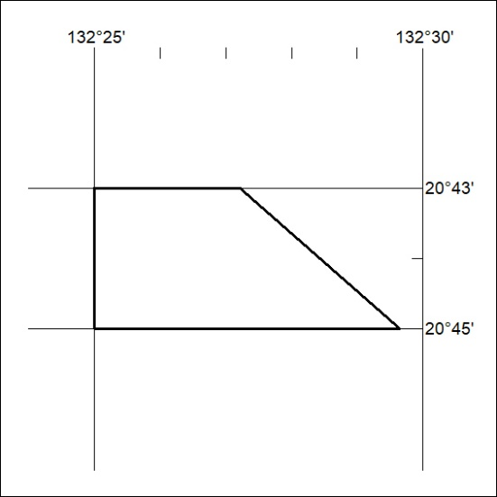

400/19

