Mineral Titles Act 2010
NOTICE OF LAND CEASING TO BE A MINERAL TITLE AREA
Title Type and Number: | Exploration Licence 26524
Area Ceased on: | 10 September 2019
Area: | 19 Blocks, 63.17 km²
Locality: | THROSBY
Name of Applicant(s)/Holder(s): | 100% AUSTRALIAN ILMENITE RESOURCES PTY LIMITED* [ACN. 093 419 311]
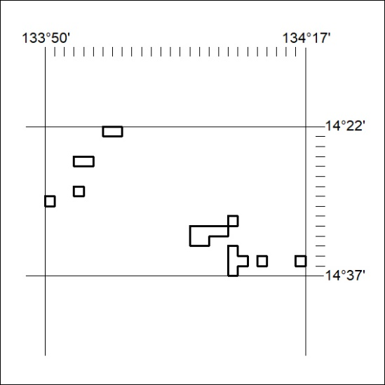

375/19

Mineral Titles Act 2010
NOTICE OF LAND CEASING TO BE A MINERAL TITLE AREA
Title Type and Number: | Exploration Licence 30384
Area Ceased on: | 10 September 2019
Area: | 57 Blocks, 189.88 km²
Locality: | THROSBY
Name of Applicant(s)/Holder(s): | 100% AUSTRALIAN ILMENITE RESOURCES PTY LIMITED* [ACN. 093 419 311]
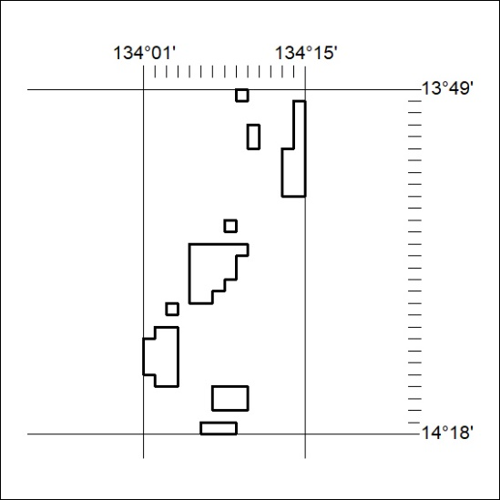

376/19
Mineral Titles Act 2010
NOTICE OF LAND CEASING TO BE A MINERAL TITLE AREA
Title Type and Number: | Exploration Licence 30385
Area Ceased on: | 11 September 2019
Area: | 60 Blocks, 185.54 km²
Locality: | CHAPMAN
Name of Applicant(s)/Holder(s): | 100% AUSTRALIAN ILMENITE RESOURCES PTY LIMITED* [ACN. 093 419 311]
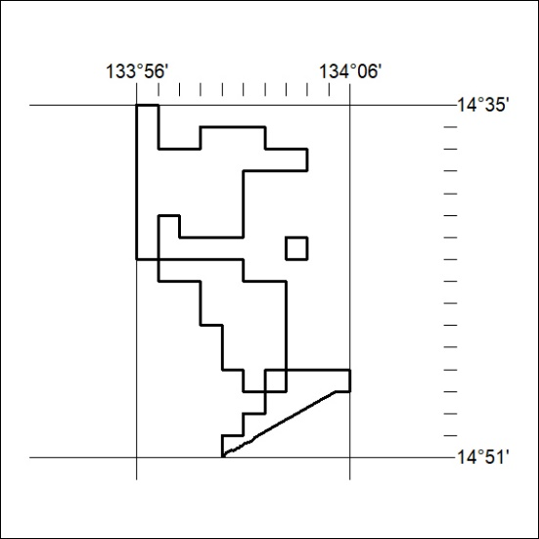

377/19

Mineral Titles Act 2010
NOTICE OF LAND CEASING TO BE A MINERAL TITLE AREA
Title Type and Number: | Exploration Licence 30386
Area Ceased on: | 11 September 2019
Area: | 50 Blocks, 165.44 km²
Locality: | MOROAK
Name of Applicant(s)/Holder(s): | 100% AUSTRALIAN ILMENITE RESOURCES PTY LIMITED* [ACN. 093 419 311]
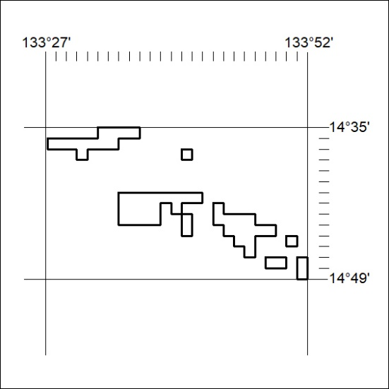

378/19
Mineral Titles Act 2010
NOTICE OF LAND CEASING TO BE A MINERAL TITLE AREA
Title Type and Number: | Exploration Licence 30387
Area Ceased on: | 11 September 2019
Area: | 50 Blocks, 166.45 km²
Locality: | FLYING FOX
Name of Applicant(s)/Holder(s): | 100% AUSTRALIAN ILMENITE RESOURCES PTY LIMITED* [ACN. 093 419 311]
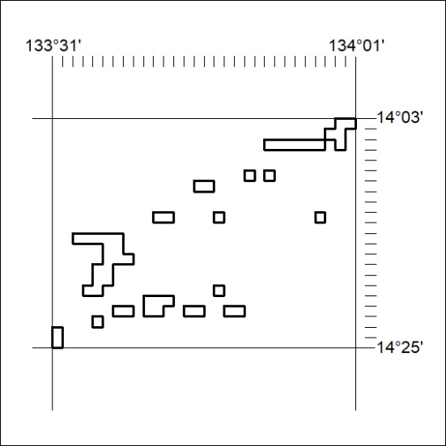

379/19

Mineral Titles Act 2010
NOTICE OF LAND CEASING TO BE A MINERAL TITLE APPLICATION AREA
Title Type and Number: | Exploration Licence 30757
Area Ceased on: | 11 September 2019
Area: | 52 Blocks, 163.64 km²
Locality: | RENNIE
Name of Applicant(s)/Holder(s): | 100% FQM EXPLORATION (AUSTRALIA) PTY LTD [ACN. 095 313 787]
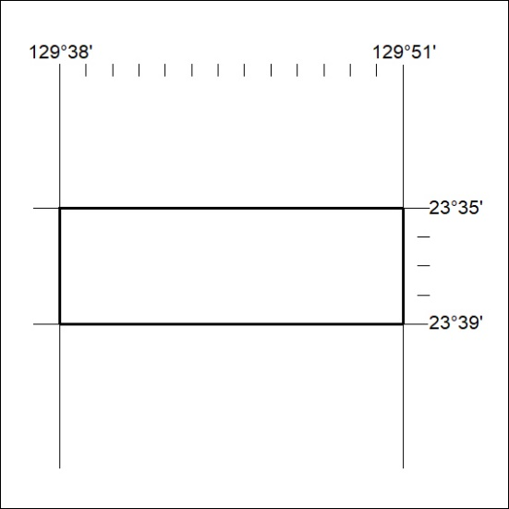

380/19
Mineral Titles Act 2010
NOTICE OF LAND CEASING TO BE A MINERAL TITLE APPLICATION AREA
Title Type and Number: | Exploration Licence 30758
Area Ceased on: | 11 September 2019
Area: | 246 Blocks, 771.59 km²
Locality: | LIGERTWOOD
Name of Applicant(s)/Holder(s): | 100% FQM EXPLORATION (AUSTRALIA) PTY LTD [ACN. 095 313 787]
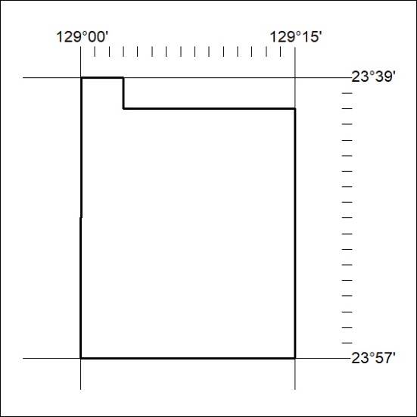

381/19

Mineral Titles Act 2010
NOTICE OF LAND CEASING TO BE A MINERAL TITLE APPLICATION AREA
Title Type and Number: | Exploration Licence 30759
Area Ceased on: | 11 September 2019
Area: | 245 Blocks, 769.34 km²
Locality: | LIGERTWOOD
Name of Applicant(s)/Holder(s): | 100% FQM EXPLORATION (AUSTRALIA) PTY LTD [ACN. 095 313 787]
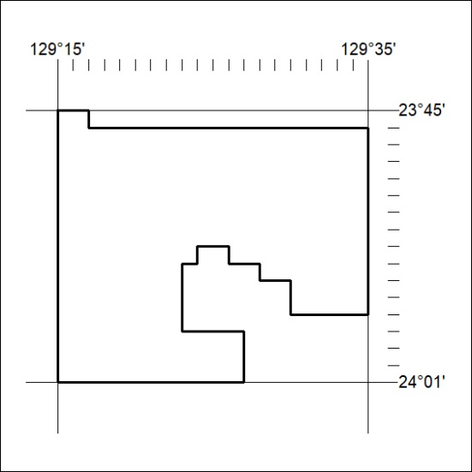

382/19
Mineral Titles Act 2010
NOTICE OF LAND CEASING TO BE A MINERAL TITLE APPLICATION AREA
Title Type and Number: | Exploration Licence 30760
Area Ceased on: | 11 September 2019
Area: | 204 Blocks, 595.21 km²
Locality: | SOUTHS RANGE
Name of Applicant(s)/Holder(s): | 100% FQM EXPLORATION (AUSTRALIA) PTY LTD [ACN. 095 313 787]
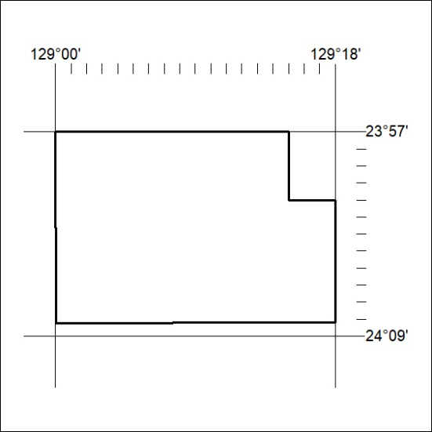

383/19

Mineral Titles Act 2010
NOTICE OF LAND CEASING TO BE A MINERAL TITLE APPLICATION AREA
Title Type and Number: | Exploration Licence 30761
Area Ceased on: | 11 September 2019
Area: | 250 Blocks, 786.59 km²
Locality: | LIGERTWOOD
Name of Applicant(s)/Holder(s): | 100% FQM EXPLORATION (AUSTRALIA) PTY LTD [ACN. 095 313 787]
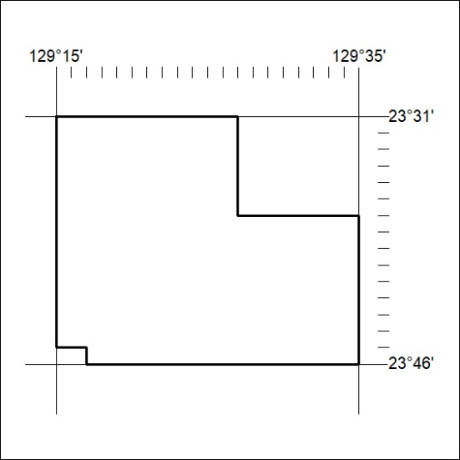

384/19

