Mineral Titles Act
NOTICE OF GRANT OF A MINERAL TITLE
Title Type and Number: | Exploration Licence 32044
Granted: | 27 August 2019, for a period of 6 Years
Area: | 173 Blocks, 561.20 km²
Locality: | ALEXANDRIA
Name of Holder/s: | 100% MLM DRILLING PTY LTD [ACN. 130 013 562]
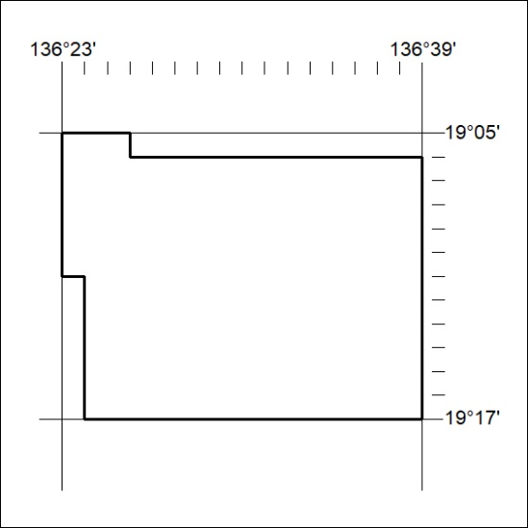
Area granted is indicated above. The titleholder is not permitted to exercise occupational rights on any land that is subject to a development title, or an application for a development title. Any land the subject of a Reserved Land gazettal under the Mineral Titles Act and all land vested in the Commonwealth of Australia is also excluded by description but not excised from the grant area.
357/19

Mineral Titles Act
NOTICE OF GRANT OF A MINERAL TITLE
Title Type and Number: | Exploration Licence 32045
Granted: | 27 August 2019, for a period of 6 Years
Area: | 223 Blocks, 717.71 km²
Locality: | ALEXANDRIA
Name of Holder/s: | 100% MLM DRILLING PTY LTD [ACN. 130 013 562]
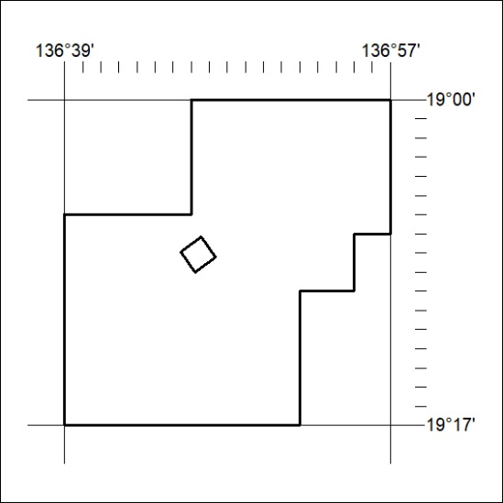
Area granted is indicated above. The titleholder is not permitted to exercise occupational rights on any land that is subject to a development title, or an application for a development title. Any land the subject of a Reserved Land gazettal under the Mineral Titles Act and all land vested in the Commonwealth of Australia is also excluded by description but not excised from the grant area.
358/19

Mineral Titles Act
NOTICE OF GRANT OF A MINERAL TITLE
Title Type and Number: | Exploration Licence 32080
Granted: | 23 August 2019, for a period of 6 Years
Area: | 63 Blocks, 187.99 km²
Locality: | DOREEN
Name of Holder/s: | 100% ECLIPSE METALS LIMITED* [ACN. 142 366 541]
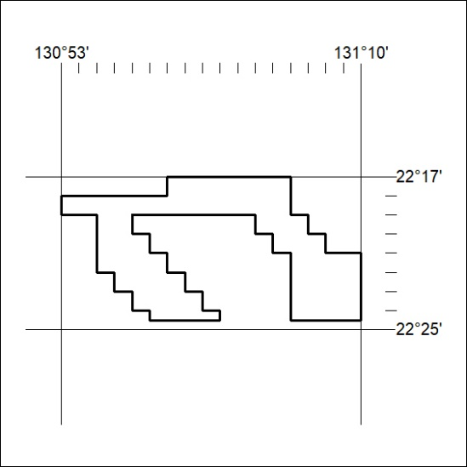
Area granted is indicated above. The titleholder is not permitted to exercise occupational rights on any land that is subject to a development title, or an application for a development title. Any land the subject of a Reserved Land gazettal under the Mineral Titles Act and all land vested in the Commonwealth of Australia is also excluded by description but not excised from the grant area.
359/19

Mineral Titles Act
NOTICE OF GRANT OF A MINERAL TITLE
Title Type and Number: | Exploration Licence 32082
Granted: | 23 August 2019, for a period of 6 Years
Area: | 35 Blocks, 114.25 km²
Locality: | MONTEJINNI
Name of Holder/s: | 100% CENTREX QLD EXPLORATION PTY LTD [ACN. 152 383 054]
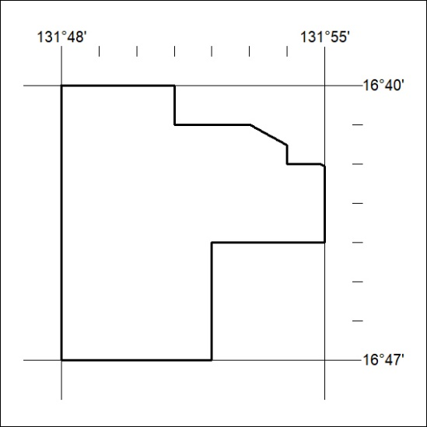
Area granted is indicated above. The titleholder is not permitted to exercise occupational rights on any land that is subject to a development title, or an application for a development title. Any land the subject of a Reserved Land gazettal under the Mineral Titles Act and all land vested in the Commonwealth of Australia is also excluded by description but not excised from the grant area.
360/19

Mineral Titles Act
NOTICE OF GRANT OF A MINERAL TITLE
Title Type and Number: | Exploration Licence 32091
Granted: | 23 August 2019, for a period of 6 Years
Area: | 11 Blocks, 36.14 km²
Locality: | MONTEJINNI
Name of Holder/s: | 100% CENTREX QLD EXPLORATION PTY LTD [ACN. 152 383 054]
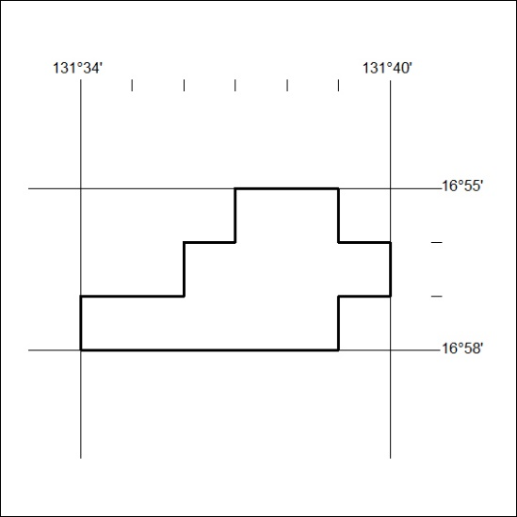
Area granted is indicated above. The titleholder is not permitted to exercise occupational rights on any land that is subject to a development title, or an application for a development title. Any land the subject of a Reserved Land gazettal under the Mineral Titles Act and all land vested in the Commonwealth of Australia is also excluded by description but not excised from the grant area.
361/19

