Mineral Titles Act 2010
NOTICE OF LAND CEASING TO BE A MINERAL TITLE AREA
Title Type and Number: | Exploration Licence 31194
Area Ceased on: | 20 August 2019
Area: | 28 Blocks, 91.84 km²
Locality: | LANCEWOOD
Name of Applicant(s)/Holder(s): | 100% SCRIVEN EXPLORATION PTY LTD [ACN. 006 264 615]
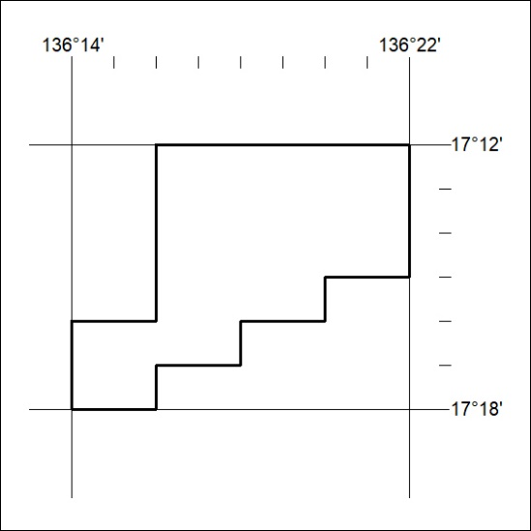

348/19

Mineral Titles Act
NOTICE OF GRANT OF A MINERAL TITLE
Title Type and Number: | Exploration Licence 22430
Granted: | 16 August 2019, for a period of 6 Years
Area: | 12 Blocks, 33.52 km²
Locality: | HOWSHIP
Name of Holder/s: | 100% VIVA RESOURCES PTY LTD [ACN. 120 165 139]
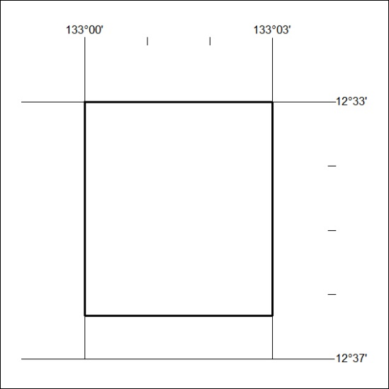
Area granted is indicated above. The titleholder is not permitted to exercise occupational rights on any land that is subject to a development title, or an application for a development title. Any land the subject of a Reserved Land gazettal under the Mineral Titles Act and all land vested in the Commonwealth of Australia is also excluded by description but not excised from the grant area.

349/19

Mineral Titles Act
NOTICE OF GRANT OF A MINERAL TITLE
Title Type and Number: | Exploration Licence 24920
Granted: | 16 August 2019, for a period of 6 Years
Area: | 8 Blocks, 19.10 km²
Locality: | HOWSHIP
Name of Holder/s: | 100% VIVA RESOURCES PTY LTD [ACN. 120 165 139]
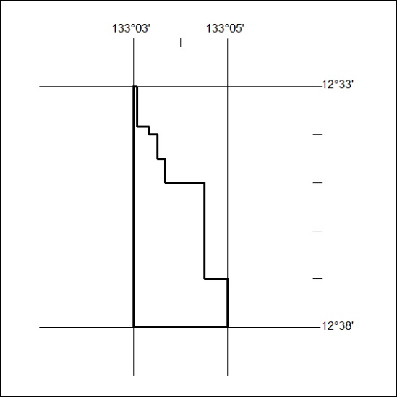
Area granted is indicated above. The titleholder is not permitted to exercise occupational rights on any land that is subject to a development title, or an application for a development title. Any land the subject of a Reserved Land gazettal under the Mineral Titles Act and all land vested in the Commonwealth of Australia is also excluded by description but not excised from the grant area.
350/19

Mineral Titles Act
NOTICE OF GRANT OF A MINERAL TITLE
Title Type and Number: | Exploration Licence 26089
Granted: | 16 August 2019, for a period of 6 Years
Area: | 9 Blocks, 24.40 km²
Locality: | OENPELLI
Name of Holder/s: | 100% VIVA RESOURCES PTY LTD [ACN. 120 165 139]
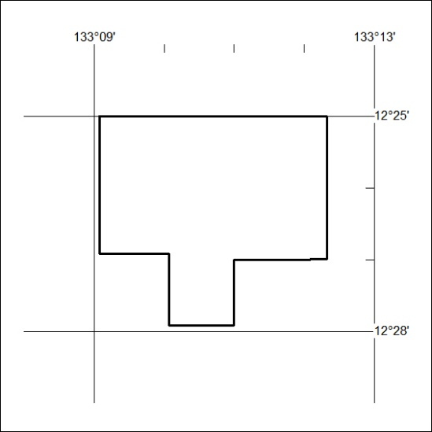
Area granted is indicated above. The titleholder is not permitted to exercise occupational rights on any land that is subject to a development title, or an application for a development title. Any land the subject of a Reserved Land gazettal under the Mineral Titles Act and all land vested in the Commonwealth of Australia is also excluded by description but not excised from the grant area.
351/19

