Corrigendum
Notice Number 236/19 appearing in MN68/19 on 31 MAY 2019 is hereby cancelled and replaced by the following:

Mineral Titles Act 2010
NOTICE OF LAND CEASING TO BE A MINERAL TITLE AREA
Title Type and Number: | Exploration Licence 31805
Area Ceased on: | 30 May 2019
Area: | 238 Blocks, 787.56 km²
Locality: | NUTWOOD
Name of Applicant(s)/Holder(s): | 100% MMG EXPLORATION PTY LTD* [ACN. 119 136 659]
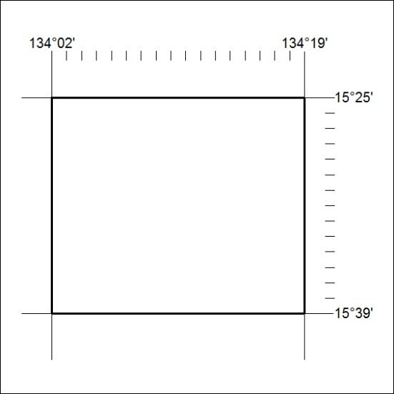

243/19

