Mineral Titles Act 2010
NOTICE OF LAND CEASING TO BE A MINERAL TITLE AREA
Title Type and Number: | Exploration Licence 29789
Area Ceased on: | 29 May 2019
Area: | 2 Blocks, 6.30 km²
Locality: | NARWIETOOMA
Name of Applicant(s)/Holder(s): | 56.28% CROSSLAND NICKEL PTY LTD* [ACN. 099 477 915], 43.72% ESSENTIAL MINING RESOURCES PTY LTD [ACN. 601 655 725]
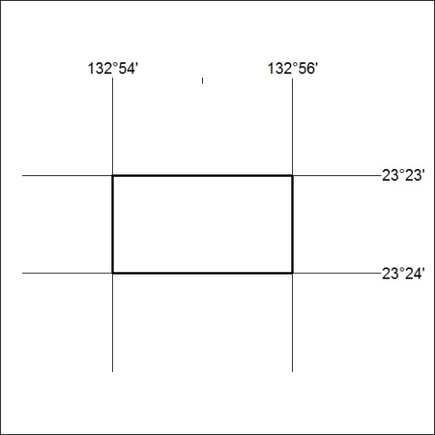

203/19

Mineral Titles Act 2010
NOTICE OF LAND CEASING TO BE A MINERAL TITLE AREA
Title Type and Number: | Exploration Licence 29853
Area Ceased on: | 30 May 2019
Area: | 2 Blocks, 6.31 km²
Locality: | BURT
Name of Applicant(s)/Holder(s): | 100% CROSSLAND NICKEL PTY LTD* [ACN. 099 477 915]
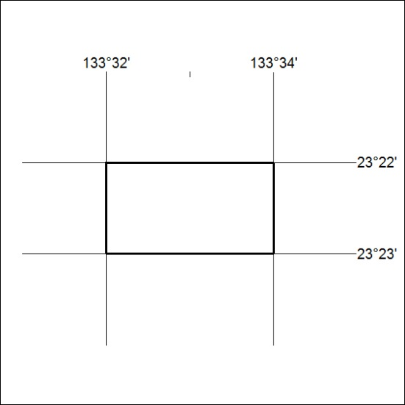

204/19
Mineral Titles Act 2010
NOTICE OF LAND CEASING TO BE A MINERAL TITLE AREA
Title Type and Number: | Exploration Licence 31024
Area Ceased on: | 30 May 2019
Area: | 5 Blocks, 16.73 km²
Locality: | NOONAMAH
Name of Applicant(s)/Holder(s): | 50% FALKO Wladimir, 50% N.T. GOLD PTY LTD * [ACN. 009 625 870]
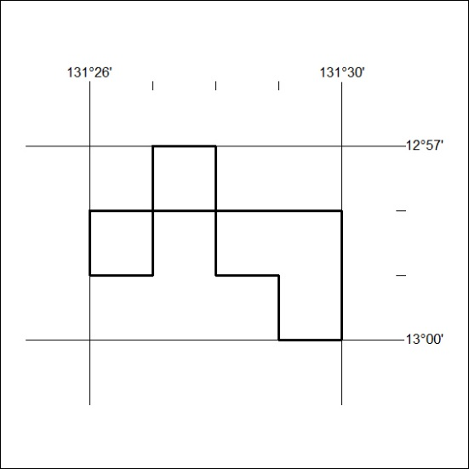

205/19

Mineral Titles Act 2010
NOTICE OF LAND CEASING TO BE A MINERAL TITLE AREA
Title Type and Number: | Exploration Licence 31389
Area Ceased on: | 30 May 2019
Area: | 89 Blocks, 284.63 km²
Locality: | CONICAL HILL
Name of Applicant(s)/Holder(s): | 100% ENIGMA MINING LIMITED [ACN. 009 225 558]
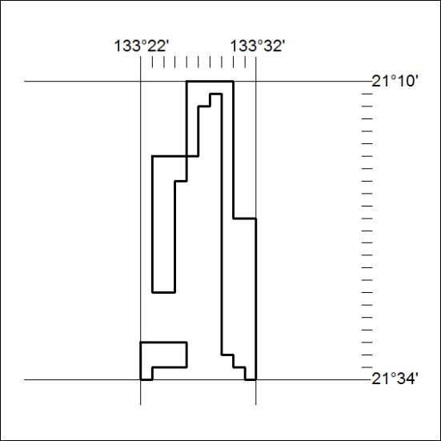

206/19
Mineral Titles Act 2010
NOTICE OF LAND CEASING TO BE A MINERAL TITLE AREA
Title Type and Number: | Exploration Licence 31443
Area Ceased on: | 30 May 2019
Area: | 11 Blocks, 34.82 km²
Locality: | JINKA
Name of Applicant(s)/Holder(s): | 100% MOLYHIL MINING PTY LTD [ACN. 112 922 497]
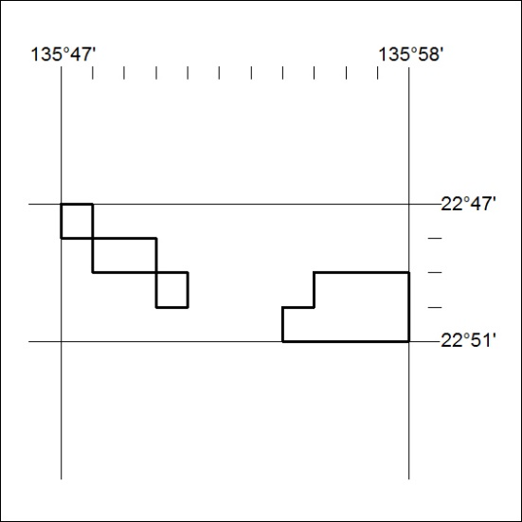

207/19

