In 2018 over 2600 international students chose to study in the Northern Territory, mostly in Darwin and with a handful in Alice Springs.
International students hold a visa to study in Australia and pay full tuition fees for their degrees, vocational education and training (VET) courses, school education and English language study. International students have much in common with many Territorians – they’ve made an active choice to live here. They’ve been attracted by the opportunities to gain high quality Australian qualifications and work experience, and want to live in a warm climate. They bring even greater diversity to the Territory community and skills to the workforce – most students can work up to 40 hours a fortnight during term time and unlimited time during vacations. Many courses require work placements and post-study working visas for two years for undergraduates and masters graduates are available. Territory employers value the skills international students bring to the Territory and the Northern Territory Government has recognised the importance of international students in contributing to the Territory’s Population Growth Strategy.
The Northern Territory International Education and Training Strategy 2019-2025 has three pillars:
- Enrich the Territory international student experience
- Showcase the Territory as a study destination and
- Strengthen and grow the Territory international education and training industry
By focusing on these three pillars, and by working in a Team NT approach, the Territory aims to increase the number of international students choosing to study here to 10 000 by 2025. A Team NT approach means education providers, business, the community and government working together towards this common goal.
International students in Australia study in cities and towns across the country. Each study destination has special offerings which meet the needs of the students who choose to study there.
The Territory’s capital, Darwin, is cosmopolitan and vibrant with all the services and infrastructure of a capital city but on a smaller scale. And the Territory is home to two of Australia’s world famous icons: Uluru and Kakadu.
The top reasons why international students choose to study in the Territory are because family and friends are here (36%), the reputation of the institution where they are studying (32%), and the weather and climate (32%).
Higher education is expected to continue leading industry growth, with an expanding number of VET students.
International student growth in the Territory, 2012 – 2025
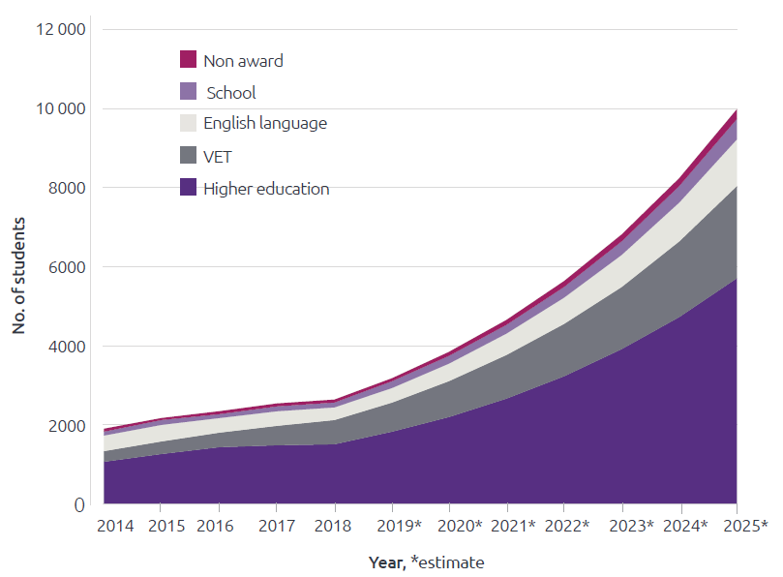
Source: Austrade data, and internal estimates

Across Australia, students come from more than 190 countries. In the Territory, students from over 70 countries around the world chose to study here in 2018. It’s a diverse student body which means both international and Territory students have opportunities to meet and study with people from all over the world. Having a global perspective is a valuable skill to have in the future world of work.
With over 100 multicultural groups in the Territory, international students are well supported. The Territory celebrates its diversity with festivals, sharing the food and culture of people who have come from Greece, India, Indonesia, Italy, the Philippines, Sri Lanka, Vietnam and many other countries.
Top 10 countries of origin of international students studying in the Territory 2018
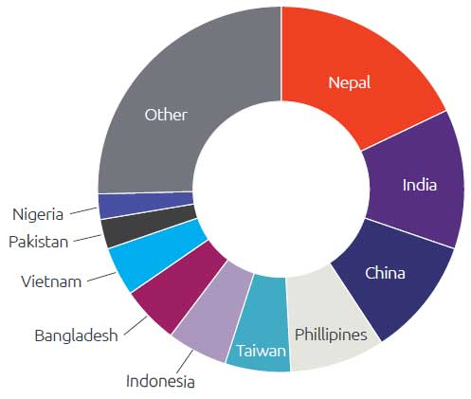
Top 10 countries of origin of international students studying in Australia 2018
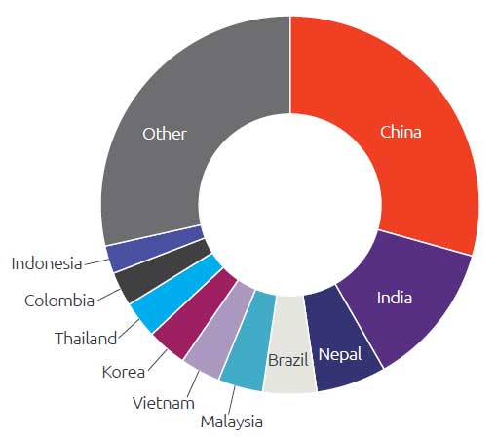
All Northern Territory education courses meet the national government accreditation, providing Australian qualifications. International students study in higher education, including undergraduate, masters and PhD. VET courses are focused on technical and vocational study.
Sector of study by international students in the Territory, 2018
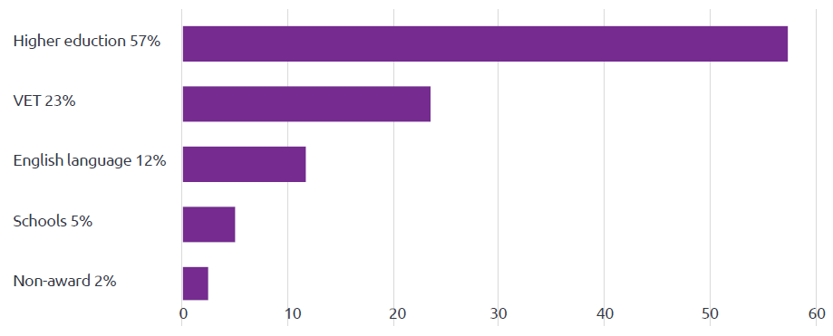
Source: Austrade
An Australian workplace experience is highly valued by international students. Territory employers and industry associations recognise the skills international students bring and their ability to fill workforce shortages. In 2017, 72% of international students in the Territory worked part-time during their studies, averaging 17 hours per week and earning $425 per week.
An international education is a significant investment for a family. After tuition fees, students in the Territory spend 74% of their weekly living expenditure on five key expenses²:
- Rent $178
- Food $71
- Phone and internet $35
- Text books $30
- Eating out $20.

Students also seek work experience related to their studies. The top fields of study in 2018 included:
Higher education
- Education
- Agriculture, environmental and related studies
- Creative Arts
- Engineering and related technologies
- Health
- Information Technology
- Management and Commerce
- Natural and Physical Sciences
- Society and Culture.

The goal
To grow the number of international students studying in the Northern Territory to 10,000 by 2025 by:
- delivering a wider range of high quality, Australian qualifications
- bringing together students and employers for work experience opportunities including casual jobs during study, work placements related to study, and with the relevant visa, post study employment.
- maximising outcomes for students, Territory communities, families and business.
We know that the Territory is relatively unknown overseas, but by working together with the international education and training industry, multicultural communities, employers and the whole Territory community in a Team NT approach we will achieve the goal.

Pillar 1
Enrich the Territory international student experience
- Connect students to the local community and employers
- Support student health and wellbeing
- Maintain the Territory’s connection to graduates.

- partner with education providers to deliver a welcome program for international students, from pre-departure to arrival in the Territory
- host an annual Northern Territory Government welcome reception for international students to build local networks with community, business and government
- inform students on accommodation options, prior to arrival and during study
- build a homestay network in the Territory
- promote Study in Australia’s Northern Territory scholarships
- work with stakeholders to deliver a safe, welcoming environment for international students
- deliver a student ambassador program to develop Territory current and future ambassadors
- leverage the StudyNT student ambassador program to increase understanding of students’ study experiences
- facilitate additional pathways for work integrated learning opportunities in the public, private and not-for-profit sectors across the Territory
- connect international students to Territory employers to increase the range of student employment options and opportunities
- connect with graduates and partner with education providers to grow an alumni network.

Pillar 2
Showcase the Territory as a study destination
- Promote international education and training opportunities in the Territory
- Expand the study tour market

- use a Team NT approach to marketing and promotion to attract international students
- leverage government, education provider, business and community relationships to grow existing and new market opportunities
- promote the Territory as a destination for study and study tours at national and international trade fairs and to visiting delegations
- partner with local community, business and government to attract study tours and develop market ready study tour itineraries and products across the Territory.

Pillar 3
Strengthen and grow the Territory international education and training industry
- Grow leadership and capacity
- Partner with industry to explore new opportunities

- deliver professional development for industry focused on best practice at each stage of the student journey – from seeking a course to study, through to lifelong alumni connections
- grow the number of CRICOS registered places available for international students in the Territory through the expansion of existing providers and new entrants to the market
- support community, business and local government student wellbeing initiatives
- pilot new innovative partnership approaches for the delivery of international education and training, onshore and offshore
- pilot digital marketing strategies and digital solutions for the industry.

Implementation
In a continuing Team NT approach, education providers, business, government and the community, particularly the multicultural community, will work together to achieve the goal of this strategy. An implementation plan will be developed by the Northern Territory International Education and Training Industry Group to measure progress against the actions and to monitor and review outcomes. The group will also assess emerging opportunities to incorporate into the strategy.

Success measures
- Increase in international students studying in the Territory to 10 000 by 2025
- increase in international student enrolments in each sector: higher education, VET, schools and English language training
- increase in brand awareness and recognition of the Territory as a study destination by onshore and offshore agents
- increase in international student satisfaction
- the number of work placements across the Territory, connecting students and employers
- increase the number of international education providers located in the Territory.

Department of Trade, Business and Innovation
Northern Territory Government
studynt@nt.gov.au
#StudyNT
TheTerritory.com.au

^{,2} Deloitte Access Economics - Economic Contribution of International Education and Training to the Northern Territory.
Deloitte Access Economics - Economic Contribution of International Education and Training to the Northern Territory.

