Mineral Titles Act
NOTICE OF LAND CEASING TO BE A MINERAL TITLE AREA
Title Type and Number: | Extractive Mineral Exploration Licence 31388
Area Ceased on: | 07 March 2019
Area: | 1 Block, .86 km²
Locality: | NOONAMAH
Name of Applicant(s)/Holder(s): | 100% ALDEBARAN CONTRACTING PTY LTD [ACN. 128 020 299]
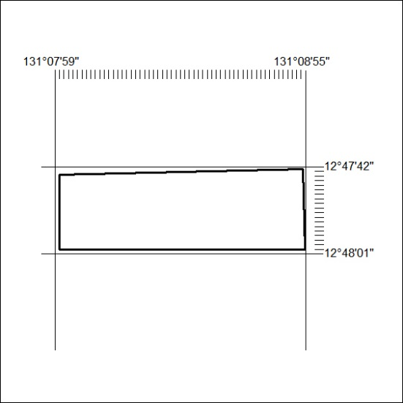

68/19

Mineral Titles Act
NOTICE OF GRANT OF A MINERAL TITLE
Title Type and Number: | Exploration Licence 31893
Granted: | 06 March 2019, for a period of 5 Years
Area: | 7 Blocks, 23.41 km²
Locality: | BATCHELOR
Name of Holder/s: | 100% PNX METALS LIMITED* [ACN. 127 446 271]
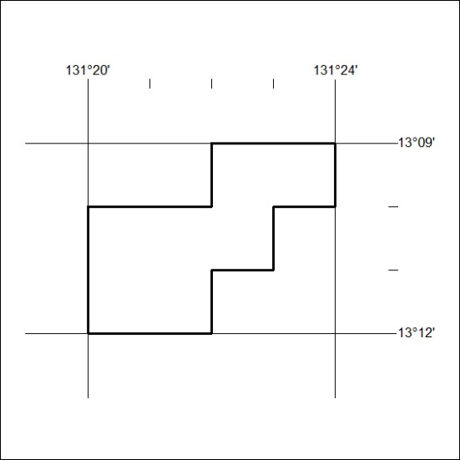
Area granted is indicated above. The titleholder is not permitted to exercise occupational rights on any land that is subject to a development title, or an application for a development title. Any land the subject of a Reserved Land gazettal under the Mineral Titles Act and all land vested in the Commonwealth of Australia is also excluded by description but not excised from the grant area.

69/19

