Mineral Titles Act
NOTICE OF LAND CEASING TO BE A MINERAL TITLE AREA
Title Type and Number: | Exploration Licence 31287
Area Ceased on: | 13 December 2018
Area: | 97 Blocks, 316.59 km²
Locality: | BOXER
Name of Applicant(s)/Holder(s): | 100% CEDAR RESOURCES PTY LTD [ACN. 612 086 932]
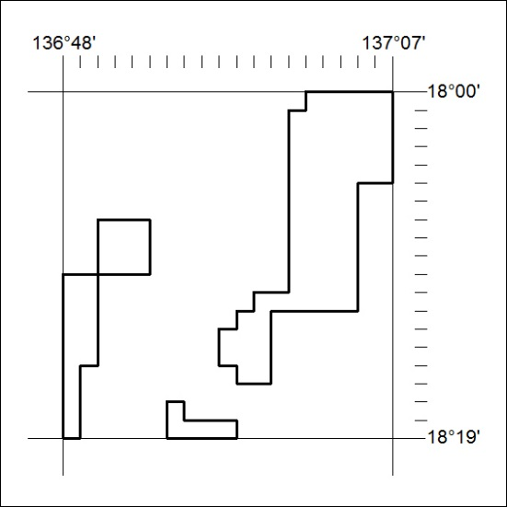

581/18

