Mineral Titles Act
NOTICE OF LAND CEASING TO BE A MINERAL TITLE AREA
Title Type and Number: | Exploration Licence 30168
Area Ceased on: | 03 December 2018
Area: | 8 Blocks, 25.05 km²
Locality: | TENNANT CREEK
Name of Applicant(s)/Holder(s): | 100% GIANTS REEF EXPLORATION PTY LTD* [ACN. 009 200 346]
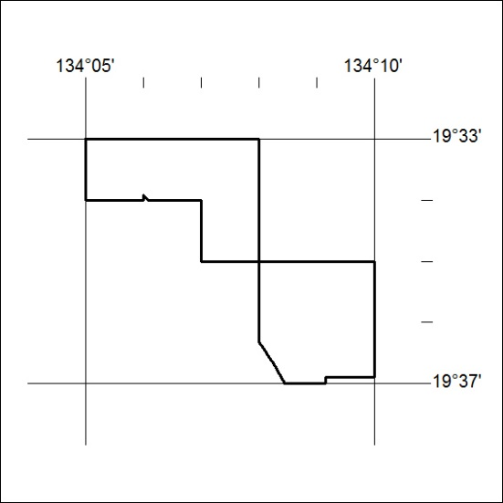
(Area now amalgamated into Exploration Licence 32030 under s102 – EL moratorium period does not apply)

560/18

Mineral Titles Act
NOTICE OF LAND CEASING TO BE A MINERAL TITLE AREA
Title Type and Number: | Exploration Licence 30301
Area Ceased on: | 03 December 2018
Area: | 5 Blocks, 9.63 km²
Locality: | TENNANT CREEK
Name of Applicant(s)/Holder(s): | 100% GIANTS REEF EXPLORATION PTY LTD* [ACN. 009 200 346]
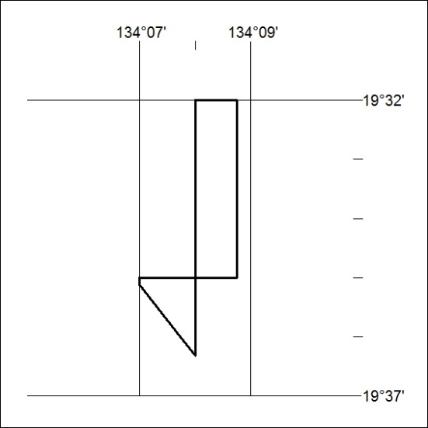
(Area now amalgamated into Exploration Licence 32030 under s102 – EL moratorium period does not apply)

561/18

Mineral Titles Act
NOTICE OF GRANT OF A MINERAL TITLE
Title Type and Number: | Extractive Mineral Permit 31149
Granted: | 04 December 2018, for a period of 5 Years
Area: | 32.14 Hectares
Locality: | NOONAMAH
Name of Holder/s: | 100% GOSSAN RESOURCES PTY LTD [ACN. 161 395 964]
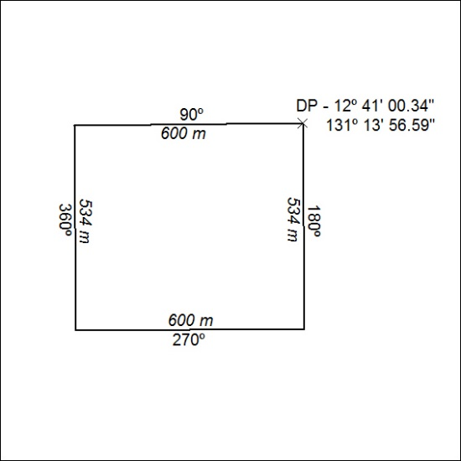

562/18

