Mineral Titles Act
NOTICE OF GRANT OF A MINERAL TITLE
Title Type and Number: | Extractive Mineral Permit 31559
Granted: | 22 November 2018, for a period of 5 Years
Area: | 63.10 Hectares
Locality: | NOONAMAH
Name of Holder/s: | 100% ALISANTE HOLDINGS PTY LTD [ACN. 067 361 559]
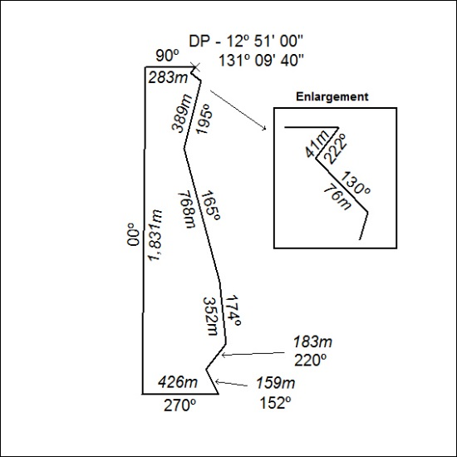

545/18

Mineral Titles Act
NOTICE OF GRANT OF A MINERAL TITLE
Title Type and Number: | Extractive Mineral Permit 31560
Granted: | 22 November 2018, for a period of 5 Years
Area: | 91.63 Hectares
Locality: | NOONAMAH
Name of Holder/s: | 100% ALISANTE HOLDINGS PTY LTD [ACN. 067 361 559]
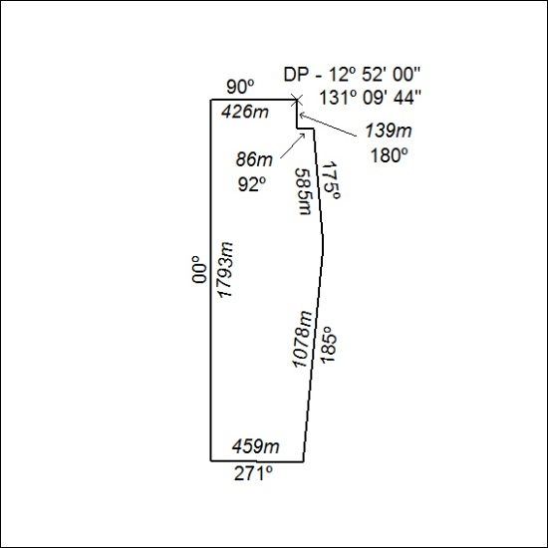

546/18

Mineral Titles Act
NOTICE OF GRANT OF A MINERAL TITLE
Title Type and Number: | Extractive Mineral Permit 31561
Granted: | 22 November 2018, for a period of 5 Years
Area: | 75.55 Hectares
Locality: | NOONAMAH
Name of Holder/s: | 100% ALISANTE HOLDINGS PTY LTD [ACN. 067 361 559]
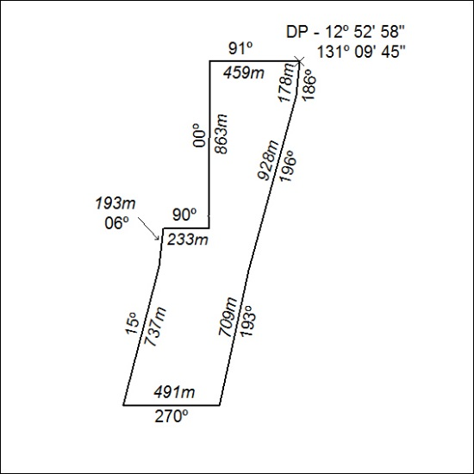

547/18

