Mineral Titles Act
NOTICE OF LAND CEASING TO BE A MINERAL TITLE AREA
Title Type and Number: | Exploration Licence 31392
Area Ceased on: | 09 November 2018
Area: | 239 Blocks, 745.71 km²
Locality: | SIDDELEY
Name of Applicant(s)/Holder(s): | 100% GBE EXPLORATION PTY LTD [ACN. 121 535 948]
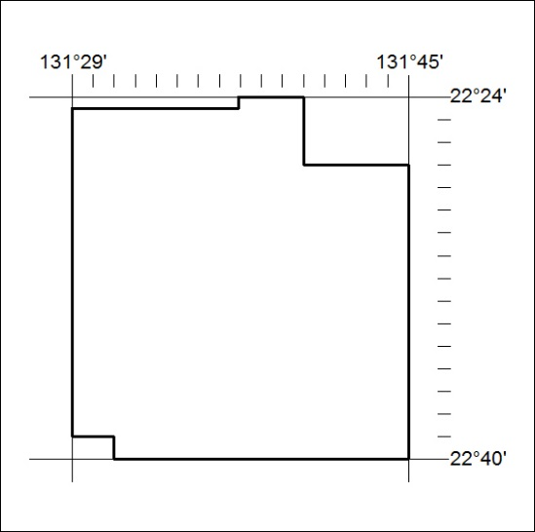

509/18

Mineral Titles Act
NOTICE OF LAND CEASING TO BE A MINERAL TITLE AREA
Title Type and Number: | Exploration Licence 31393
Area Ceased on: | 09 November 2018
Area: | 241 Blocks, 762.70 km²
Locality: | SIDDELEY
Name of Applicant(s)/Holder(s): | 100% GBE EXPLORATION PTY LTD [ACN. 121 535 948]
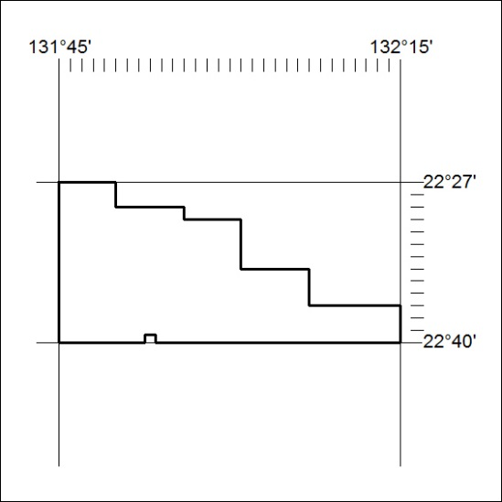

510/18

Mineral Titles Act
NOTICE OF GRANT OF A MINERAL TITLE
Title Type and Number: | Exploration Licence 31919
Granted: | 07 November 2018, for a period of 6 Years
Area: | 9 Blocks, 20.82 km²
Locality: | TENNANT CREEK
Name of Holder/s: | 100% GIANTS REEF EXPLORATION PTY LTD* [ACN. 009 200 346]
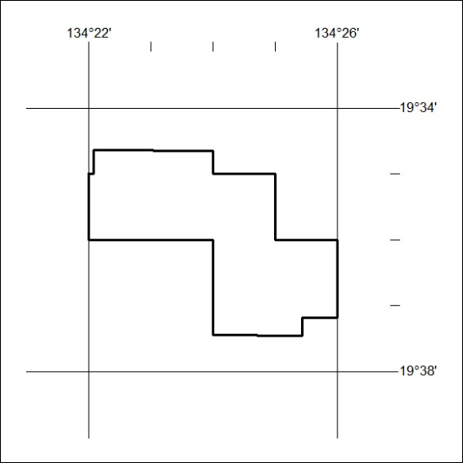
Area granted is indicated above. The titleholder is not permitted to exercise occupational rights on any land that is subject to a development title, or an application for a development title. Any land the subject of a Reserved Land gazettal under the Mineral Titles Act and all land vested in the Commonwealth of Australia is also excluded by description but not excised from the grant area.

511/18

