Mineral Titles Act
NOTICE OF LAND CEASING TO BE A MINERAL TITLE AREA
Title Type and Number: | Exploration Licence 27703
Area Ceased on: | 01 November 2018
Area: | 3 Blocks, 9.53 km²
Locality: | GOOMADEER
Name of Applicant(s)/Holder(s): | 100% NORTH MINERALS PTY LTD [ACN. 139 469 195]
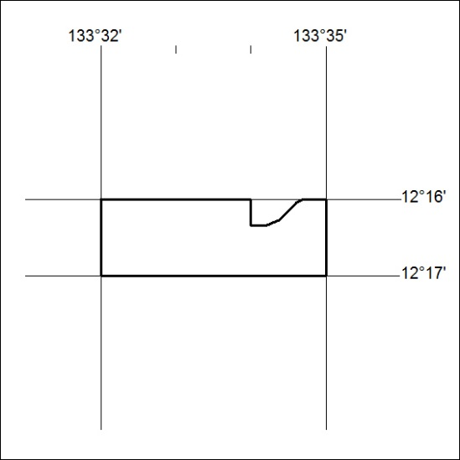

497/18

Mineral Titles Act
NOTICE OF LAND CEASING TO BE A MINERAL TITLE AREA
Title Type and Number: | Exploration Licence 28748
Area Ceased on: | 01 November 2018
Area: | 71 Blocks, 216.33 km²
Locality: | TAYLOR
Name of Applicant(s)/Holder(s): | 100% PRODIGY GOLD NL* [ACN. 009 127 020]
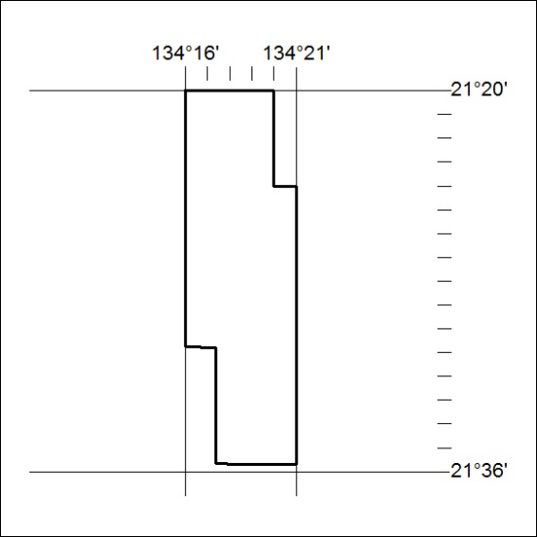

498/18

Mineral Titles Act
NOTICE OF LAND CEASING TO BE A MINERAL TITLE AREA
Title Type and Number: | Exploration Licence 30834
Area Ceased on: | 01 November 2018
Area: | 9 Blocks, 28.43 km²
Locality: | QUARTZ
Name of Applicant(s)/Holder(s): | 100% STARPART HOLDINGS PTY LTD [ACN. 614 613 099]
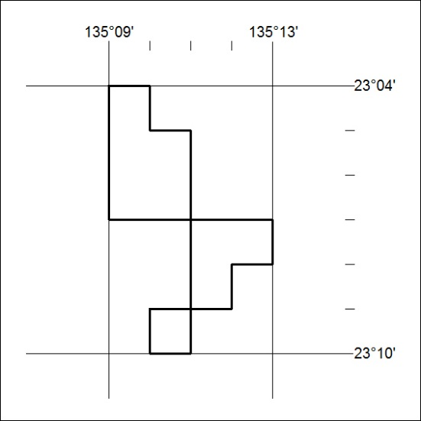

499/18

