Corrigendum
Notice Number 459/18 appearing in MN132/18 on 19 OCTOBER 2018 is hereby cancelled and replaced by the following:

Mineral Titles Act
NOTICE OF LAND CEASING TO BE A MINERAL TITLE AREA
Title Type and Number: | Exploration Licence 30780
Area Ceased on: | 21 October 2018
Area: | 63 Blocks, 198.92 km²
Locality: | LAUGHLEN
Name of Applicant(s)/Holder(s): | 100% TERRITORY EXPLORATION PTY LTD [ACN. 123 338 376]
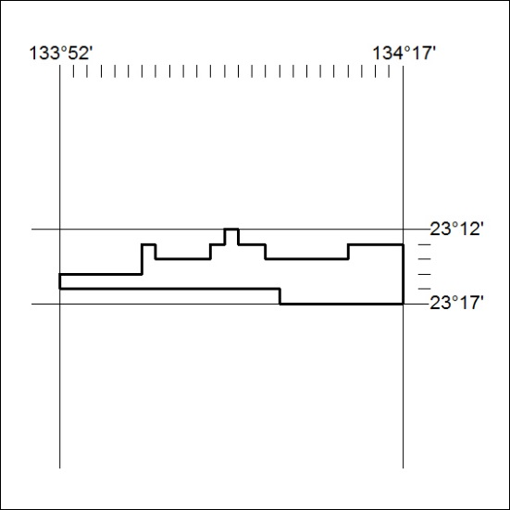

473/18

Corrigendum
Notice Number 460/18 appearing in MN132/18 on 19 OCTOBER 2018 is hereby cancelled and replaced by the following:

Mineral Titles Act
NOTICE OF LAND CEASING TO BE A MINERAL TITLE AREA
Title Type and Number: | Exploration Licence 30786
Area Ceased on: | 21 October 2018
Area: | 36 Blocks, 112.70 km²
Locality: | BURT
Name of Applicant(s)/Holder(s): | 100% TERRITORY EXPLORATION PTY LTD [ACN. 123 338 376]
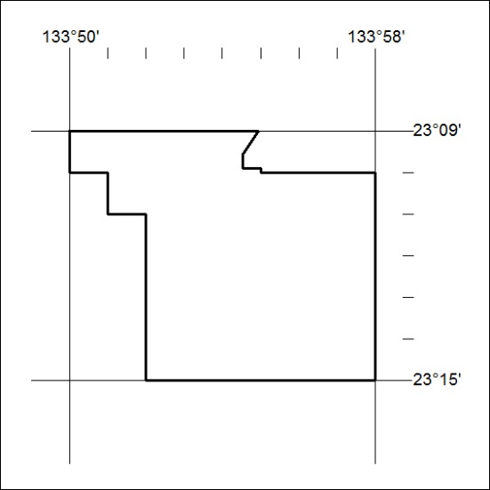

474/18

Corrigendum
Notice Number 461/18 appearing in MN132/18 on 19 OCTOBER 2018 is hereby cancelled and replaced by the following:

Mineral Titles Act
NOTICE OF LAND CEASING TO BE A MINERAL TITLE AREA
Title Type and Number: | Exploration Licence 31286
Area Ceased on: | 21 October 2018
Area: | 82 Blocks, 251.68 km²
Locality: | BURT
Name of Applicant(s)/Holder(s): | 100% TERRITORY EXPLORATION PTY LTD [ACN. 123 338 376]
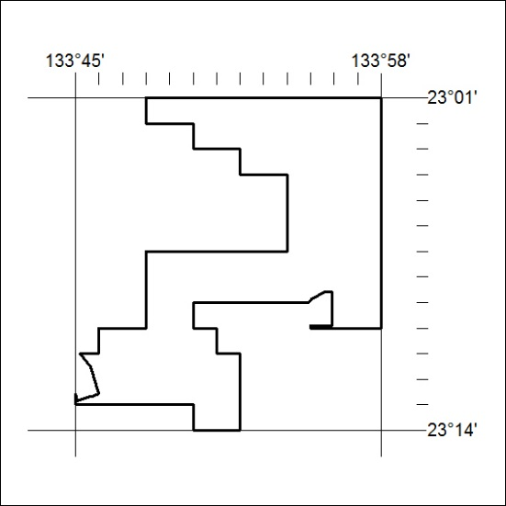

475/18

