Mineral Titles Act
NOTICE OF LAND CEASING TO BE A MINERAL TITLE AREA
Title Type and Number: | Extractive Mineral Exploration Licence 31944
Area Ceased on: | 09 August 2018
Area: | 2 Blocks, 6.70 km²
Locality: | MARY RIVER
Name of Applicant(s)/Holder(s): | 100% BORAL RESOURCES (QLD) PTY LIMITED [ACN. 009 671 809]
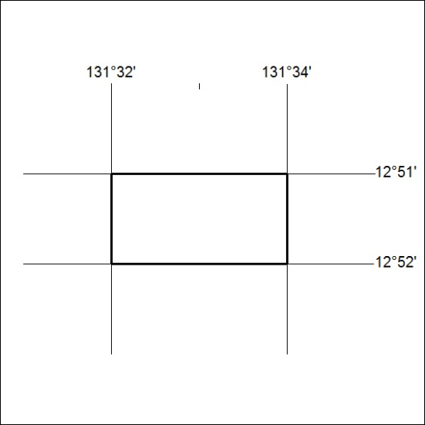

341/18

