Mineral Titles Act
NOTICE OF LAND CEASING TO BE A MINERAL TITLE AREA
Title Type and Number: | Exploration Licence 30689
Area Ceased on: | 06 July 2018
Area: | 4 Blocks, 12.71 km²
Locality: | DOREEN
Name of Applicant(s)/Holder(s): | 100% ENERGY METALS LTD [ACN. 111 306 533]
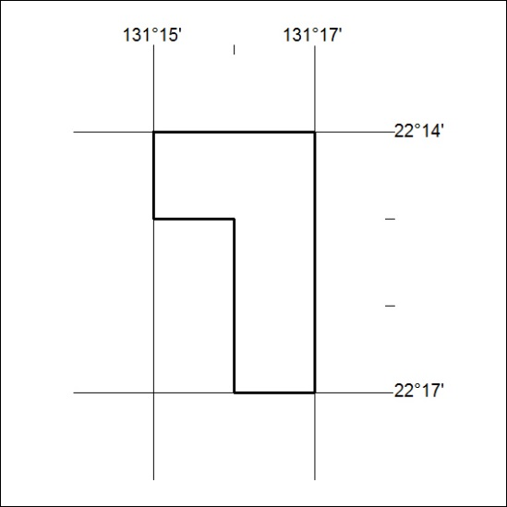

288/18

Mineral Titles Act
NOTICE OF GRANT OF A MINERAL TITLE
Title Type and Number: | Exploration Licence 31764
Granted: | 06 July 2018, for a period of 6 Years
Area: | 12 Blocks, 37.91 km²
Locality: | RANFORD HILL
Name of Holder/s: | 100% BACCHUS RESOURCES PTY LTD [ACN. 606 340 872]
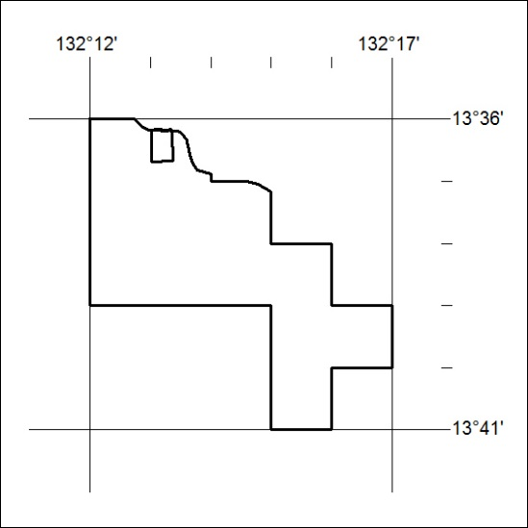
Area granted is indicated above. The titleholder is not permitted to exercise occupational rights on any land that is subject to a development title, or an application for a development title. Any land the subject of a Reserved Land gazettal under the Mineral Titles Act and all land vested in the Commonwealth of Australia is also excluded by description but not excised from the grant area.

289/18

