Overview
State final demand (SFD) increased by 3% in the December quarter, the strongest growth of the jurisdictions. The result was driven by a rebound in business investment, which increased by $200 million in the quarter (and accounted for 90% of growth [2.7 percentage points (ppt)]), and was a post-Inpex record supported by construction activity for the Barossa gas field. Public investment increased by 3.4% in the quarter driven by Territory Government investment in community housing, roads and utilities projects.
Household consumption fell by 0.7% in the quarter as Territory households continue to be concerned about interest rates and cost of living pressures, with reduced spending on discretionary items as households substituted eating out for home cooked meals (food spending was up by 1.4%, while spending on recreation, culture and hospitality was down by more than 3%). Government consumption increased by 1% due to increased spending on frontline services.
After a record high in the September quarter 2023, mineral exploration expenditure in the Territory decreased by 16% to $57 million in the December quarter (but is still 11% higher than December quarter 2022), while the value of mineral production in 2022-23 was $4.4 billion.
Indicator | Most recent | Measure | Period change¹ | Annual change² | Year on Year³ | COVID period change⁴
Economic Growth |  | $B
State final demand (NT) (sa) | Dec-23 | 7.695 | 3% | 3.6% | 1.5% | 16.2%
Consumption |  | 5.605 | 0.1% | 1.4% | 0.8% | 9.3%
Investment |  | 2.09 | 11.5% | 10.1% | 3.4% | 39.5%
Domestic final demand (Aus) (sa) | Dec-23 | 576.654 | 0.1% | 2.3% | 2.3% | 12.1%
Consumption |  | 432.312 | 0.2% | 0.9% | 1.3% | 10.7%
Investment |  | 144.342 | -0.2% | 6.7% | 5.4% | 16.5%
Gross state product (NT) | 2022-23 | 30.123 | na | na | -5.2% | na
Gross domestic product (Aus) | 2022-23 | 2406.726 | na | na | 3.2% | na
Partial Indicators |  | $B
Nominal retail sales (NT) (sa) | Jan-24 | 0.324 | 1% | 2.9% | 3.6% | 24.1%
Nominal retail sales (Aus) (sa) | Jan-24 | 35.724 | 1.1% | 1.1% | 2.6% | 29.1%
Construction work done (NT) (sa) | Dec-23 | 0.873 | 9.2% | 9.5% | 7.6% | 44.6%
Construction work done (Aus) (sa) | Dec-23 | 65.44 | 0.7% | 8.7% | 9% | 11%
Residential building activity (NT) | Sep-23 | 0.099 | 0.1% | -0.6% | 5.1% | 4.5%
Residential building activity (Aus) | Sep-23 | 21.383 | 2% | 4.9% | 1% | -4.1%
Nominal goods exports (NT) | Jan-24 | 0.835 | -15.1% | -43.2% | -8.4% | 26.9%
Nominal goods exports (Aus) (sa) | Jan-24 | 47.511 | 1.6% | -5.2% | -7.2% | 42.4%
Prices |  | Annual Δ²
Inflation (Darwin) | Dec-23 | 3.9% | -0.4 ppt | -3.2 ppt | na | 4.4 ppt
Inflation (8 Capitals) | Dec-23 | 4.1% | -1.3 ppt | -3.8 ppt | na | 4 ppt
WPI growth (NT) | Dec-23 | 4.3% | 0.2 ppt | 1.8 ppt | na | 1.4 ppt
WPI growth (Aus) | Dec-23 | 4.3% | 0.2 ppt | 0.9 ppt | na | 1.6 ppt
Employment |  | #M
Employment (NT) (sa) | Feb-24 | 0.139 | 0.9% | 2.6% | 1.6% | 4.4%
Employment (Aus) (sa) | Feb-24 | 14.27 | 0.8% | 3.2% | 3.2% | 9.7%
Unemployment |  | Rate
Unemployment rate (NT) (sa) | Feb-24 | 4.4% | 0 ppt | -1 ppt | na | -1.7 ppt
Unemployment rate (Aus) (sa) | Feb-24 | 3.7% | -0.4 ppt | 0.1 ppt | na | -1.4 ppt
Population |  | #M
Population (NT) | Sep-23 | 0.252 | 0% | 0.7% | na | 2.2%
Population (Aus) | Sep-23 | 26.822 | 0.6% | 2.5% | na | 4.7%
1. Monthly change for retail sales, goods exports, employment and unemployment; quarterly change for all other variables.
2. Compares the latest period with the same period last year.
3. Compares the 12 months up to and including the latest period with the previous 12-month period using original data.
4. Compares the 12 months up to and including latest period with the year to December 2019 period using original data.
Chart 1: In 2023 Territory SFD increased by 1.3%, with increased government investment (15.2%, 1.0 ppt) and government consumption (1.1%, 0.4 ppt). Business investment remained at high levels, while household spending and confidence continued to be impacted by economic uncertainty. The Australian Government’s announcement of funding support for Arafura Resources’ $1.6 billion rare earths mine and refinery project in Central Australia will support confidence and create local business and employment opportunities. | Chart 2: The mining industry (which includes oil and gas) is the largest contributor to economic activity in the NT, accounting for 27% of output in 2022-23. The value of mineral production in 2022-23 was $4.4 billion. Exploration is the life blood of the industry and, like the industry, is highly cyclical. Growth in the Territory’s mineral exploration spending (excluding oil and gas) moderated over 2023 but, in level terms, is at its highest level in more than a decade, with gold, base metals and copper the major commodites being targeted. Strong exploration expenditure augurs well for future industry production.
State Final Demand – NT  Components, moving annual total ($B)  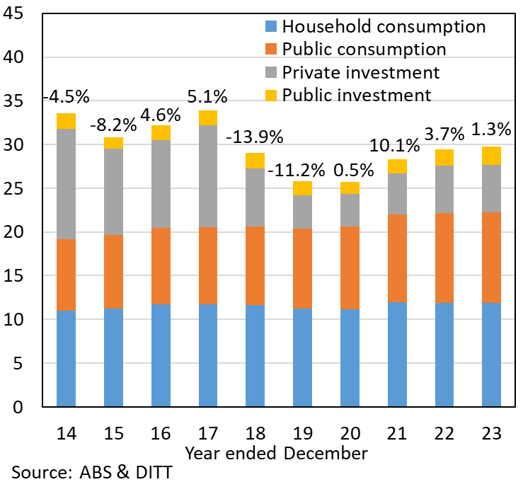 | Mineral Exploration Expenditure  Year on year growth (%)  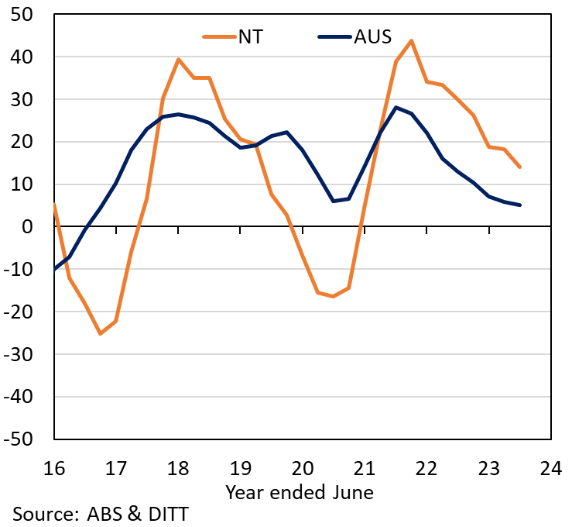
Chart 3: Lithium was among the best-performing commodities in 2021 and 2022, underpinned by strong electric vehicle (EV) sales. A different picture emerged through 2023, with a less bullish outlook for EV sales as China’s subsidies expired and household confidence fell. At the same time supply increased dramatically in 2023, with some analysts estimating production increased by up to 40%, led by Australia and China, and with Chile and Iran known to have significant reserves. | Chart 4: Though the short term prospects for lithium production are for continued headwinds, the International Energy Agency expects demand to strengthen significantly over the next decade as the global net zero transition gains pace, and notably as households transition to EV’s. Beyond 2035 growth in lithium demand is expected to moderate. Notwithstanding positive projections for future lithium demand, low cost producers are more likely to survive market volatility in the rapidly evolving critical minerals market.
Lithium Spodumene  Commodity spot price (USD per ton) | Lithium Demand Projections  Net Zero by 2050 Scenario, components (Kiloton)
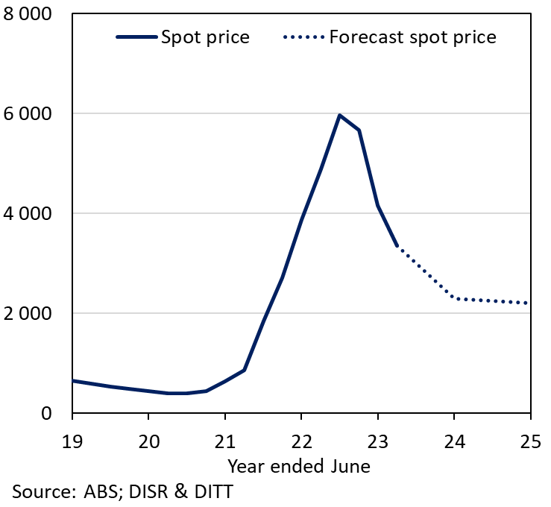 | 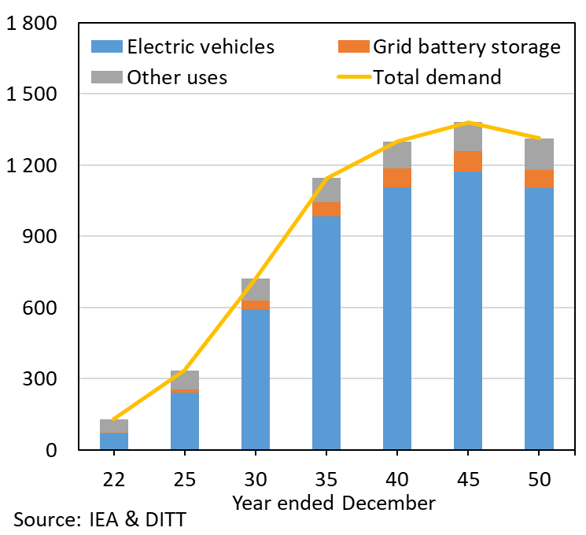
The Northern Territory of Australia exercised due care and skill to ensure that at the time of publication the information contained in this publication is true and correct. However, it is not intended to be relied on as professional advice or used for commercial purposes. The Territory gives no warranty or assurances as to the accuracy of the information contained in the publication and to the maximum extent permitted by law accepts no direct or indirect liability for reliance on its content.

