Overview
State final demand (SFD) increased by 1.1% in the September quarter, driven by public consumption and investment. Public investment continues to trend up, reporting a 5.8% increase, for the highest quarterly level since 2014, supported by spending on defence and in the university sector. Government consumption increased by 1.2%, with a 3.2% increase at the national level also driven by defence expenditure.
Private investment reported a 1.3% increase in the quarter, driven by mining investment construction (up by 6.0%) and intellectual property (up by 5.0%) on the back of a record quarter for mineral exploration expenditure. This was somewhat offset by dwelling investment (down by 6.4%). Household consumption reported slight growth of 0.1% in the quarter and 0.6% annually, as tight monetary policy acts to quell consumer demand. In year-on-year terms, growth in Territory SFD moderated to 1.1% in the year the September (Chart 1).
With the return of overseas migration from 2022 (Chart 2), the number of job vacancies has moderated albeit slightly, as many businesses continue to struggle to find skilled workers. The challenge is particularly acute in the Territory, with low spare capacity (evidenced by the higher participation rate than nationally), and a significantly higher number of advertised job vacancies per unemployed people (Chart 3). Reflecting the tight labour market more broadly, wage growth is accelerating, notably in the private sector (Chart 4).
Indicator | Most recent | Measure | Period change¹ | Annual change² | Year on Year³ | COVID period change⁴
Economic Growth |  | $B
State final demand (NT) (sa) | Sep-23 | 7.428 | 1.1% | 0.9% | 1.1% | 15.3%
Consumption |  | 5.603 | 0.6% | 1.7% | 0.5% | 9.3%
Investment |  | 1.826 | 2.6% | -1.5% | 2.7% | 35.2%
Domestic final demand (Aus) (sa) | Sep-23 | 575.376 | 0.5% | 2.2% | 2.5% | 11.4%
Consumption |  | 431.556 | 0.4% | 1.0% | 2.1% | 10.5%
Investment |  | 143.819 | 1.1% | 5.9% | 3.7% | 14.3%
Gross state product (NT) | 2022-23 | 30.123 | na | na | -5.2% | na
Gross domestic product (Aus) | 2022-23 | 2405.101 | na | na | 3.1% | na
Partial Indicators |  | $B
Nominal retail sales (NT) (sa) | Oct-23 | 0.323 | -0.1% | 2.7% | 3.8% | 23.1%
Nominal retail sales (Aus) (sa) | Oct-23 | 35.768 | -0.2% | 1.2% | 4.4% | 28.7%
Construction work done (NT) (sa) | Sep-23 | 0.809 | -0.7% | 8.5% | 3.8% | 40.8%
Construction work done (Aus) (sa) | Sep-23 | 64.769 | 1.3% | 8.5% | 7.3% | 8.6%
Residential building activity (NT) | Jun-23 | 0.088 | 10.6% | 2.2% | 5.1% | 3.2%
Residential building activity (Aus) | Jun-23 | 18.961 | 9.1% | 3.4% | -1.8% | -5.4%
Nominal goods exports (NT) | Oct-23 | 1.188 | -10.1% | -40.6% | -4.8% | 34.1%
Nominal goods exports (Aus) (sa) | Oct-23 | 45.548 | 0.4% | -11.9% | -1.2% | 45.5%
Prices |  | Annual Δ²
Inflation (Darwin) | Sep-23 | 4.3% | -1.0 ppt | -2.7 ppt | na | 5.2 ppt
Inflation (8 Capitals) | Sep-23 | 5.4% | -0.7 ppt | -1.9 ppt | na | 4.9 ppt
WPI growth (NT) | Sep-23 | 4.2% | 0.9 ppt | 1.7 ppt | na | 1.0 ppt
WPI growth (Aus) | Sep-23 | 4.1% | 0.4 ppt | 0.9 ppt | na | 1.4 ppt
Employment |  | #M
Employment (NT) (sa) | Nov-23 | 0.138 | -1.0% | -1.9% | 2.9% | 6.6%
Employment (Aus) (sa) | Nov-23 | 14.257 | 0.4% | 3.2% | 3.4% | 9.0%
Unemployment |  | Rate
Unemployment rate (NT) (sa) | Nov-23 | 4.6% | 0.6 ppt | 1.5 ppt | na | -1.1 ppt
Unemployment rate (Aus) (sa) | Nov-23 | 3.9% | 0.1 ppt | 0.4 ppt | na | -1.5 ppt
Population |  | #M
Population (NT) | Jun-23 | 0.252 | 0.3% | 0.9% | na | 2.0%
Population (Aus) | Jun-23 | 26.639 | 0.6% | 2.4% | na | 4.0%
1. Monthly change for retail sales, goods exports, employment and unemployment; quarterly change for all other variables.
2. Compares the latest period with the same period last year.
3. Compares the 12 months up to and including the latest period with the previous 12-month period using original data.
4. Compares the 12 months up to and including latest period with the year to December 2019 period using original data.
Chart 1: Territory SFD increased by 1.1% in the year to September 2023, mainly driven by increased public investment (12.4%), supported by increased household consumption (0.6%) and government consumption (0.4%), with a decrease in private investment (0.5%) being the sole detractor. Domestic demand has been on a growth trajectory since 2020 supported by investment in resource and economic and social infrastructure projects. | Chart 2: The Territory’s population is now above 252,400 with annual growth of 0.9% to June 2023, or 2,245 persons. The strongest contributor over the past year was net overseas migration at 3,335 persons. Given net interstate migration has historically been a ‘drag’ on population growth in the Territory, overseas migration will be integral to not only meeting skilled labour demands in the short term, but laying the foundations for broader economic growth going forward.
State Final Demand – NT  Components, moving annual total ($B)  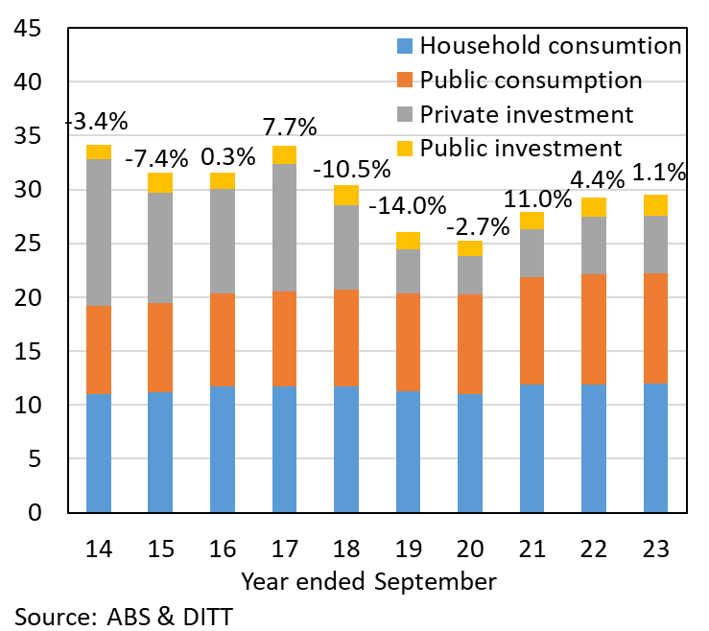 | Population – NT  Components, moving annual total (persons)  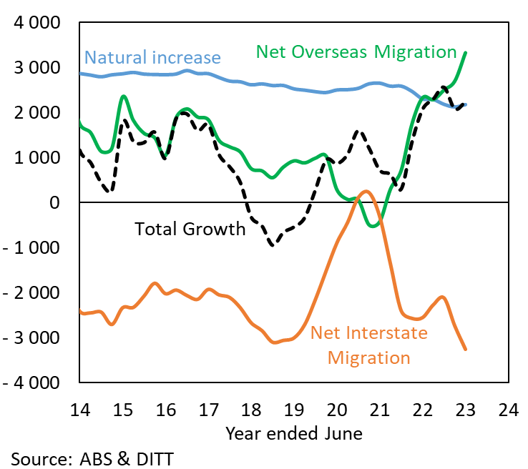
Chart 3: The Territory grapples with the dual challenges of skills and geographic mismatch – where the right persons are not available in the place of job openings, and job opportunities are scarce in regions with high unemployment. These issues are more pronounced in the Territory than nationally. In Darwin there are around 1.8 job vacancies per unemployed person compared with a 1:1 ratio for the capital cities. The ratio is significantly lower in regional areas, where there tend to be fewer job opportunities. | Chart 4: The private sector is more agile to changing economic conditions. This is reflected in recent wage growth. Tight labour market conditions since 2021 are being felt in the private and public sectors, but it is the private sector that is responding with remuneration, with wages growth of 4.4% in the year to September 2023, compared with 1.5% for the public sector. That said, over the past 10 years annual growth for both sectors has averaged 2.4% per annum. Latest Treasury forecasts expect Territory private sector wage growth to remain above 4% through 2024.
Vacancies per one unemployed person  Capital cities vs rest of NT/AUS, Moving Annual Average (#) | Wage Price Index  Year-on-year (% change)
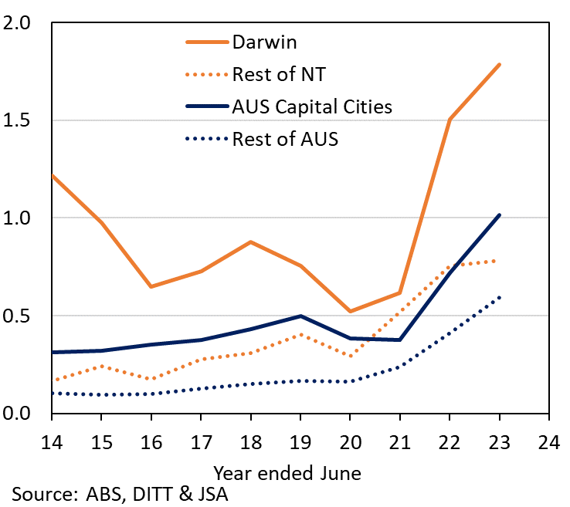 | 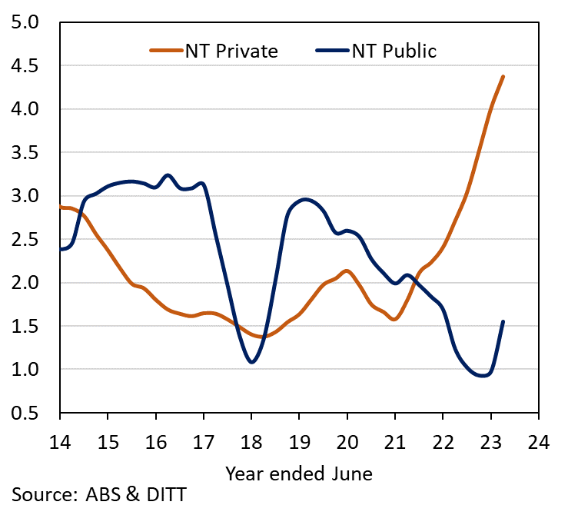

The Northern Territory of Australia exercised due care and skill to ensure that at the time of publication the information contained in this publication is true and correct. However, it is not intended to be relied on as professional advice or used for commercial purposes. The Territory gives no warranty or assurances as to the accuracy of the information contained in the publication and to the maximum extent permitted by law accepts no direct or indirect liability for reliance on its content.

