This release mainly looks at national data with only high-level results for the jurisdictions. Detailed data on Territory businesses (by industry, turnover, employment size and location) will be released in December.

The Territory recorded higher business growth than nationally
The number of businesses operating in the Territory grew by 2.0% in 2022-23, well above the national rate of 0.8% (Table 1) and the third highest of the jurisdictions, below the Australian Capital Territory (3.5%) and Queensland (2.3%). Nationally, the weakest overall growth since 2016-17 was recorded, driven by a decline in small businesses (1 to 19 employees), which experienced a decrease of 2.2% (Chart 1).
Table 1: Business Counts for 2022-23
 | Jun-23  (#) | Jun-22  (#) | Change  (#) | Change (%) | Entries  (#) | Entry rate (%) | Exits  (#) | Exit rate (%)
NT | 16,107 | 15,796 | 311 | 2.0 | 2,673 | 16.9 | 2,256 | 14.3
AUS | 2,589,873 | 2,569,900 | 19,973 | 0.8 | 406,365 | 15.8 | 386,392 | 15.0

Territory businesses represent 0.6% of all Australian businesses despite having 0.9% of the population. As such, historically the Territory has had the lowest number of businesses per capita of the jurisdictions. In 2022-23, the Territory had 64 businesses per 1000 people (up from 63 last year), but below the national average of 99 businesses per 1000 people (down from 100 last year) (Chart 2).
Chart 1 | Chart 2
Australian Business Growth  Annual growth rate (%) by employment size | Businesses per capita  Number of businesses per 1000 people in 2022-23
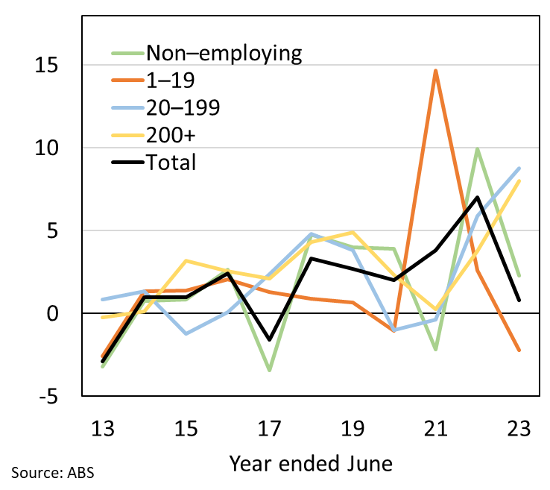 | 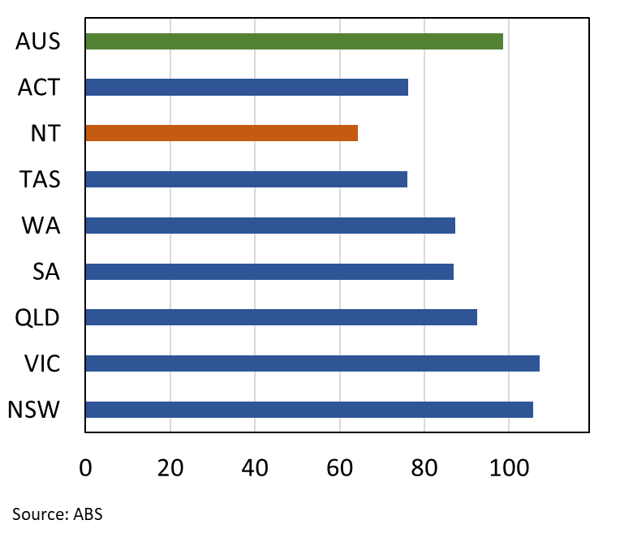

Higher business exits constrain growth
In 2022-23, all jurisdictions recorded an increase in business entries broadly in line with the national level (15.8%). The Territory recorded the second highest entry rate (16.9%) below only the Australian Capital Territory (18.3%). This follows the record business entry rates reported in 2021-22 (both nationally and in the Territory) and maintains solid growth compared with the past decade.
However, all jurisdictions reported an increased level of business exits in 2022-23, and the national exit rate (15.0%) was the highest of the past decade, and the highest since 2012-13 for four of the jurisdictions including the Territory (14.3%) (Chart 3).
The impact of adverse macroeconomic conditions, including elevated inflation and increasing interest rates, has likely contributed to the increased exit rate nationally. This has been notable in customer facing industries such as the wholesale, retail and hospitality sectors, all recording net declines (more exits than entries) in 2022-23 (Chart 4). The tightening of monetary policy has resulted in a decrease in household spending, particularly discretionary spending, with real national retail turnover down by 1.4% annually to June 2023. Nationally, the number of exits in the retail industry increased by 34%.
The construction industry also reported a high number of exits (up by 32%) and a decline in entries (down by 18%) which reflects headwinds arising from the end of stimulus initiatives such as the Homebuilder grants, supply chain disruption, labour shortages, and increasing costs of input materials.
Chart 3 | Chart 4
Business Entry and Exit Rates  Annual rate (%) | Net Change in Operating Businesses  By industry, nationally; annual change (%)
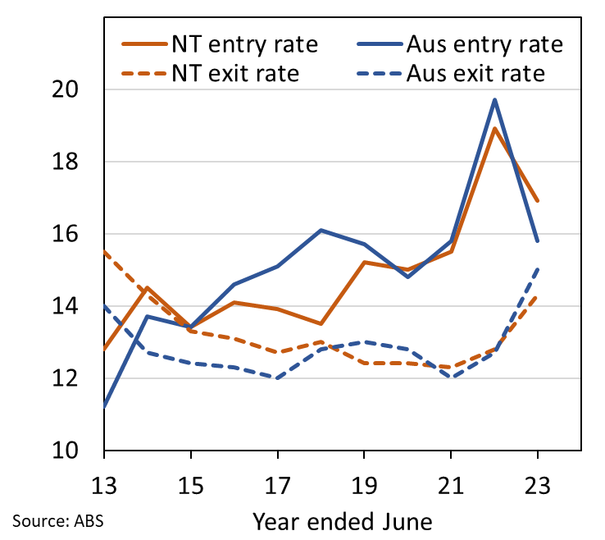 | 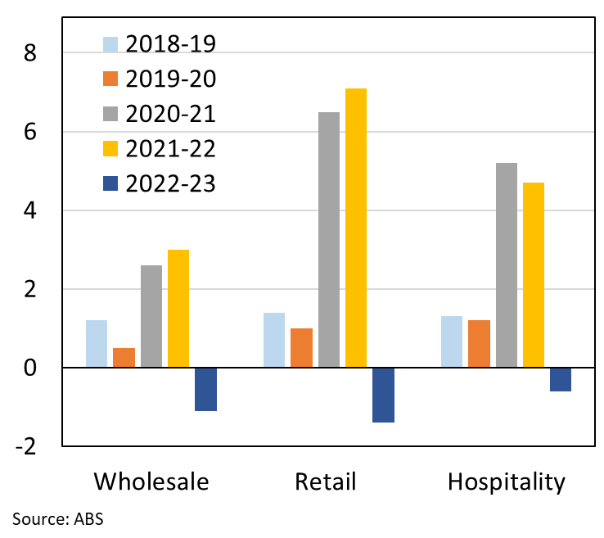

Lower survival rate of new entries in the Territory than nationally
The survival rates of Territory businesses are in line with the national average (Chart 5) while the survival rates of new businesses in the Territory remain slightly below the national average (Chart 6). Around 48% of new Territory businesses in 2019-20 survived to June 2023, slightly below the national rate.
Chart 5 | Chart 6
Survival Rates  Businesses operating since four years ago (%) | Survival Rates of New Entries  Business operating since entering three years ago (%)
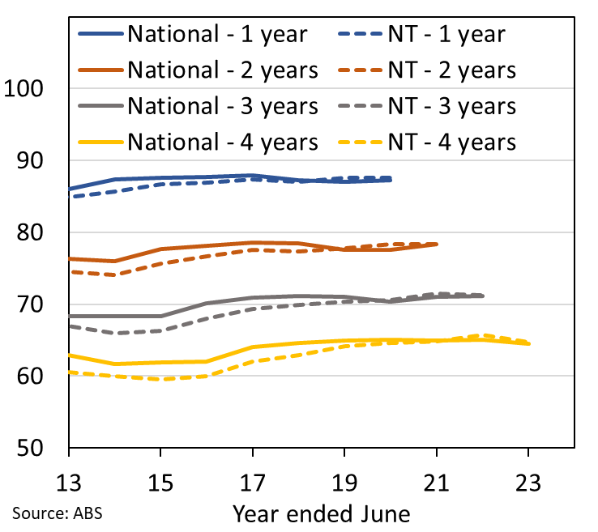 | 