Mineral Titles Act 2010
NOTICE OF LAND CEASING TO BE A MINERAL TITLE AREA
Title Type and Number: | Extractive Mineral Exploration Licence 32589
Area Ceased on: | 29 November 2022
Area: | 4 Blocks, 13.13 km²
Locality: | NEWCASTLE WATERS
Name of Applicant(s)/Holder(s): | 100% TERRITORY SANDS PTY LTD [ACN. 632 797 972]
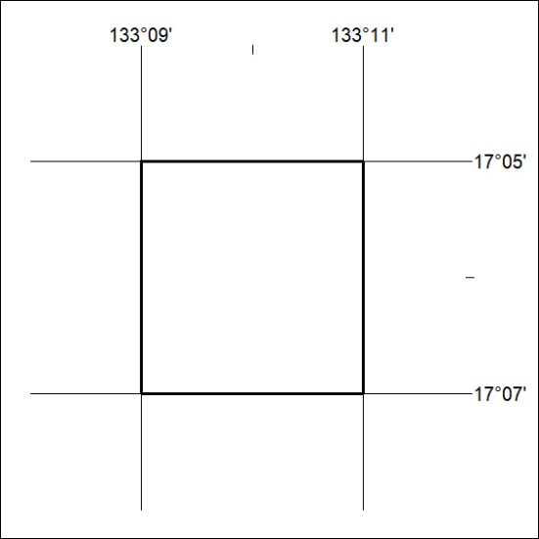

413/22

Mineral Titles Act 2010
NOTICE OF LAND CEASING TO BE A MINERAL TITLE AREA
Title Type and Number: | Extractive Mineral Exploration Licence 32605
Area Ceased on: | 29 November 2022
Area: | 4 Blocks, 13.13 km²
Locality: | NEWCASTLE WATERS
Name of Applicant(s)/Holder(s): | 100% TERRITORY SANDS PTY LTD [ACN. 632 797 972]
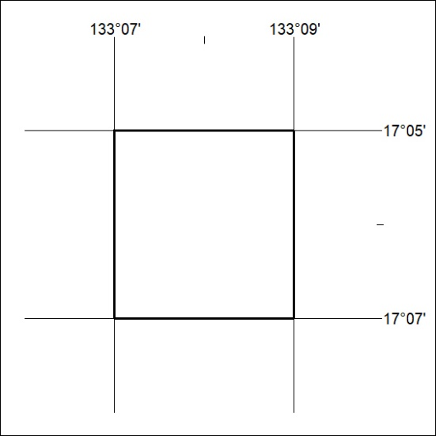

414/22

