Mineral Titles Act 2010
NOTICE OF LAND CEASING TO BE A MINERAL TITLE AREA
Title Type and Number: | Exploration Licence 31618
Area Ceased on: | 09 November 2022
Area: | 95 Blocks, 261.10 km²
Locality: | TENNANT CREEK
Name of Applicant(s)/Holder(s): | 100% TREASURE CREEK PTY LTD [ACN. 619 057 644]
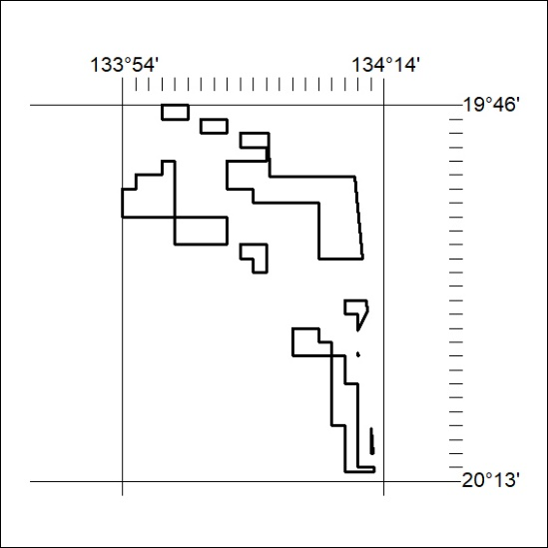

384/22

Mineral Titles Act 2010
NOTICE OF LAND CEASING TO BE A MINERAL TITLE AREA
Title Type and Number: | Exploration Licence 31629
Area Ceased on: | 10 November 2022
Area: | 72 Blocks, 207.03 km²
Locality: | HATCHES
Name of Applicant(s)/Holder(s): | 100% TREASURE CREEK PTY LTD [ACN. 619 057 644]
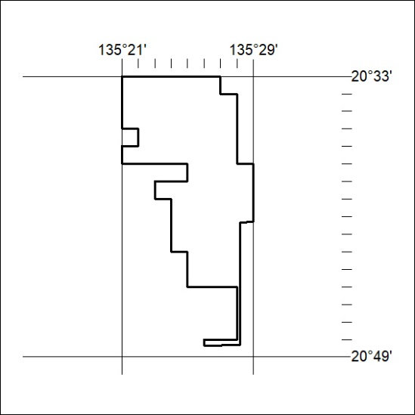

385/22
Mineral Titles Act 2010
NOTICE OF LAND CEASING TO BE A MINERAL TITLE AREA
Title Type and Number: | Exploration Licence 31692
Area Ceased on: | 09 November 2022
Area: | 22 Blocks, 72.37 km²
Locality: | MALLAPUNYAH
Name of Applicant(s)/Holder(s): | 100% CERBERUS RESOURCES PTY LTD [ACN. 615 192 535]
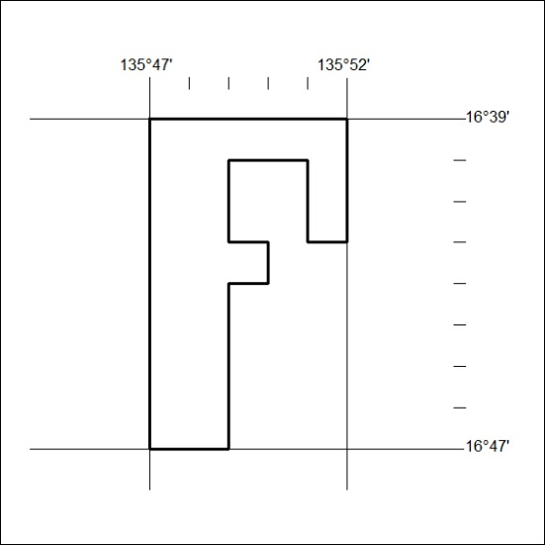

386/22

Mineral Titles Act 2010
NOTICE OF LAND CEASING TO BE A MINERAL TITLE AREA
Title Type and Number: | Exploration Licence 31784
Area Ceased on: | 09 November 2022
Area: | 3 Blocks, 9.53 km²
Locality: | VAUGHAN
Name of Applicant(s)/Holder(s): | 100% CERBERUS RESOURCES PTY LTD [ACN. 615 192 535]
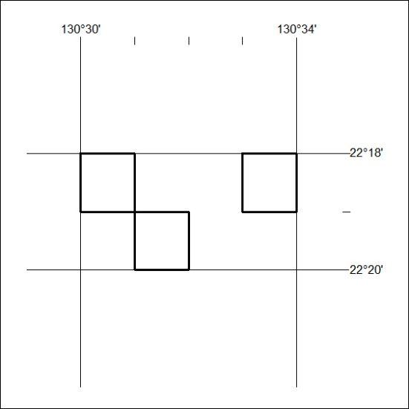

387/22
Mineral Titles Act 2010
NOTICE OF LAND CEASING TO BE A MINERAL TITLE AREA
Title Type and Number: | Exploration Licence 32297
Area Ceased on: | 07 November 2022
Area: | 35 Blocks, 110.92 km²
Locality: | DALMORE
Name of Applicant(s)/Holder(s): | 100% BARKLY OPERATIONS PTY LTD [ACN. 641 856 706]
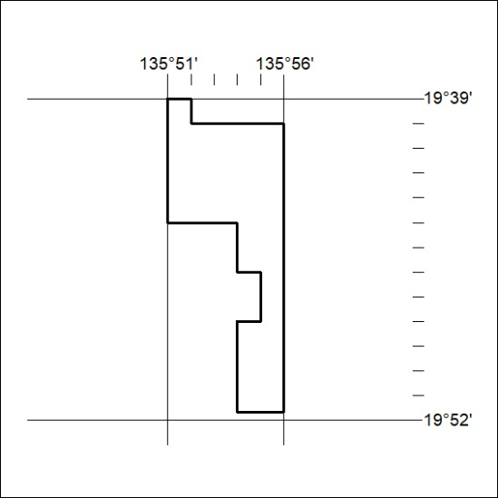
(Area now amalgamated into Exploration Licence 33276 under s102 – EL moratorium period does not apply)

388/22

Mineral Titles Act 2010
NOTICE OF LAND CEASING TO BE A MINERAL TITLE AREA
Title Type and Number: | Exploration Licence 32298
Area Ceased on: | 07 November 2022
Area: | 137 Blocks, 443.37 km²
Locality: | DALMORE
Name of Applicant(s)/Holder(s): | 100% BARKLY OPERATIONS PTY LTD [ACN. 641 856 706]
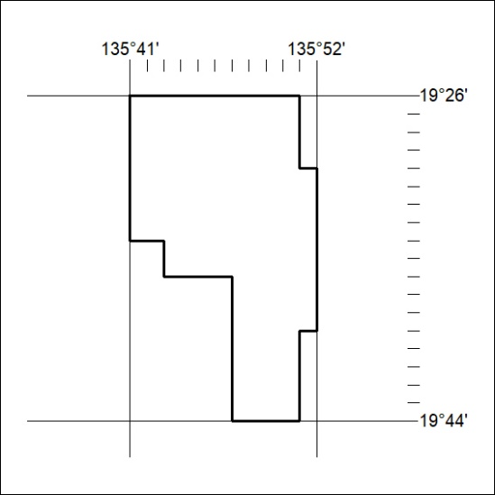
(Area now amalgamated into Exploration Licence 33276 under s102 – EL moratorium period does not apply)

389/22
Mineral Titles Act 2010
NOTICE OF LAND CEASING TO BE A MINERAL TITLE AREA
Title Type and Number: | Exploration Licence 32344
Area Ceased on: | 28 October 2022
Area: | 26 Blocks, 83.41 km²
Locality: | DAVENPORT RANGE
Name of Applicant(s)/Holder(s): | 100% TREASURE CREEK PTY LTD [ACN. 619 057 644]
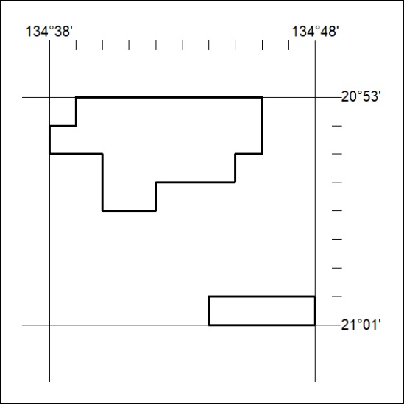

390/22

Mineral Titles Act 2010
NOTICE OF LAND CEASING TO BE A MINERAL TITLE AREA
Title Type and Number: | Exploration Licence 32814
Area Ceased on: | 07 November 2022
Area: | 2 Blocks, 6.46 km²
Locality: | DALMORE
Name of Applicant(s)/Holder(s): | 100% BARKLY OPERATIONS PTY LTD [ACN. 641 856 706]
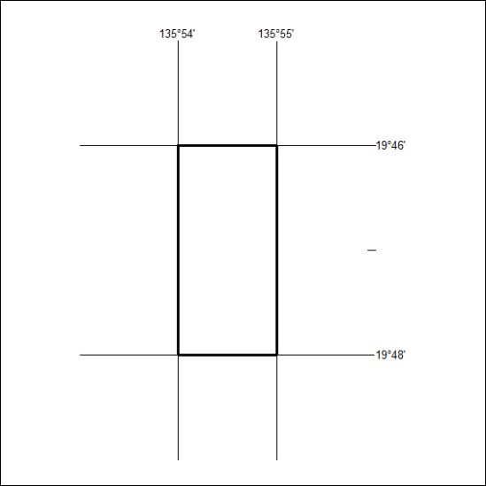
(Area now amalgamated into Exploration Licence 33276 under s102 – EL moratorium period does not apply)

391/22
Mineral Titles Act 2010
NOTICE OF LAND CEASING TO BE A MINERAL TITLE AREA
Title Type and Number: | Exploration Licence 32815
Area Ceased on: | 07 November 2022
Area: | 4 Blocks, 12.94 km²
Locality: | DALMORE
Name of Applicant(s)/Holder(s): | 100% BARKLY OPERATIONS PTY LTD [ACN. 641 856 706]
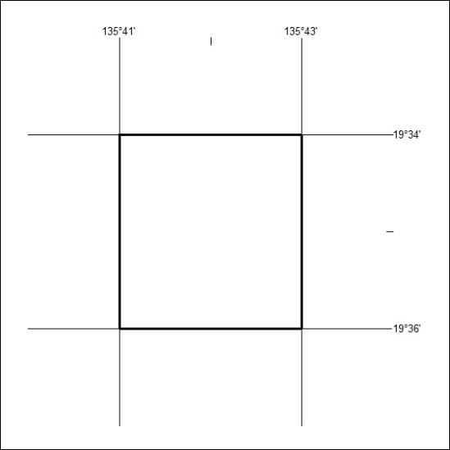
(Area now amalgamated into Exploration Licence 33276 under s102 – EL moratorium period does not apply)

392/22

Mineral Titles Act
NOTICE OF GRANT OF A MINERAL TITLE
Title Type and Number: | Extractive Mineral Permit 33122
Granted: | 09 November 2022, for a period of 5 Years
Area: | 76.12 Hectares
Locality: | MARANBOY
Name of Holder/s: | 66% D&S SAND, SOIL & GRAVEL PTY LTD [ACN. 645 168 752], 34% TEELOW Leslie John
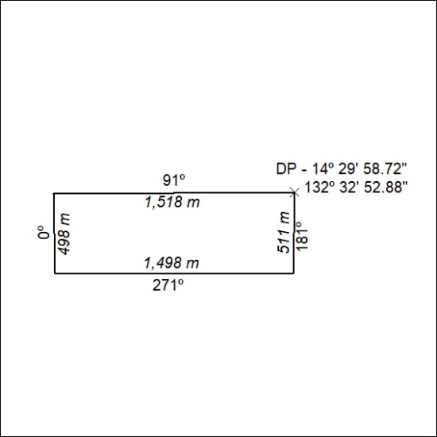

393/22

