Mineral Titles Act
NOTICE OF GRANT OF A MINERAL TITLE
Title Type and Number: | Exploration Licence 33148
Granted: | 11 October 2022, for a period of 6 Years
Area: | 28 Blocks, 91.06 km²
Locality: | WINGATE MOUNTAINS
Name of Holder/s: | 100% RAGUSA MINERALS LTD [ACN. 143 194 165]
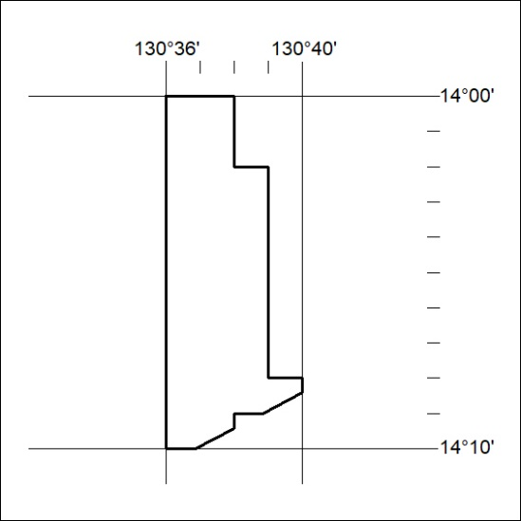
Area granted is indicated above. The titleholder is not permitted to exercise occupational rights on any land that is subject to a development title, or an application for a development title. Any land the subject of a Reserved Land gazettal under the Mineral Titles Act and all land vested in the Commonwealth of Australia is also excluded by description but not excised from the grant area.

351/22

