Mineral Titles Act 2010
NOTICE OF LAND CEASING TO BE A MINERAL TITLE APPLICATION AREA
Title Type and Number: | Exploration Licence 33288
Area Ceased on: | 27 September 2022
Area: | 250 Blocks, 772.87 km²
Locality: | ALLANAH
Name of Applicant(s)/Holder(s): | 100% MCCLEARY Norman Sydney
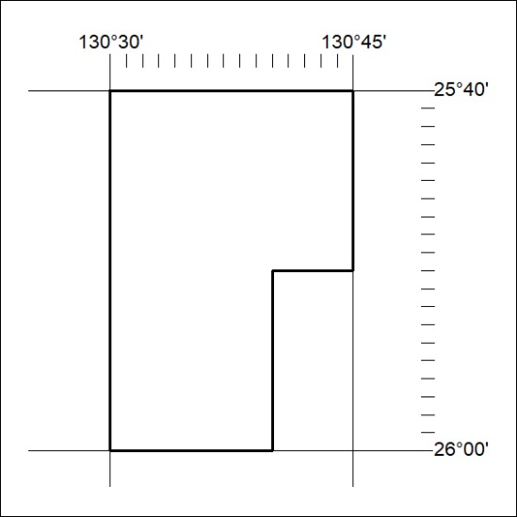

344/22

Mineral Titles Act 2010
NOTICE OF LAND CEASING TO BE A MINERAL TITLE APPLICATION AREA
Title Type and Number: | Exploration Licence 33289
Area Ceased on: | 27 September 2022
Area: | 250 Blocks, 772.77 km²
Locality: | ALLANAH
Name of Applicant(s)/Holder(s): | 100% MCCLEARY Norman Sydney
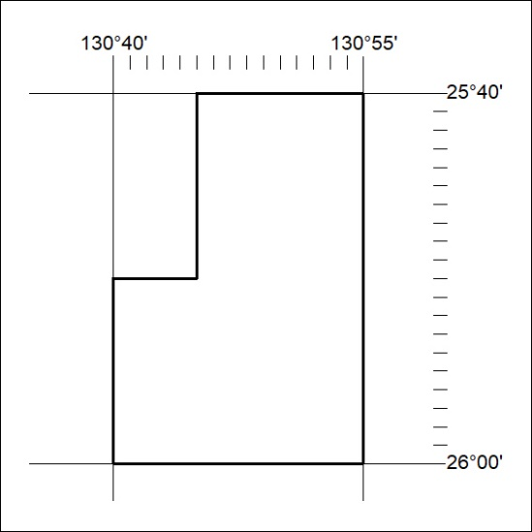

345/22

Mineral Titles Act 2010
NOTICE OF LAND CEASING TO BE A MINERAL TITLE APPLICATION AREA
Title Type and Number: | Exploration Licence 33290
Area Ceased on: | 27 September 2022
Area: | 250 Blocks, 772.73 km²
Locality: | BRITTEN JONES
Name of Applicant(s)/Holder(s): | 100% MCCLEARY Norman Sydney
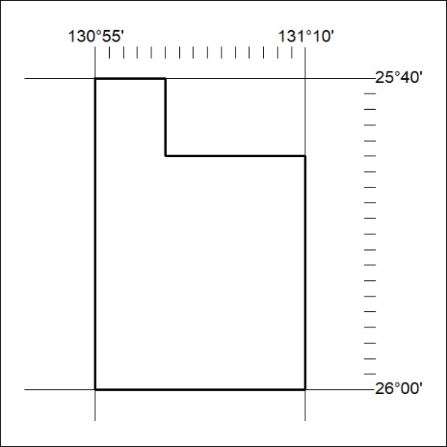

346/22

Mineral Titles Act 2010
NOTICE OF LAND CEASING TO BE A MINERAL TITLE APPLICATION AREA
Title Type and Number: | Exploration Licence 33291
Area Ceased on: | 27 September 2022
Area: | 50 Blocks, 154.73 km²
Locality: | BRITTEN JONES
Name of Applicant(s)/Holder(s): | 100% MCCLEARY Norman Sydney
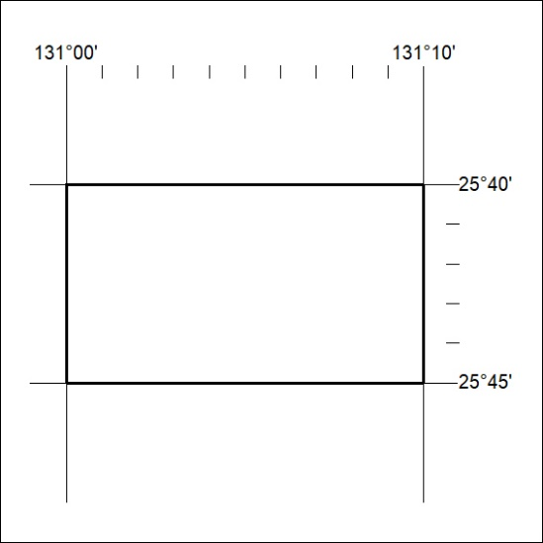

347/22

