Mineral Titles Act 2010
NOTICE OF LAND CEASING TO BE A MINERAL TITLE AREA
Title Type and Number: | Exploration Licence 31332
Area Ceased on: | 14 July 2022
Area: | 33 Blocks, 99.02 km²
Locality: | MALLEE
Name of Applicant(s)/Holder(s): | 100% PRODIGY GOLD NL* [ACN. 009 127 020]
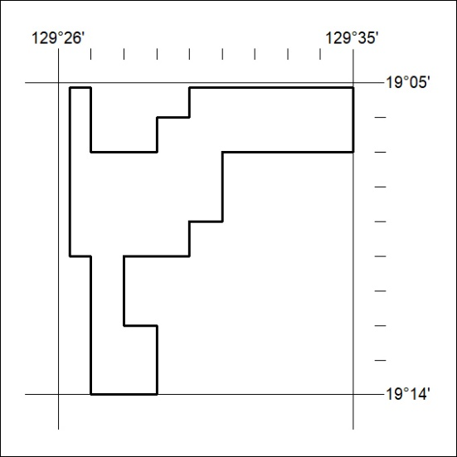

238/22

