Mineral Titles Act 2010
NOTICE OF LAND CEASING TO BE A MINERAL TITLE APPLICATION AREA
Title Type and Number: | Exploration Licence 32941
Area Ceased on: | 01 July 2022
Area: | 93 Blocks, 291.12 km²
Locality: | SANTA TERESA
Name of Applicant(s)/Holder(s): | 100% GEMPART (NT) PTY LTD* [ACN. 081 859 896]
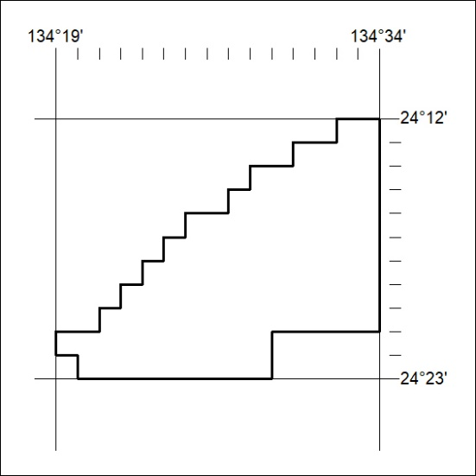

225/22

