Mineral Titles Act 2010
NOTICE OF LAND CEASING TO BE A MINERAL TITLE AREA
Title Type and Number: | Exploration Licence 28904
Area Ceased on: | 26 March 2022
Area: | 69 Blocks, 223.69 km²
Locality: | SHORT RANGE
Name of Applicant(s)/Holder(s): | 100% MANTO MINING PTY LTD [ACN. 152 392 562]
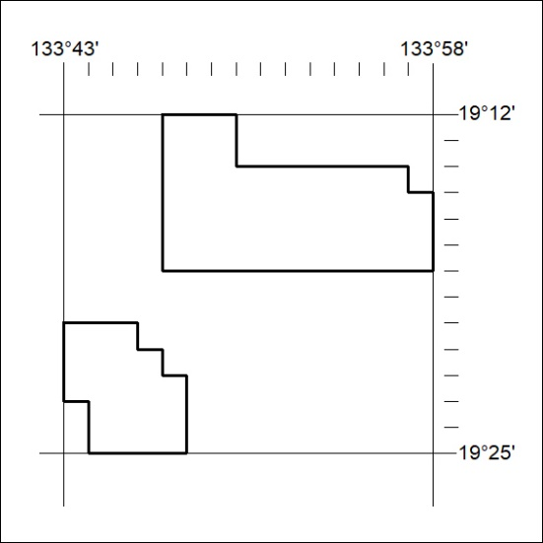

76/22

Mineral Titles Act 2010
NOTICE OF LAND CEASING TO BE A MINERAL TITLE AREA
Title Type and Number: | Exploration Licence 28907
Area Ceased on: | 26 March 2022
Area: | 33 Blocks, 106.94 km²
Locality: | FLYNN
Name of Applicant(s)/Holder(s): | 100% MANTO MINING PTY LTD [ACN. 152 392 562]
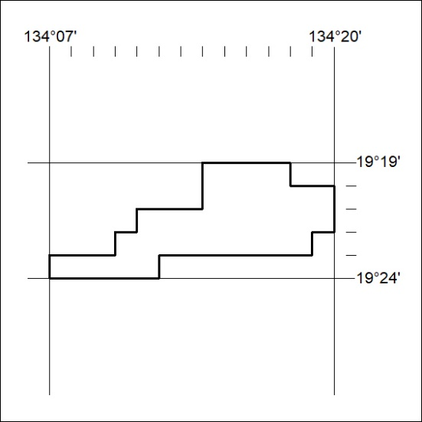

77/22
Mineral Titles Act 2010
NOTICE OF LAND CEASING TO BE A MINERAL TITLE AREA
Title Type and Number: | Exploration Licence 32316
Area Ceased on: | 31 March 2022
Area: | 152 Blocks, 501.37 km²
Locality: | VICTORIA RIVER DOWNS
Name of Applicant(s)/Holder(s): | 100% ALBIAN RESOURCES PTY LTD [ACN. 629 786 161]
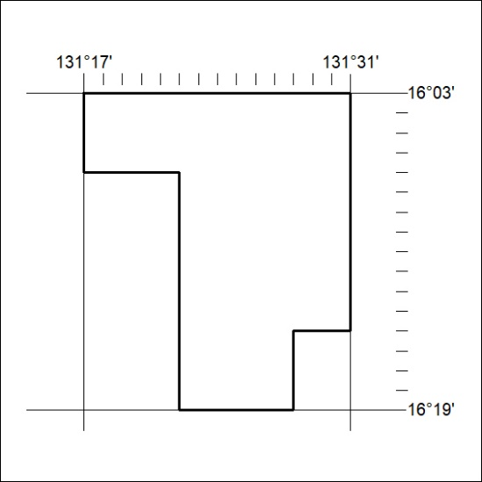

78/22

Mineral Titles Act 2010
NOTICE OF LAND CEASING TO BE A MINERAL TITLE AREA
Title Type and Number: | Extractive Mineral Permit 25858
Area ceased on: | 31 March 2022
Area: | 31.00 Hectare
Locality: | BYNOE
Name of Applicants(s)Holder(s): | 100% ALLAN KING & SONS CONSTRUCTION PTY LTD [ACN. 068 688 148]
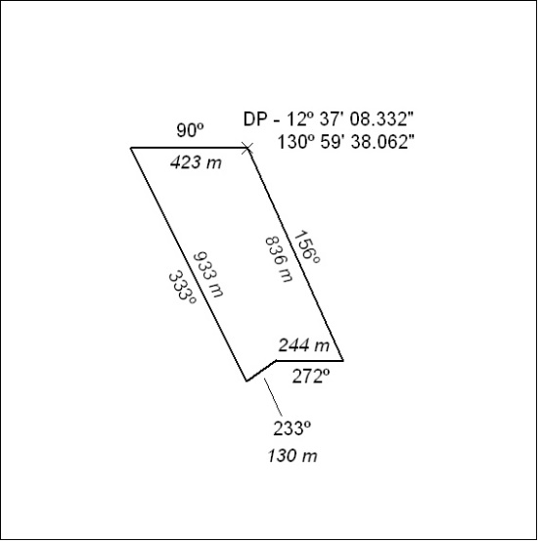

79/22

Mineral Titles Act
NOTICE OF GRANT OF A MINERAL TITLE
Title Type and Number: | Exploration Licence 32830
Granted: | 23 March 2022, for a period of 6 Years
Area: | 207 Blocks, 653.29 km²
Locality: | ANNINGIE
Name of Holder/s: | 100% PURE MINING PTY LTD [ACN. 627 691 721]
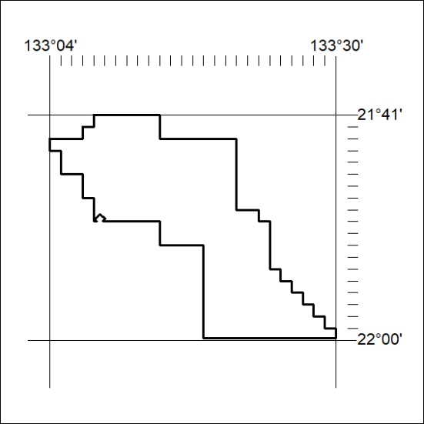
Area granted is indicated above. The titleholder is not permitted to exercise occupational rights on any land that is subject to a development title, or an application for a development title. Any land the subject of a Reserved Land gazettal under the Mineral Titles Act and all land vested in the Commonwealth of Australia is also excluded by description but not excised from the grant area.
80/22

Mineral Titles Act
NOTICE OF GRANT OF A MINERAL TITLE
Title Type and Number: | Exploration Licence 32873
Granted: | 28 March 2022, for a period of 6 Years
Area: | 67 Blocks, 219.67 km²
Locality: | CALVERT HILLS
Name of Holder/s: | 100% REDBANK OPERATIONS PTY LTD* [ACN. 109 362 165]
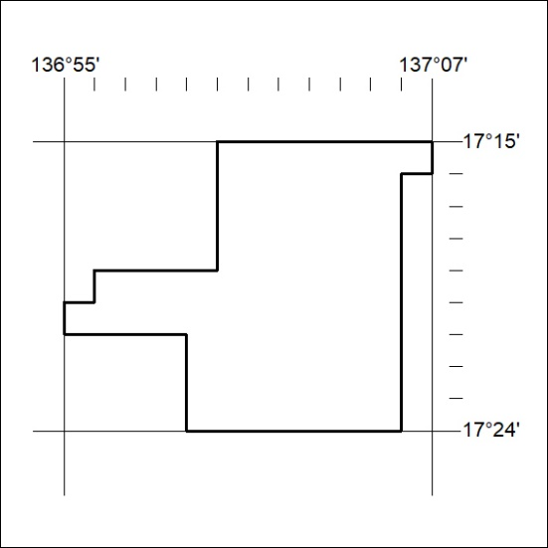
Area granted is indicated above. The titleholder is not permitted to exercise occupational rights on any land that is subject to a development title, or an application for a development title. Any land the subject of a Reserved Land gazettal under the Mineral Titles Act and all land vested in the Commonwealth of Australia is also excluded by description but not excised from the grant area.
81/22

