Mineral Titles Act
NOTICE OF GRANT OF A MINERAL TITLE
Title Type and Number: | Exploration Licence 32836
Granted: | 23 March 2022, for a period of 6 Years
Area: | 205 Blocks, 649.84 km²
Locality: | DENISON
Name of Holder/s: | 100% CONSOLIDATE LITHIUM TRADING PTY LTD [ACN. 644 114 170]
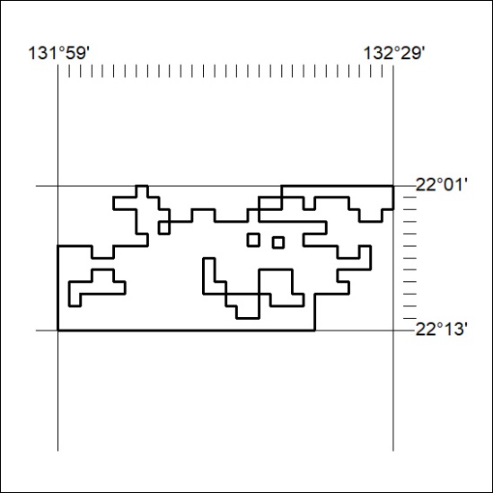
Area granted is indicated above. The titleholder is not permitted to exercise occupational rights on any land that is subject to a development title, or an application for a development title. Any land the subject of a Reserved Land gazettal under the Mineral Titles Act and all land vested in the Commonwealth of Australia is also excluded by description but not excised from the grant area.

75/22

