Mineral Titles Act 2010
NOTICE OF LAND CEASING TO BE A MINERAL TITLE APPLICATION AREA
Title Type and Number: | Mineral Lease 32789
Area ceased on: | 08 November 2021
Area: | 88.00 Hectare
Locality: | HELEN
Name of Applicants(s)Holder(s): | 100% OM (MANGANESE) LTD [ACN. 097 091 506]
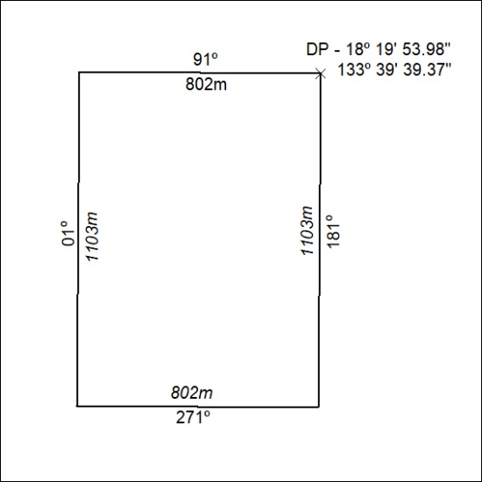

420/21

